**AWS Security & Compliance: Data Protection and Threat Monitoring System**

Objectives:

The overall objective of this project is intended to create and implement a security system within AWS that provides data protection, identify threats being monitored and maintain security compliances such as protecting important data utilizing encryption, restricting access and configure appropriate lifecycle rules. Ensure that the Identity Access Management roles, policies and Multi Factor Authentication features are configured to ensure that the least amount of privileged access is granted. Set up CloudTrail, Guard Duty and Config to ensure that they are able to monitor any unauthorized activity. There should be some kind of automated process that ensures compliances are met and enforces remediation in the event that misconfiguration happens. Real time alerts should occur if high severities are discovered and potential breaches that can occur. This project will be documented for future references.

Tools and AWS Services:

**IAM (Identity & Access Management)** – Secure Access Control, roles containing policies and permissions.

**S3 (Simple Storage Service)** – Store and protect data using bucket policies, encryption and versions.

**CloudTrail** – Logs and monitors AWS API activities.

**AWS Config** – Tracks any configuration changes while ensuring and maintaining compliances.

**Guard Duty** – Intelligent threat detection used to detect any malicious or unusual behaviors

**Amazon Inspector** – Scans EC2 instances for vulnerabilities

**SNS (Simple Notification Service)** – set up alerts to notify any high severity findings.

**KMS (Key Management Service)** – Encrypts data and manages secure access to keys

**CloudWatch** – Monitors visualization of logs and metrics while setting up alarms for unusual activities.

**AWS Security Hub** – Unified security dashboard designed to combine all findings from Guard duty, AWS Config and AWS Inspector.

Purpose: The purpose of the AWS Security & Compliance: Data Protection and Threat Monitoring System project is to set up a well working functional robust security framework with the AWS Cloud platform. This project should cover the scope of protecting sensitive data, monitoring and detecting threats, enforce compliance, minimize security risks, automates security responses, demonstrate the ability to generate real time alerts then logs and audits all activities that occur. It will store data in a secure manner while encrypting all of it using AWS services such as S3, KMS and IAM policies. It will also implement continuous monitoring and intelligent threat detections using Guard Duty, CloudTrail and Security Hub. In terms of enforcing compliances, it will use AWS Config and Security Hub to track misconfigurations, enforce compliance rules and will most likely utilize and maintain industry standards which could be CIS benchmarks or NIST, etc. In order to reduce and minimize security risks, access restrictions will be done based on what kinds of IAM policies are being implemented and utilized, as well as Multi-Factor Authentication (MFA), and least privilege principles to reduce any malicious insider threat from finding attack surfaces to exploit. The automated security responses will be done by implementing auto remediation workflows using AWS Lambda, AWS Systems Manager and event bridge to patch and resolve security issues that occur in real time. We will be configuring SNS and CloudWatch alarms to notify security of any severe high level security findings. The logs and auditing of all activities will be done using Cloud Trail and AWS Config to maintain audit trail of all API actions and configuration changes which can later be used for security investigation references. In summary, we should have a fully functional security monitoring and compliance system in AWS that is capable of not only detecting threats, enforcing data protection policies but also automating remediate misconfigurations that will prevent and reduce the risk of vulnerabilities being exploited. This should meet the necessary standards for implementing a secure and safe AWS Cloud environment platform. This project is divided into 12 sections: Identity and Access Management (IAM) Configuration, Data Protection in S3, AWS CloudTrail for API Activity Logging, AWS Config for Compliance Enforcement, AWS GuardDuty for threat detection, Amazon Inspector for Vulnerability Scanning, SNS (Simple Notification Service) for Alerting, AWS KMS (Key Management Service) for Encryption, CloudWatch for Security Monitoring, AWS Security Hub for Centralized Security Management, Automated Compliance and Remediation then Final Testing & Validations.

The 13 Main Steps that will be covered in this project are

1. Identity and Access Management (IAM) Configuration
2. Data Protection in S3
3. AWS CloudTrail for API Activity Logging
4. AWS Config for Compliance Enforcement
5. AWS GuardDuty for Threat Detection
6. Amazon EC2 Inspector for Vulnerability Scanning
7. SNS (Simple Notification Service) for Alerting
8. AWS KMS (Key Management Service) for Encryption
9. CloudWatch for Security Monitoring
10. AWS Security Hub for Centralized Security Management
11. Automated Compliance and Remediation
12. Final Testing & Validation
13. Cleaning up all Resources

**Identity and Access Management (IAM) Configuration**

To begin with implementing the IAM configurations we begin by focusing on the least privilege access control and secure the authentication mechanisms as the primary objective of this section. Start by heading over to the AWS IAM Dashboard, under users, press create user, enter username “sandbox21”, Select AWS Management Console access for interactive users, set the user type to “Specify a user in Identity Center – recommended”. This is ideally a better option since you can centrally manage user access to their AWS accounts and cloud applications. The option to create an IAM user is only needed if you need to enable programmatic access through access keys, service specific credentials for AWS Code Commit or Amazon Keyspaces, or a backup credential for emergency account access. Press next and press manage in IAM identity center. Then review the IAM Identity Center prerequisites before press Enable IAM Identity Center. Review the Account ID and Current AWS Region before enabling it. You should be prompted by a green message saying something like You have successfully created the organization instance of IAM Identity Center 7223823c52adeb34. If an error message prompt rate exceeded, then try again later. After this, review the AWS region under identity center to ensure that the IAM Identity center is enabled in a single region, in this case we should see identity source as Identity center directory and Region as US East (N. Virginia) | us-east-1. Next we need to create/import users that will access AWS services. Head over to IAM identity Center Dashboard, under users select add user, enter in a username & email, first/last name then assign an email with password set up instructions that the user will create, press next and assigned permissions then create user. Press next until you hit confirm to add user. For this instance, we set the username to sandbox21 and the password as TestRun41=+ Once this is done we can begin setting up the permissions needed. Head over to IAM Identity Center under Permission sets, press create permission set. The purpose of permission set is to define what level of access that users in the IAM Identity Center are allowed to have on their assigned AWS accounts. When it comes to permissions we will be focusing only on selecting monitoring and auditing only by choosing security Audit + read only access, then for enforcing security changes, we will be using custom permission set with the only necessary permissions needed. Since the permissions page only lets us choose either predefine or custom permission sets, we will be choosing custom permissions sets, continue then before attaching AWS Managed Policies, we need to add SecurityAudit (AWS Managed – job function, that allows reviewing security configurations) and ReadOnlyAccess (AWS Managed – job function, that grants view only access to AWS services). Next under Inline policy’s JSON, we will paste this entire statement into it to ensure that the IAMPermissions, S3Permissions, KMSPermissions, CloudTrailPermissions, ConfigPermissions, GuardDutyPermissions are implemented in the json to ensure we have a custom permission set:

{

"Version": "2012-10-17",

"Statement": [

{

"Sid": "IAMPermissions",

"Effect": "Allow",

"Action": [

"iam:CreateRole",

"iam:AttachRolePolicy",

"iam:UpdateAssumeRolePolicy",

"iam:ListRoles",

"iam:GetRole",

"iam:ListUsers",

"iam:GetUser"

],

"Resource": "*"

},

{

"Sid": "S3Permissions",

"Effect": "Allow",

"Action": [

"s3:GetBucketPolicy",

"s3:PutBucketPolicy",

"s3:ListBucket",

"s3:GetObject"

],

"Resource": "*"

},

{

"Sid": "KMSPermissions",

"Effect": "Allow",

"Action": [

"kms:ListKeys",

"kms:DescribeKey",

"kms:EnableKeyRotation"

],

"Resource": "*"

},

{

"Sid": "CloudTrailPermissions",

"Effect": "Allow",

"Action": [

"cloudtrail:CreateTrail",

"cloudtrail:DescribeTrails",

"cloudtrail:StartLogging",

"cloudtrail:GetTrailStatus"

],

"Resource": "*"

},

{

"Sid": "ConfigPermissions",

"Effect": "Allow",

"Action": [

"config:PutConfigurationRecorder",

"config:DescribeConfigurationRecorders",

"config:PutDeliveryChannel",

"config:StartConfigurationRecorder"

],

"Resource": "*"

},

{

"Sid": "GuardDutyPermissions",

"Effect": "Allow",

"Action": [

"guardduty:EnableOrganizationAdminAccount",

"guardduty:ListDetectors",

"guardduty:CreateDetector",

"guardduty:UpdateDetector",

"guardduty:GetFindings"

],

"Resource": "*"

}

]

}

Double check to make sure the inline policy says (set) instead of not set because otherwise it will not save the json script that you pasted in there.

The purpose of IAM Permissions is to allow the creation and management of IAM roles, in order to allow the proper setting up of roles that can be used by the security services. S3 Permissions is designed to provide the ability to view and modify bucket policies which are needed to make sure that the measurements for allowing data protection in S3 is aligned and properly configured. The KMS Permissions allows you to monitor and manage encryption keys with AWS KMS, this allows the encryption of sensitive data. The CloudTrail Permissions provides permission to create and manage cloudtrail’s trail which can be used to audit API activities across the aws environment. Config Permissions provides permission to configure AWS config in order to be able to monitor and enforce compliance across multiple resources. Guard Duty Permissions, this provides enough permissions to set up and configure guard duty for threat detection and monitoring. Press next to continue, before we attach the custom permission set to the IAM Identity Center user. Additionally, we will not be making any changes to the customer managed policies and permissions boundary – optional for this case unless there is a need to do so. Note: The purpose of having an AWS managed policies (set) is to ensure that the standalone policies that are created and managed by AWS, provide you with the ability to grant predefined permissions towards multiple different use cases. Job function policies are designed to grant permission for common job functions while full access policies are designed to grant service administrators full access towards a specific or specified AWS service. You want to ensure that there are clear distinctions and differences within a permission set between AWS managed policies and customer managed policies. Keeping note of what permissions are needed and granted for each user or administrator allows you to mitigate any security risks in the event of a security breach if a user account is compromised.

Under the Specify permission set details, we will set the permission set name to SecurityReadOnlySet, in order to make it easily identifiable when selecting roles in the AWS access portal. Set the description as “this provides read only access and security audit permissions including IAM, S3, KMS, CloudTrail, Config, and GuardDuty setup.” As for Session Duration, it is intended to set the maximum session time when a user assumes the role via the AWS SingleSignOn Portal, generally we could set the time limit to 4 hours since it’s a good balance for working sessions, however realistically 12 hours is ideal if a user needs full day access as their primary role. We will be skipping the relay state since the user will be using custom SSO or any specific integrations. Press continues then review the entire configuration for the IAM Identity Center’s Permission sets before press create. You should be prompted permission set is successfully created. If you see a status that says provision status: not provisioned, it means that permission set exists, but it hasn’t been assigned to any user or group in an AWS account. In order to provision the permission set, begin by heading over to the IAM Identity center under AWS accounts section, select the AWS account that you want to assign the permission set, press assign users or groups, select the user (sandbox21) that you created earlier, then select the permission set (SecurityReadOnlySet) that you created, press next and submit. You should be prompted a new message “We reprovisioned your AWS account successfully and applied the updated permission set to the account.” Head back to the Permissions set then under that permission set that was created, you should be able to see “provisioned” with a green check mark.

**Data Protection in S3**

In order to secure data stored in S3 buckets, we will be using Bucket encryption (SSE-S3 or SSE-KMS), block public access settings, ensure that there is the least number of permissions or privileges granted for access control based on the bucket policies and enabling version and access logging. The first part will be to create an encrypt S3 bucket, begin by heading over to S3 console, press create bucket, name the bucket as secure-data-monitoring-bucket, set the region to be the exact same region shown on the IAM identity center configuration setup. Under bucket settings, ensure that the bucket blocks all public access is enabled, set bucket versioning enabled, set the default encryption to enable, then select either SSE-S3 or SSE-KMS and press create bucket. Within the General Configuration page our AWS Region should be US East (N. Virginia) us-east-1. The bucket type should be set to General Purpose, the reason we are selecting General purpose is because it is recommended for most use cases and access patterns. This type of bucket is also considered the original S3 bucket type. This bucket allows a mixture of storage classes that redundantly store objects across multiple availability zones. The second option as a bucket type is directory, this type of bucket is only recommended for low latency use cases. These buckets only use the S3 Express One Zone storage class, which is designed to provide faster processing of data within a single availability zone. We’re skipping the option of choosing to copy settings from existing bucket since we want to create our own S3 bucket from scratch for our data protection and security compliance. Under the Object Ownership we can see we have two options: Access Control lists Disabled (recommended) or access control lists enabled. The purpose of controlling object ownership is to determine who can specify access to objects being stored in the bucket. Control ownership of objects written to the S3 bucket from other AWS accounts and the use of access control lists (ACLs). For security compliance purposes and narrowing the permissions scope to assignment or job based, we will be disabling the ACL so that the object ownership is enforced to bucket owners. ACLs Disabled (recommended) means that all objects in the bucket are owned by the main AWS account. Access to the bucket and its objects are specified using only policies. The ACLs enabled option causes objects within the bucket can be owned by other AWS accounts. Access to the bucket and its objects can be specified using ACLs. If we head over to the Block Public Access settings for this bucket, we can see there’s flexible options: Block all public access (this option will enable all four settings, however each settings are independent of each other), Block public access to buckets and objects granted through **new** access control lists (ACLs) [This will cause the S3 to block public access permissions applied only to newly added buckets or objects, and prevent the creation of new public access ACLs for existing buckets and objects. This setting does not change any existing permissions that allow public access to S3 resources using ACLs], Block public access to buckets and objects granted through **any** access control lists (ACLs) [This will cause the S3 to ignore all ACLs that grant public access to buckets and objects], Block public access to buckets and objects granted through new public bucket or access point policies (This will cause the S3 to block new bucket and access point policies that grant public access to buckets and objects. This setting does not change any existing policies that allow public access to S3 resources) and the last option is block and across-account access to buckets and objects through any public bucket or access point policies. (This will cause the S3 to ignore public and cross account access for buckets or access points with policies that grant public access to buckets and objects). Before applying any of the settings, ensure that the applications that will be affected will still work correctly without public access. If a certain amount of public access to the bucket or objects within is needed then you will need to customize the individual block public access settings in order to better suit the specific storage use cases within the scope of what the applications are intended to do. If we head over to the bucket versioning, versioning means to keep multiple variants of an object within the same bucket. We can use versioning to preserve, retrieve and restore every version of every object stored in your amazon S3 bucket, this is also helpful when you need to easily recover from both unintended user actions and application failures. For the scope of this project and for security compliance purposes, we will be selecting enable bucket versioning. Skip tags, Under Default encryption, we can see that there are three options for what kind of encryption type we will be using: such as Server-side encryption with Amazon S3 managed keys (SSE-S3), server-side encryption with AWS Key Management Service keys (SSE-KMS) and the third option is Dual-layer server-side encryption with AWS Key Management Service keys (DSSE-KMS) [This option will secure your objects with two separate layers of encryption. This also comes with additional cost which is listed under the DSSE-KMS pricing on the Amazon S3 pricing page. Under the Bucket key we can see the option to either enable or disable it, enabling it will allow us to use an S3 Bucket Key for SSE-KMS reduces encryption costs by lowering calls to AWS KMS. S3 Bucket Keys are not supported for DSSE-KMS.

If you decide to create KMS key using SSE-KMS then go to AWS Key Management Service (KMS) under Customer managed keys, press create key, select type as symmetric, set usage to Encrypt and decrypt, set the alias as secureS3KMSKey, under key permissions: add the IAM Identity Center’s role and user that you created earlier then press finish and note the key ARN. Once that is all done, head back to the S3 bucket under properties tab, press edit default encryption to use the new KMS key. Additionally, if we want extra control for the bucket policy we can ensure we set only to allows read access to IAM identity center roles and deny all public access explicitly. The JSON should be the following:

{

"Version": "2012-10-17",

"Statement": [

{

"Sid": "AllowReadOnlyAccessForMonitoring",

"Effect": "Allow",

"Principal": {

"AWS": "arn:aws:iam::<your-account-id>:role/aws-reserved/sso.amazonaws.com/<your-permission-set-name>"

},

"Action": [

"s3:GetObject",

"s3:ListBucket"

],

"Resource": [

"arn:aws:s3:::secure-data-monitoring-bucket",

"arn:aws:s3:::secure-data-monitoring-bucket/*"

]

},

{

"Sid": "DenyPublicAccess",

"Effect": "Deny",

"Principal": "*",

"Action": "*",

"Resource": [

"arn:aws:s3:::secure-data-monitoring-bucket",

"arn:aws:s3:::secure-data-monitoring-bucket/*"

],

"Condition": {

"Bool": {

"aws:SecureTransport": "false"

}

}

}

]

}

Replace <Your account ID> with the actual AWS account ID and <your permission set name> with the actual permission set name you originally created.

For simplicity purposes we will be selecting SSE-S3 because it is the simplest option that ensures that AWS will manage the encryption keys for us. If we head over to advanced settings, we can see the only setting we have is object lock which is disabled by default. The purpose of object lock is to store objects using a write-once-read-many model to help you prevent objects from being deleted or overwritten for a fixed amount of time or can be set to indefinitely. This setting only works in versioned buckets. The enable option will permanently allow objects within the bucket to be locked. However additional object lock configuration is required in bucket details after bucket creation to protect objects in this bucket from being deleted or overwritten. If you enable object lock then it will automatically enable versioning. Once you create the bucket, you can upload files and folders to the bucket then you will be able to configure additional bucket settings if needed. After pressing create bucket, you should be prompted a green message saying “Successfully created bucket "secure-data-monitoring-bucket"

To upload files and folders, or to configure additional bucket settings, choose **View details**.”

**AWS CloudTrail for API Activity Logging**

In order for us to perform an AWS CloudTrail for API Activity Logging, we will begin by heading over to CloudTrail in the AWS console, press create trail, set the name to “monitoring-trail”, select apply trail to all regions (recommended), Under management events such as read/write events set to select all, Under data events press check S3 and select choose all current and future buckets. Under Insights events (Optional), select enable if you want to detect unusual API call patterns. For storage location, select choose existing bucket “secure-data-monitoring-bucket”, then skip the log file SSE-KMS encryption since we are using SSE-SE and lastly we will leave the rest as default and press create trail. Though there is no cost to log these events, you incur charges for the S3 bucket that AWS creates to store your logs. After creating the trail, we should be seeing home region as US East (N. Virginia), Multi-region trail is set to yes and status is set to logging. We should have the baseline CloudTrail logging configuration as auditing, S3 activity tracking and security visibility (we’ll have to confirm later), the remaining tasks left would be to manually attach cloud trail to the CloudWatch logs and ensure the AWS Config and Guard Duty will also be logging to the S3 bucket that we created (secure-data-monitoring-bucket), not the default cloud trail (if there is one).

Linking the cloud trail to the cloud watch log is an ideal task to complete since it allows you to be able to generate real time alerts and directly filter logs as well (This is useful for guard duty and security hub). Begin by creating a new CloudWatch Logs Group by heading over to cloud watch console, under logs press log groups then select create log group, name it “CloudTrail-monitoring-logs”, unless there is a need to customize later, we will leave retention as default for whatever time we can set in terms of the expiration for 7 days since that’s the scope of our use cases given that amount is ideal for testing and cost saving, set log class to standard and next press create. The 30 day is for general monitoring and never expires is only meant for compliance logging purposes. Once that is done we can begin by attaching the log group to the existing CloudTrail trail. In order for us to attach the log group to the existing CloudTrail’s trail we first need to create a cloud trail, begin by heading over to cloud trail’s console then under trails press create trail. AWS should be able to allow you to set up configurations and settings within the trail to be able to perform the connection and link between the cloud watch logs and the cloud trail. The create trail page should be able to support full configurations such as choosing an S3 storage. Enabling Cloud watch logs, specify log group name, auto create IAM role with necessary permissions then enabling management, data and insights events. Set the trail name to monitoring-trail, under enable for all accounts in my organization (we will disable it) since we don’t need it for individual use, that option is only needed if you are managing multiple aws accounts through aws organizations. Leaving that option blank is the best choice since it creates a trail for your single account only, which is most compatible for doing projects and personal monitoring. Under storage location we will select to create a new S3 bucket which creates a bucket to store logs for the trail. Under trail log bucket and folder, enter a new S3 bucket name and folder (prefix) to store your logs. Bucket names must be globally unique. AWS should automatically create a unique name for you and Logs will be stored in aws-cloudtrail-logs-539247487256-640a1b71/AWSLogs/539247487256. This indicates that AWS has already assigned a folder prefix to store your logs. We are going to leave log file SSE-KMS encryption option disabled because we never created a custom KMS key nor choose an SSE-KMS. SSE-KMS is only needed if you are under compliance when building some sort of regulated environments. We are going to enable log file validation because this ensures that log files are not tampered with due to integrity validation using SHA-256 hashing, this is ideal for security compliance or log auditing. We will be enabling SNS notification delivery because this allows cloud trail to send notifications to an SNS topic when files are delivered, this is also useful for receiving real time alerts each time activity gets logged. When creating a new SNS topic we should get: aws-cloudtrail-logs-539247487256-27121b3d, since we only have an email notification set up for this aws account we should only be able to receive notifications through email. As we head over to Cloudwatch logs – optional, we can see that we have the ability to configure CloudWatch logs that can monitor your trail logs and notify you whenever a specific activity occurs. However, you may incur charges from using cloudwatch and it’s logs if there’s a high amount of traffic that needs to be monitored and logged. If you select enable cloudwatch logs then you will have the option to select your own log group and IAM role that you can either create a new one or an existing one for each of them as well as naming them. In this case we should already have a unique log group name assigned to us by AWS. The IAM role created under cloud trail will be a new one that you can use to set JSON policy and a new role name. AWS Cloud Trail will assume this role will send cloud trail events to your cloudwatch log’s log group. Role Name: Cloud-Trail-Role-For-Cloud-Watch-Logs-monitoring-trail. We are going to use the standardized default JSON policy that was created by AWS by default which should be this:

{

"Version": "2012-10-17",

"Statement": [

{

"Sid": "AWSCloudTrailCreateLogStream2014110",

"Effect": "Allow",

"Action": [

"logs:CreateLogStream"

],

"Resource": [

"arn:aws:logs:us-east-1:539247487256:log-group:aws-cloudtrail-logs-539247487256-1365eec5:log-stream:539247487256_CloudTrail_us-east-1*"

]

},

{

"Sid": "AWSCloudTrailPutLogEvents20141101",

"Effect": "Allow",

"Action": [

"logs:PutLogEvents"

],

"Resource": [

"arn:aws:logs:us-east-1:539247487256:log-group:aws-cloudtrail-logs-539247487256-1365eec5:log-stream:539247487256_CloudTrail_us-east-1*"

]

}

] }

Press next to go from choose trail attributes to choose log event page. We can see here that we only have two configurations: Events and management events. Under events, we can see that the purpose of being able to choose up to 5 different event options is because it allows us to record API activity for individual resources or for all current and future resources in an AWS account, however you may incur additional charges based on how much traffic you need to process. In this case you can choose what type of events that you would want to log: Management events are meant for capturing management operations performed on your AWS resources in your AWS account. Data events will log in onto resource operations performed within or on a resource. Insights events will identify unusual activities, errors or any user behaviors in your account. Lastly, Network activity events are designed to provide you with information about resource operations that were performed on a resource within a virtual private cloud endpoint. Then under the configurations for management events we can see here that no additional charges will apply to log management events on this trial because this is your first copy of management events. We have up to four different options we can select for the API activity: Read, Write, Exclude AWS KMS events or Exclude Amazon RDS Data API events. In this case we’re only going to enable management events, and its API activities will be read and write both selected. The reason we are not selecting Data events is because we’re not doing anything very specific with logging S3’s object-level access and lambda functions. Insights events can be useful for logging high error rates, large increases in resource access but will definitely incur charges, we will be skipping this unless there is a need for security or anomaly detection. The Network activity events primarily logs through VPC endpoints traffic which is not something we will be doing within this project unless there is a need for it. We will be skipping exclude AWS KMS events because we want to enable the visibility into finding out who is using and or decrypting data with your KMS keys however we’re not using KMS keys in our project. We will not be selecting exclude amazon RDS data API events since we will want to know our amazon RDS Data API events. Press next and create trail, we should be prompted green message saying create trail. To recap: we have created a cloud trail’s trail, linked S3 bucket with SSE-S3 encryption, linked to cloudwatch logs, created IAM role for CloudTrail to write to cloudwatch and lastly create an SNS topic for notifications.

**AWS Config for Compliance Enforcement**

The purpose of AWS Config is to track all state and or configurations of your resources, logs changes over time and check whether they comply with predefined rules. In summary, AWS Config is designed to provide a comprehensive detailed view of the resources associated with your AWS account, as well as how they were configured, how they are related to each other and how the configurations and their relationships have changed over time. Begin by heading over to AWS Config under console, press get started, select record all resources supported in this region, this ensures config tracks everything not just selected types of resources. Once that is done, create a separate new S3 bucket that is only meant for config log (recommended) or otherwise you can use an existing one. You can also name the new bucket as aws-config-logs-<account-id>-<region>. After that you should also set up alerts on non-compliant resources by creating a new SNS topic (if needed). Once you are in the setting’s page of the Set up AWS Config, we should see separate configurations for recording methods, Data Governance, Delivery channel, etc. Under Recording method, we can see that recording strategy is designed to customize WS Config to record configuration changes for all supported resource types or for only the supported resource types that are relevant to you. Global resource types (RDS global clusters and IAM users, groups, roles, and customer managed policies) might be recorded in more than this Region. You are charged based on the number of configuration items recorded. In this case we will be choosing “All resource types with customizable overrides” this will allow AWS Config to record all current and future supported resource types in this region. You can override the recording frequency for specific resource types or exclude specific resource types from recording. The other option Specific resource types will cause AWS Config to only record the resource types that you specify. The Reason we are not selecting specific resource types is because this limits what gets tracked. It’s only useful for cost saving and not very ideal for security focused projects. The all resource types with customizable overrides is the best option to select because it is best for security, auditing and compliance. It records everything, including future resources, giving you full visibility and control. If we head over to default settings we can see that the recording frequency is designed to configure the default recording frequency for all current and future supported resource types. It will affect the cost to your bill. We have two options: continuous recording or daily recording. Continuous recording will record configuration changes continuously whenever a change occurs, and daily recording receive configuration data once every day only if a change has occurred. For security compliance purposes we will choose continuous recording since it captures config changes as soon as they occur. This is ideal for security, compliance and quick response. While daily recording is only meant to be a cost saving approach which results in delayed visibility of changes which can also delay identifying misconfigurations or breaches. If we head over to Override settings we have the option to choose what resource type to override. Override the recording frequency for specific resource types, or exclude specific resource types from recording. If you change the recording frequency for a resource type or stop recording a resource type, the configuration items that were already recorded will remain unchanged. For our case we will remove any overrides items listed and be left with “no overrides added”, the reason for this is because we previously selected all resource types with customizable overrides and continuous recording. Additionally we did not manually exclude anything, the reason we are doing all of this is because we want full security compliance tracking for our resources. If we head over to Data Governance under IAM role for AWS Config, we have two options Create AWS Config service-linked role and choose a role from you account. The first option ensures that service-linked roles are predefined and include all the permissions that AWS Config requires to call other AWS services, while the second option is meant to choose an IAM role from one of your pre-existing roles and permission policies. For our case we will choose “Create AWS Config service-linked role” this is because AWS automatically creates a role with the exact permissions that AWS Config needs, it also avoids mistakes that can happen if you manually select or create a role. It also ensures that compatibility with current and future AWS Config features. The other option “Choose a role from your account” this only applies if you already have a custom IAM role that is configured specifically for AWS Config with all of the right policies selected in place. As we head over to Delivery channel, we have the option to create a bucket, choose an existing bucket or a bucket from another account. In this case we are going to create an S3 bucket since we’re not exactly sure what the 3 cloud trail buckets represent nor do we want to alter any preexisting configurations and conditions that were already set in motion from our previous steps. Ensure the new bucket is named “aws-config-logs-[youraccountid]-us-east-1”. If possible all buckets should leave all blocked public access settings enabled and select bucket encryption to be SSE-S3. Under Amazon SNS topic that says Stream configuration changes and notifications to an Amazon SNS topic. If you choose email as the notification endpoint for your SNS topic, this can cause a high volume of email. We will leave that disabled since that option is only meant for high volume traffic purposes. Now that we at the AWS Managed rules section of the AWS Config set up, this is the full comprehensive list of rules that we should be selecting prior to the creation of the AWS Config.

**IAM & Identity Management (Access Control & Least Privilege) – 7 Rules**

iam-password-policy

iam-user-mfa-enabled

iam-root-access-key-check

iam-policy-no-statements-with-admin-access

iam-user-group-membership-check

root-account-mfa-enabled

**S3 Data Protection – 5 Rules**

s3-bucket-public-read-prohibited

s3-bucket-public-write-prohibited

s3-bucket-server-side-encryption-enabled

s3-bucket-logging-enabled

s3-bucket-versioning-enabled

**Logging, Monitoring, & Auditing – 9 Rules**

cloudtrail-enabled

cloudtrail-log-file-validation-enabled

cloud-trail-cloud-watch-logs-enabled

cloud-trail-encryption-enabled

multi-region-cloudtrail-enabled

Cloudwatch-log-group-encrypted

Cloudtrail-S3-dataevents-enabled

Cloudtrail-security-trail-enabled

CW-loggroup-retention-period-check

**Network Security & VPC – 4 Rules**

vpc-default-security-group-closed

vpc-sg-open-only-to-authorized-ports

vpc-flow-logs-enabled

restricted-ssh

**General Security & Compliance – 6 Rules**

ec2-instance-no-public-ip

ec2-volume-inuse-check

rds-storage-encrypted

ec2-ebs-encryption-by-default

encrypted-volumes

ec2-instance-profile-attached

**Additional IAM Rules – 4 Rules**

iam-no-inline-policy-check

iam-policy-no-statements-with-full-access

iam-user-no-policies-check

mfa-enabled-for-iam-console-access

**RDS Rule – 1 Rule**

rds-cluster-iam-authentication-enabled

**Total: 30 AWS Config rules**  
These give you excellent coverage over identity management, encryption, networking, monitoring, and compliance. In our case we will be selecting all of these rules to make the most out of our security and compliance purposes. In addition, here is a comprehensive overview of what each policy can do and what their purposes are:

**IAM & Identity Management (Access Control & Least Privilege) – 7 Rules**

1. **iam-password-policy**
   * **Purpose**: Ensures that your AWS Identity and Access Management (IAM) password policy adheres to best practices (e.g., password length, complexity, expiration). If your password policy doesn't meet the specified requirements, this rule marks the resources as NON_COMPLIANT.
   * **Goal**: Enforce strong password policies to improve account security.
2. **iam-user-mfa-enabled**
   * **Purpose**: Checks if multi-factor authentication (MFA) is enabled for all IAM users. If any IAM user doesn't have MFA enabled, the rule will flag it as NON_COMPLIANT.
   * **Goal**: Increase security by ensuring that a second factor of authentication is used for IAM users.
3. **iam-root-access-key-check**
   * **Purpose**: Checks if the root account has active access keys. If active keys exist for the root account, the rule flags it as NON_COMPLIANT.
   * **Goal**: Prevent the use of root account keys, as the root account should be reserved for account management, and its access keys pose a significant security risk.
4. **iam-policy-no-statements-with-admin-access**
   * **Purpose**: Ensures that IAM policies do not contain statements that grant full (admin) access to any AWS service. If a policy contains any full access (e.g., Action: "*") statements, it is flagged as NON_COMPLIANT.
   * **Goal**: Prevent overly permissive IAM policies, enforcing the principle of least privilege.
5. **iam-user-group-membership-check**
   * **Purpose**: Verifies whether IAM users are part of appropriate IAM groups. It ensures that users inherit permissions via groups instead of being directly assigned policies.
   * **Goal**: Encourage the use of IAM groups for better access control and manageability.
6. **root-account-mfa-enabled**
   * **Purpose**: Ensures that MFA is enabled for the root account of your AWS account. If MFA is not enabled for the root account, it is flagged as NON_COMPLIANT.
   * **Goal**: Enforce MFA for the root account to secure your account’s most privileged credentials.

**S3 Data Protection – 5 Rules**

1. **s3-bucket-public-read-prohibited**
   * **Purpose**: Checks that S3 buckets do not allow public read access. If a bucket allows public read access, it is flagged as NON_COMPLIANT.
   * **Goal**: Protect your data by preventing unauthorized public read access to your S3 buckets.
2. **s3-bucket-public-write-prohibited**
   * **Purpose**: Ensures that S3 buckets do not allow public write access. If a bucket allows public write access, it is flagged as NON_COMPLIANT.
   * **Goal**: Prevent data manipulation or unauthorized uploads by blocking public write access to S3 buckets.
3. **s3-bucket-server-side-encryption-enabled**
   * **Purpose**: Ensures that server-side encryption is enabled for S3 buckets. If encryption is not enabled, the bucket is flagged as NON_COMPLIANT.
   * **Goal**: Protect your data at rest by enforcing encryption for all objects stored in S3 buckets.
4. **s3-bucket-logging-enabled**
   * **Purpose**: Checks if logging is enabled for S3 buckets. If logging is disabled, the bucket is flagged as NON_COMPLIANT.
   * **Goal**: Enable access logging for S3 buckets to monitor and audit all access and changes to the bucket.
5. **s3-bucket-versioning-enabled**
   * **Purpose**: Ensures that versioning is enabled for S3 buckets. If versioning is disabled, the bucket is flagged as NON_COMPLIANT.
   * **Goal**: Enable versioning for S3 buckets to preserve, retrieve, and restore every version of every object stored in the bucket.

**Logging, Monitoring, & Auditing – 9 Rules**

1. **cloudtrail-enabled**
   * **Purpose**: Ensures that AWS CloudTrail is enabled for your AWS account to log API calls. If CloudTrail is not enabled, it will be flagged as NON_COMPLIANT.
   * **Goal**: Enable CloudTrail to log API activities for auditing, monitoring, and compliance.
2. **cloudtrail-log-file-validation-enabled**
   * **Purpose**: Ensures that CloudTrail log file validation is enabled. This ensures the integrity of your CloudTrail logs by verifying that they have not been tampered with.
   * **Goal**: Secure and validate CloudTrail logs for forensic analysis.
3. **cloud-trail-cloud-watch-logs-enabled**
   * **Purpose**: Verifies whether CloudTrail is sending logs to Amazon CloudWatch Logs. If CloudTrail is not configured to send logs to CloudWatch, the rule flags it as NON_COMPLIANT.
   * **Goal**: Enable CloudWatch for real-time monitoring and alerts based on CloudTrail logs.
4. **cloud-trail-encryption-enabled**
   * **Purpose**: Ensures that CloudTrail logs are encrypted, either using AWS KMS or another method. If logs are not encrypted, the trail is marked as NON_COMPLIANT.
   * **Goal**: Secure CloudTrail logs by encrypting them to ensure confidentiality and integrity.
5. **multi-region-cloudtrail-enabled**
   * **Purpose**: Ensures that CloudTrail is enabled for all regions in your AWS account. If CloudTrail is not enabled for all regions, the trail is flagged as NON_COMPLIANT.
   * **Goal**: Monitor all AWS activity across all regions, especially for compliance purposes.
6. **Cloudwatch-log-group-encrypted**
   * **Purpose**: Ensures that CloudWatch log groups are encrypted using KMS (AWS Key Management Service). If not encrypted, the log group is marked as NON_COMPLIANT.
   * **Goal**: Protect CloudWatch log data by ensuring encryption is applied.
7. **Cloudtrail-S3-dataevents-enabled**
   * **Purpose**: Ensures that CloudTrail is configured to log S3 data events for all S3 buckets. If no trails are recording these events, the rule flags it as NON_COMPLIANT.
   * **Goal**: Capture detailed API actions performed on S3 data for audit and compliance.
8. **Cloudtrail-security-trail-enabled**
   * **Purpose**: Ensures that a CloudTrail trail is set up to log security-related events, which is essential for security auditing.
   * **Goal**: Enable a security-specific trail to capture detailed information related to security activities.
9. **CW-loggroup-retention-period-check**
   * **Purpose**: Verifies that CloudWatch log groups have appropriate retention periods set. If logs are kept longer than necessary, it may incur extra costs.
   * **Goal**: Manage CloudWatch log retention to optimize storage costs and maintain necessary logs.

**Network Security & VPC – 4 Rules**

1. **vpc-default-security-group-closed**
   * **Purpose**: Ensures that the default security group in a VPC is closed (i.e., doesn't allow all inbound traffic). If it's open, it is flagged as NON_COMPLIANT.
   * **Goal**: Prevent unnecessary access through the default VPC security group.
2. **vpc-sg-open-only-to-authorized-ports**
   * **Purpose**: Ensures that security groups only allow traffic from authorized ports (e.g., HTTP, HTTPS, SSH) and are not overly permissive.
   * **Goal**: Harden network security by restricting inbound/outbound traffic to essential ports only.
3. **vpc-flow-logs-enabled**
   * **Purpose**: Ensures that VPC flow logs are enabled to capture information about the IP traffic going to and from network interfaces in your VPC.
   * **Goal**: Enable traffic logging for security monitoring, troubleshooting, and auditing purposes.
4. **restricted-ssh**
   * **Purpose**: Ensures that SSH access to EC2 instances is restricted to authorized IP addresses (e.g., via security group settings).
   * **Goal**: Limit SSH access to EC2 instances to prevent unauthorized access.

**General Security & Compliance – 6 Rules**

1. **ec2-instance-no-public-ip**
   * **Purpose**: Ensures that EC2 instances do not have public IPs assigned. If an EC2 instance has a public IP, it is flagged as NON_COMPLIANT.
   * **Goal**: Prevent EC2 instances from being exposed directly to the internet, reducing the attack surface.
2. **ec2-volume-inuse-check**
   * **Purpose**: Ensures that all EBS volumes are attached to running EC2 instances. If an EBS volume is not in use, it is flagged as NON_COMPLIANT.
   * **Goal**: Optimize storage resources by ensuring unused volumes are either deleted or properly managed.
3. **rds-storage-encrypted**
   * **Purpose**: Verifies that Amazon RDS instances are encrypted. If the instance is not encrypted, it will be marked as NON_COMPLIANT.
   * **Goal**: Protect RDS data by ensuring it is encrypted at rest.
4. **ec2-ebs-encryption-by-default**
   * **Purpose**: Ensures that new EBS volumes are encrypted by default. If the setting is not enabled, the rule flags it as NON_COMPLIANT.
   * **Goal**: Ensure all new EBS volumes are encrypted, enhancing data protection.
5. **encrypted-volumes**
   * **Purpose**: Ensures that all EBS volumes are encrypted. If an EBS volume is not encrypted, it is marked as NON_COMPLIANT.
   * **Goal**: Protect data stored on EBS volumes by enforcing encryption.
6. **ec2-instance-profile-attached**
   * **Purpose**: Ensures that EC2 instances are launched with an IAM instance profile (to grant them permissions). If the instance does not have an instance profile, it is flagged as NON_COMPLIANT.
   * **Goal**: Ensure that EC2 instances have appropriate permissions and access control through IAM roles.

**Additional IAM Rules – 4 Rules**

1. **iam-no-inline-policy-check**
   * **Purpose**: Ensures that IAM roles, users, and groups do not have inline policies attached. Inline policies are considered less manageable and harder to audit compared to managed policies.
   * **Goal**: Promote the use of managed policies for easier access control management.
2. **iam-policy-no-statements-with-full-access**
   * **Purpose**: Ensures that IAM policies do not include statements that provide full access to resources (e.g., Action: "*") in any policy.
   * **Goal**: Enforce the principle of least privilege by preventing full access policies.
3. **iam-user-no-policies-check**
   * **Purpose**: Ensures that IAM users do not have directly attached policies. Instead, users should inherit permissions via IAM groups.
   * **Goal**: Promote better management of IAM permissions through groups instead of direct user attachments.
4. **mfa-enabled-for-iam-console-access**
   * **Purpose**: Ensures that MFA is enabled for IAM users accessing the AWS Management Console. If MFA is not enabled, the rule flags it as NON_COMPLIANT.
   * **Goal**: Enhance security by requiring a second factor of authentication for accessing the AWS Management Console.

**RDS Rule – 1 Rule**

1. **rds-cluster-iam-authentication-enabled**
   * **Purpose**: Ensures that IAM database authentication is enabled for RDS clusters. This means users can authenticate to the RDS database using IAM roles and policies.
   * **Goal**: Strengthen database authentication by integrating IAM, reducing the need for static passwords.

Once we have reached the review page we should be left with Recording strategy: Record all resource types with customizable overrides, Default recording frequency: Continuous, Delivery method asS3 bucket name: aws-config-logs-539247487256-us-east-1 and at least 32 AWS Config rules as previously listed. Press Confirm to begin creating the AWS Config. It should take you to a page where you are able to access the AWS Config Dashboard. It should display compliance status as in **Rules:** 3 Noncompliant rules,5 Compliant rules and Resources: 3 Noncompliant resources, 6 Compliant resources.

Before we continue, we need to first evaluate what services are linked towards writing logs to the S3 buckets, this is very important to know because S3 buckets utilize a lot of data traffic and it can easily incur costs in a relatively short amount of time even if left unmonitored. In our case we can start off by finding out how to trace exactly what aws services are writing to the S3 buckets. There should only be two services: Cloud watch and Cloud Trail. Begin by heading over to cloud trail’s trail page, select the trail we created, look at the storage location that should help you identify what the name of the S3 bucket is and where the logs are being delivered to. In our case we named our trail: monitoring-trail and set the S3 bucket to aws-cloudtrail-logs-539247487256-f53742b5, our status is logging and the Cloudwatch log’s log group is arn:aws:logs:us-east-1:539247487256:log-group:aws-cloudtrail-logs-539247487256-7b329c13:* and lastly the ARN is arn:aws:cloudtrail:us-east-1:539247487256:trail/monitoring-trail. In Summary this means that Cloud Trail (monitoring-trail) is sending copies of it’s logs to cloudwatch logs under log group aws-cloudtrail-logs-539247487256-7b329c13, in addition it is storing a copy of all event logs to the S3 bucket aws-cloudtrail-logs-539247487256-f53742b5 and that S3 bucket is only being used by cloudtrail (unless it is manually configured with other things implemented or added. Another way to find out what the S3 buckets are configured to have, head over to S3 under buckets, click on a bucket then go to permissions tab then find the JSON policy and it will tell you what permissions are written in it. This means that the aw config bucket allows config service to getBucketAc1, listbucket and putobject in the correct folder /AWSLogs/539247487256/Config/. In short aws-cloudtrail-logs-539247487256-f53742b5 is for CloudTrail logging and aws-config-logs-539247487256-us-east-1 is for AWS Config logging, we should only have a total of two S3 buckets: one for Cloud trail and one for AWS Config. Cloud trail needs its own bucket to store API call logs, Console login events and service event history while AWS Config needs its own bucket to store resource configuration snapshots, compliance evaluation results and change history data. Both services should not share the same bucket, and they should have their own proper bucket policies to allow their respective aws services to write logs. If any additional buckets appear by mistake it could be caused by misconfiguration, a wizard or template auto generate it, or you pressed create new instead of use existing during an aws service setup. Additionally, you will receive a usage limit alert from aws based on what tier account you are using and aws service you are about to exceed its limit.

Back to AWS Config’s dashboard we see there’s 3 noncompliant rules and 5 compliant rules while resources have 3 non-compliant resources and 6 compliant resources. The first one means that 3 of the config rules found resources that were not meeting best practices, the second one means that 5 config rules checked resources and found them fully compliant (good), the third one means that 3 AWS resources (like an S3 bucket, an EC2 instance, etc.) are misconfigured according to the rules and the forth one means that 6 resources are correctly configured according to the rules. For our case we will focus on resolving the non-compliant rules and resources before we can continue. Under the non-compliant rules, we have vpc-flow-logs-enabled, cw-loggroup-retention-period-check and CloudTrail-security-trail-enabled. In terms of diving deep into vpc flow logs enabled, this means that one or more VPCs do not have flow logs enabled, including the default VPC created by aws if there is one. The purpose of flow logs is to record network traffic going in and out of a VPC. It is a critical part of monitoring and auditing network activities. To fix this, head over to the VPC dashboard and select a VPC that has the same VPC ID that aligns with the same VPC ID that is listed under AWS Config’s noncompliant vpc-flow-logs-enabled. Under that VPC that is selected, press flow logs tab and create a flow log. Under create flow log page, we will name it flow-log-for-default-vpc, for the filter we will select all traffic types to capture this will include both accepted and rejected traffic types. For the maximum aggregation internal we will select 1 minute, this ensures we receive a finer grain log which is better for security visibility. The purpose of this is to maximize the internal of time during a flow of packets being captured and aggregated into a flow log record. The destination that we will choose to publish the flow log data would be to send all of them to the Cloudwatch logs, this is easier than managing them through the S3 bucket. We will be creating a brand new separate destination log group instead of an existing one since each log group serves different purposes. To do this we will go to the cloudwatch dashboard, under log groups, create log group and name it default-vpc-flow-logs, 30 days for retention and press create. Head back to the flow logs creation page and select that same default vpc flow logs we just created from cloud watch. Under service access, we will select create and use a new service role because AWS will automatically create an IAM role that ensures it contains the proper and correct permissions needed. We will name it “VPC-FlowLogs-Cloudwatch-1745871943743-service-access”. Under log record format we will select AWS default format and leave the include amazon ECS metadata unchecked since we have no use cases to include them. Once all of that is done, press create flow log for the default VPC. Under that Default vpc dashboard under flow logs we should see the active status Wait a few minutes or more for AWS Config rule to refresh and change that vpc-flow-log-enabled from non compliant to compliant. Otherwise select reevaluate under the aws config then wait a few minutes and refresh the aws config page to see if the non compliance rules have changed, if it did then you successfully resolved the non compliance issue. As we can see here we now remain with 2 non compliant rules and 6 compliant rules, 2 non compliant resources and 8 complaint resources. The remaining non-compliant rules are cw-loggroup-retention-period-check and cloudtrail-security-trail-enabled. To resolve the cw-loggroup-retention-period-check, we will need to fix the retention for each log group in the cloud watch log group and set the retention to at least a year for compliance purposes and save the settings for each log groups individually. Once that is done, press reevaluate under aws config for that non-compliant page then refresh after a few minutes. Once that is cleared, head to aws config dashboard and see the updated number of non-compliant and compliant rules and resources. As we can see there is one remaining non-compliant rule and resource which is CloudTrail-security-trail-enabled. This means that aws wants to ensure that at least one CloudTrail is set up as a security trail. The trail should consist of capturing management events (API actions) across all regions, not just one. If Organization is used then the trail needs to ensure multi-region and enabled for all accounts is fully functional. For our case we named it monitoring-trail, press that trail within the trail page, then review the entire configuration page. We can see that multi-region trail is enabled, logging management events for API is set to all, S3 bucket is connected since we have the S3 bucket aws CloudTrail log ID listed and as well as the cloudwatch log group ID listed. We also have log file validation enabled. But we can see here that the data event collection is not configured which is causing us to get flagged as non-compliant. To do this we will need to enable data event logging for an S3 bucket since we’re not using lambda service. The purpose of a security trail in CloudTrail is to monitor management events and data events for maximum protection. To resolve this, under data event collection press edit, we can see that events will record API activity for individual resources or for all current and future resources in AWS account. Select data events as the type of events that we want to log the resource operations performed on or within a resource. Under resource type for data events we will select S3, select log all events for log selector template. This should capture both reading and writing events on all S3 objects and will satisfy the AWS Config rule that’s requiring full logging coverage for CloudTrail. Press create then press reevaluate under the aws config’s non-compliant page then wait a few minutes. If it still shows up as non-compliant then delete the rule. Next readd that rule by pressing add rule in aws Config, search CloudTrail-security-trail-enabled and press next until you have added that rule again. If it still shows up as non-compliant then we will need to reevaluate what went wrong with configuring the cloud trail’s security trail under monitoring-trail. Based on everything we see here the only thing that could cause the non-compliant is not enabling log file SSE-KMS encryption. We will need to head back to the configuration page of the cloud trail, under edit and select enable SSE-KMS encryption and create one from there in order to resolve the non-compliant issue. Select enable AWS KMS key and select existing Customer managed AWS KMS key. Before we continue we will head over to the Key Management Service console, under customer managed keys, select create key. For Key type we have the option of either Symmetric or Asymmetric. Symmetric is a single key used for encrypting decrypting data or generating and verifying HMAC codes, While Asymmetric is a public and private key pair used for encrypting and decrypting data, signing and verifying messages or deriving shared secrets. For our case we will select Symmetric because AWS Cloud trail requires and only supports symmetric KMS keys due to being a single key that is capable of being able to encrypt and decrypt log files, they’re also faster and more efficient for large scale encryption such as logs. The problem with Asymmetric keys is that they’re designed to be mainly used for digital signatures and public/private key encryption such as for secure communications or code signing. They are not designed to be used for encrypting S3 objects, cloud trail logs nor most AWS services for encryption at rest. Once that is done, under key usage we have two options Encrypt and decrypt then there’s generate and verify MAC. The first option is using the key to only encrypt and decrypt data while the second option is to use the key only to generate and verify hash-based message authentication codes (HMAC). For our case we will select encrypt and decrypt since our use cases have nothing to do with HMAC. Under advanced option we have key material origin and regionality. Under key material origin, it is a KMS key property that represents the source of the key material when creating the KMS key. The four options we have for it are KMS (AWS KMS creates and manages the key material for the KMS key), External imported key material (you can create and import the key material for the KMS key), AWS CloudHSM key store (AWS KMS creates the key material in the AWS CloudHSM cluster of your AWS CloudHSM key store) and lastly External key store (The key material for the KMS key is in an external key manager outside of AWS). For our use case we will select KMS since it is the recommended option because AWS creates and manages the key material for you without any import nor export hassle. Under Regionality, it can create your KMS key in a single AWS Region (default) or create a MS key that you can replicate into multiple AWS Regions. For our case, we will be selecting single region key since we are not spreading the scope of our project to multiple regions, in fact it must be in the same region as your S3 bucket and CloudTrail’s trail. Doing this will never allow the key to be replicated into other regions. Press continues then set the alias as CloudTrail-KMS-Keys and the description as “These are KMS Keys for CloudTrail”, press continue. Under Define Key administrator permissions – optional, we will select allow key administrator to delete this key, this gives us full control over the keys and allows us to schedule deletion of the KMS keys in the future if they are no longer needed, however AWS enforces a minimum of 7-30 days of waiting period after scheduling the deletion of the keys. In terms of the key administrator, this allows you to select the IAM users and roles that are authorized to manage this key via the KMS API. The administrator will be added to the key policy under the statement identifier (SID) ‘Allow administration of the key’, modifying this SID might impact the console’s ability to update the administrator statement in the key policy. Additionally, the benefit of selecting our own IAM user or role as the key administrator is that you can manage the key by rotating, disable, view policies or you can add other trusted roles if needed for cloudtrail or security compliance purposes. Since we’re signed in as the root user we don’t need to assign a key administrator as of this case since the root user has full control over everything. As the root user and the creator of the key, we will still be able to use and assign the key in the next steps. We will also be able to explicitly grant permissions to cloudtrail’s IAM role during the next “define key usage permissions” step, this is necessary for resolving the noncompliant Config rule. As we enter the next page: Key user, we will need to select the IAM role or service that will use the KMS key to encryption and decryption data which is the cloudtrail service role either we enter cloud-trail-role-for-cloud-watch-logs-monitoring-trail or enter it’s ARN as arn:aws:iam::539247487256:role/service-role/Cloud-Trail-Role-For-Cloud-Watch-Logs-monitoring-trail once you select the cloud-trail-role-for-cloud-watch-logs-monitoring-trail we can press continue. Our key policy should look like this:

{

"Id": "key-consolepolicy-3",

"Version": "2012-10-17",

"Statement": [

{

"Sid": "Enable IAM User Permissions",

"Effect": "Allow",

"Principal": {

"AWS": "arn:aws:iam::539247487256:root"

},

"Action": "kms:*",

"Resource": "*"

},

{

"Sid": "Allow use of the key",

"Effect": "Allow",

"Principal": {

"AWS": "arn:aws:iam::539247487256:role/service-role/Cloud-Trail-Role-For-Cloud-Watch-Logs-monitoring-trail"

},

"Action": [

"kms:Encrypt",

"kms:Decrypt",

"kms:ReEncrypt*",

"kms:GenerateDataKey*",

"kms:DescribeKey"

],

"Resource": "*"

},

{

"Sid": "Allow attachment of persistent resources",

"Effect": "Allow",

"Principal": {

"AWS": "arn:aws:iam::539247487256:role/service-role/Cloud-Trail-Role-For-Cloud-Watch-Logs-monitoring-trail"

},

"Action": [

"kms:CreateGrant",

"kms:ListGrants",

"kms:RevokeGrant"

],

"Resource": "*",

"Condition": {

"Bool": {

"kms:GrantIsForAWSResource": "true"

}

}

}

]

}

This whole thing means that it grants full KMS permissions to the account’s root principal, setting the standard and requirements for it, allowing CloudTrail to use the key for encryption and decryption, also allows cloud trail to create grants which is required for persistent log delivery. In short, the key JSON policy is fully valid and follows AWS best practices for cloudtrail integration. We can now create the key, once it is done, update the cloudtrail configuration to use this new KMS key for log encryption. Press continue then review the entire configuration of the key before continue to create it, once that is done head back to the cloudtrail’s monitoring trail configuration page and select that same KMS key alias that we just created. We should be prompted a confirmation saying: Success Your AWS KMS key was created with alias **CloudTrail-KMS-Keys** and key ID **7cf1c28f-852a-4b83-a564-961789014214**. The ARN for the AWS KMS alias: CloudTrail-KMS-keys is arn:aws:kms:us-east-1:539247487256:key/7cf1c28f-852a-4b83-a564-961789014214 once you have selected the correct AWS KMS alias ARN, press save change. As we can see here we are prompted an error message saying: InsufficientEncryptionPolicyException

Insufficient permissions to access S3 bucket aws-cloudtrail-logs-539247487256-f53742b5 or KMS key arn:aws:kms:us-east-1:539247487256:key/7cf1c28f-852a-4b83-a564-961789014214.

This means that although we assigned the KMS key policy to the CloudTrail’s cloudwatch log role, we have not grant access to the KMS key for the cloudtrail service itself which needs permission to write encrypted logs to the S3 bucket. The two steps that need to happen to resolve this is by update the KMS key policy to allow cloudtrail access and ensure the S3 bucket policy allows cloudtrail access. Begin by heading back into the configurations of the KMS key we just created under KMS console, press edit key policy and replace the entire JSON statement with this:

{

"Version": "2012-10-17",

"Id": "key-consolepolicy-3",

"Statement": [

{

"Sid": "Enable IAM User Permissions",

"Effect": "Allow",

"Principal": {

"AWS": "arn:aws:iam::539247487256:root"

},

"Action": "kms:*",

"Resource": "*"

},

{

"Sid": "Allow use of the key",

"Effect": "Allow",

"Principal": {

"AWS": "arn:aws:iam::539247487256:role/service-role/Cloud-Trail-Role-For-Cloud-Watch-Logs-monitoring-trail"

},

"Action": [

"kms:Encrypt",

"kms:Decrypt",

"kms:ReEncrypt*",

"kms:GenerateDataKey*",

"kms:DescribeKey"

],

"Resource": "*"

},

{

"Sid": "Allow attachment of persistent resources",

"Effect": "Allow",

"Principal": {

"AWS": "arn:aws:iam::539247487256:role/service-role/Cloud-Trail-Role-For-Cloud-Watch-Logs-monitoring-trail"

},

"Action": [

"kms:CreateGrant",

"kms:ListGrants",

"kms:RevokeGrant"

],

"Resource": "*",

"Condition": {

"Bool": {

"kms:GrantIsForAWSResource": "true"

}

}

},

{

"Sid": "Allow CloudTrail to use the key",

"Effect": "Allow",

"Principal": {

"Service": "cloudtrail.amazonaws.com"

},

"Action": [

"kms:GenerateDataKey*",

"kms:Decrypt"

],

"Resource": "*",

"Condition": {

"StringEquals": {

"kms:EncryptionContext:aws:cloudtrail:arn": "arn:aws:cloudtrail:us-east-1:539247487256:trail/monitoring-trail"

}

}

}

]

}

Then press save change. The previous statement we had was missing permissions for the CloudTrail service itself, it only grants access to the cloudwatch logs role which is used for log streaming cloudtrail but not to cloudtrail, that directly encrypts logs with the KMS key before writing to the S3 bucket. Head back to the Cloudtrail’s configuration page for the monitoring trail and press save after selecting the correct AWS KMS alias and ARN as previously stated. Head back to the AWS Config rule that was listed as non-compliant “cloudtrail-security-trail-enabled”, press reevaluate under action and wait a few minutes then refresh page to see if its cleared. Once it is cleared from the non-compliant rules we should have no more non-compliant rules and resources listed as flagged. The final result on our AWS config dashboard will show zero non-compliant rules and zero non-compliant rules. While there are a total of 8 compliant rules and 11 compliant resources. As long as we continue to maintain having zero non-compliant rules and resources then we are in good standing practice with implementing AWS Security compliance’s best standards.

**AWS Guard Duty for Threat Detection**

The primary objectives needed to complete the AWS Guard Duty for Threat Detection step will be to enable guard duty, enable all data sources, set up S3 Protection (Optionally Strongly Recommended), Integrate with AWS Organizations (Optional for Multi-Account), Configure SNS for alerts (Optional) and lastly review and understand findings. Head to Amazon guard duty console, select your region and press enable guard duty. Then under settings for data sources, make sure VPC flow logs, CloudTrail management events, DNS logs and malware protections are all enabled. Next head to settings under S3 protection and enable it, make sure cloudtrail is logging S3 data events to allow this. Create a cloudwatch event rule or guardduty detector rule to forward findings to SNS. This can alert security team or send email notifications. After all of this is enabled, guard duty will analyze logs and generating findings. The severities of the findings will be labeled as either low, medium or high. The summary of this step should ensure that guard duty is enabled within all available data sources. Additionally, the findings console should either show no current findings or legitimate alerts that would otherwise be sent to the aws account’s email. SNS or security Hub integration could optionally be configured for visibility. Unless you run an organization account that manages multiple accounts throughout the organization, then guard duty would be linked across all accounts. Under Amazon GuardDuty, we have two options: Amazon GuardDuty – all features (experience threat detection capabilities in your AWS environment) or GuardDuty Malware Protection for S3 only (detect malicious files that are newly uploaded to your Amazon S3 buckets. Enabling amazon guard duty is not required). In our case we will select all the features option since the services we are using will greatly benefit from guard duty’s full threat detection, such as CloudTrail, AWS Config, Inspector, Security Hub and SNS. The VPC Flow Logs, CloudTrail Events, DNS Logs and S3 Data Access will be able to retrieve more log data directly from guard duty’s full threat detections. The reason we are not selecting the second option “Malware protection for S3” is because it is a singular subset of what Guard Duty is capable of doing. After Selecting all features option for launching guard duty, we will be prompted to the enable guard duty page. Once you enable it, **your AWS account will be given a 30 day free trial before** being placed on the incurring subscription service charge. Upon enabling guard duty, you will be granting guard duty permissions to use Analyze VPC Flow logs, AWS CloudTrail management event logs, DNS query logs, AWS CloudTrail S3 data event logs, EKS audit logs, Lambda network activity logs, and RDS login activity logs to generate security findings. Analyze Elastic Block Storage (EBS) volume data to generate malware detection findings. If we view the service role’s permissions we will see the following JSON scripts each role. The AWSServiceROleForAmazonGuardDuty’s JSON Script is the following:

{

"Version": "2012-10-17",

"Statement": [

{

"Effect": "Allow",

"Action": [

"ec2:DescribeInstances",

"ec2:DescribeImages",

"ec2:DescribeVpcEndpoints",

"ec2:DescribeSubnets",

"ec2:DescribeVpcPeeringConnections",

"ec2:DescribeTransitGatewayAttachments",

"organizations:ListAccounts",

"organizations:DescribeAccount",

"s3:GetBucketPublicAccessBlock",

"s3:GetEncryptionConfiguration",

"s3:GetBucketTagging",

"s3:GetAccountPublicAccessBlock",

"s3:ListAllMyBuckets",

"s3:GetBucketAcl",

"s3:GetBucketPolicy",

"s3:GetBucketPolicyStatus"

],

"Resource": "*"

}

]

}

These sets of permissions is what guard duty is required to have in order to be able to generate findings for the AWS environment. As for the AWSServiceRoleForAmazonGuardDutyMalwareProtection it contains the following permissions that guard duty malware protection needs to be able to perform malware scans and generate the findings for the AWS environment:

{

"Version": "2012-10-17",

"Statement": [

{

"Effect": "Allow",

"Action": [

"ec2:DescribeInstances",

"ec2:DescribeVolumes",

"ec2:DescribeSnapshots",

"ecs:ListClusters",

"ecs:ListContainerInstances",

"ecs:ListTasks",

"ecs:DescribeTasks",

"eks:DescribeCluster"

],

"Resource": "*"

},

{

"Effect": "Allow",

"Action": "ec2:CreateSnapshot",

"Resource": "arn:aws:ec2:*:*:volume/*",

"Condition": {

"Null": {

"aws:ResourceTag/GuardDutyExcluded": "true"

}

}

},

{

"Effect": "Allow",

"Action": "ec2:CreateSnapshot",

"Resource": "arn:aws:ec2:*:*:snapshot/*",

"Condition": {

"ForAnyValue:StringEquals": {

"aws:TagKeys": "GuardDutyScanId"

}

}

},

{

"Effect": "Allow",

"Action": "ec2:CreateTags",

"Resource": "arn:aws:ec2:*:*:*/*",

"Condition": {

"StringEquals": {

"ec2:CreateAction": "CreateSnapshot"

}

}

},

{

"Effect": "Allow",

"Action": "ec2:CreateTags",

"Resource": "arn:aws:ec2:*:*:snapshot/*",

"Condition": {

"StringLike": {

"ec2:ResourceTag/GuardDutyScanId": "*"

},

"ForAllValues:StringEquals": {

"aws:TagKeys": [

"GuardDutyExcluded",

"GuardDutyFindingDetected"

]

}

}

},

{

"Effect": "Allow",

"Action": [

"ec2:DeleteSnapshot",

"ec2:ModifySnapshotAttribute"

],

"Resource": "arn:aws:ec2:*:*:snapshot/*",

"Condition": {

"StringLike": {

"ec2:ResourceTag/GuardDutyScanId": "*"

},

"Null": {

"aws:ResourceTag/GuardDutyExcluded": "true"

}

}

},

{

"Effect": "Deny",

"Action": [

"ec2:ModifySnapshotAttribute"

],

"Resource": "arn:aws:ec2:*:*:snapshot/*",

"Condition": {

"StringEquals": {

"ec2:Add/group": "all"

}

}

},

{

"Effect": "Allow",

"Action": "kms:CreateGrant",

"Resource": "arn:aws:kms:*:*:key/*",

"Condition": {

"Null": {

"aws:ResourceTag/GuardDutyExcluded": "true"

},

"StringLike": {

"kms:EncryptionContext:aws:ebs:id": "snap-*"

},

"ForAllValues:StringEquals": {

"kms:GrantOperations": [

"Decrypt",

"CreateGrant",

"GenerateDataKeyWithoutPlaintext",

"ReEncryptFrom",

"ReEncryptTo",

"RetireGrant",

"DescribeKey"

]

},

"Bool": {

"kms:GrantIsForAWSResource": "true"

}

}

},

{

"Effect": "Allow",

"Action": [

"kms:ReEncryptTo",

"kms:ReEncryptFrom"

],

"Resource": "arn:aws:kms:*:*:key/*",

"Condition": {

"StringLike": {

"kms:ViaService": "ec2.*.amazonaws.com"

},

"Null": {

"aws:ResourceTag/GuardDutyExcluded": "true"

}

}

},

{

"Effect": "Allow",

"Action": "kms:DescribeKey",

"Resource": "arn:aws:kms:*:*:key/*"

},

{

"Effect": "Allow",

"Action": [

"logs:DescribeLogGroups",

"logs:CreateLogGroup",

"logs:PutRetentionPolicy"

],

"Resource": "arn:aws:logs:*:*:log-group:/aws/guardduty/*"

},

{

"Effect": "Allow",

"Action": [

"logs:CreateLogStream",

"logs:PutLogEvents",

"logs:DescribeLogStreams"

],

"Resource": "arn:aws:logs:*:*:log-group:/aws/guardduty/*:log-stream:*"

}

]

}

These policies are managed by AWS, you can’t modify these policies. Only guard duty will notify you of any changes before these policies get updated. Once you enable guard duty for the first time, it will automatically enable all guard duty protection plans, except runtime monitoring and malware protections for S3, both of these can be enabled by using the guard duty console or APIs. You can suspend or disable guard duty or disable select protection plans at any time to stop guard duty from processing and analyzing data, events, logs. Suspending or disabling guard duty does not impact malware protection for S3. In order to stop guard duty from scanning the S3 buckets for malware, you must delete the malware protection plan for each protected S3 bucket separately. Another thing to note is that guard duty does not manage the data, events and logs listed above, nor make data, events or logs available to you. You would need to configure the settings of each of these data sources through their respective consoles or APIs. Be sure to review the entire protection plans before enabling guard duty. We will not be entering account ID for delegating administrator to manage guard duty since we are not running an organization instead we’re only using a standalone account. After enabling guard duty, we now have to wait for a short amount of time before it generates a comprehensive summary in regard to all of the findings that it uncovers throughout investigating the account’s AWS environment. While waiting, head over to guard duty’s console left side bar press usage, then select data sources and enable data sources and verify each source. Because AWS decided that all of the data sources listed are included in the 30 day free trial for guard duty, here is a list of what they are and why each of them are important: Cloud trail is meant for monitoring API calls and account activities across AWS services. They are useful for detecting compromised account, policy misuse and unauthorized actions. DNS logs will log DNS queries made by your AWS resources, they are used to help identify connections to known malicious domains and malware Command and control servers. VPC Flow Logs will capture IP traffic flow data in and out of network interfaces, they are used for detecting port scanning, exfiltration and anomalous traffic patterns. The S3 Logs will be monitoring access and activities within S3 buckets, they are useful for detecting suspicious access to storage, potential data exfiltration or exposure. Kubernetes Audit logs (EKS) will log Kubernetes API server activities for EKS cluster, they are used for identifying threats in container orchestration privilege escalation or misconfigurations, normally this data source would be enabled primarily if EKS is being used in our environment. Malware protection for EC2 will be scanning the attached EBS volumes for malware in EC2 instances, they also detect known malware inside virtual machines. Lambda Network Activity Monitoring will observe outbound traffic from lambda functions, they also ensure serverless functions are not being misused to access external malicious endpoints, this would normally be enabled if lambda is being used in our aws environments. EKS Runtime Monitoring will monitor container behavior within EKS during run time, they also detect run time threats like process injection and abnormal file access, this option would normally be enabled if EKS is being used in the environment. ECS Runtime monitoring will monitor container behavior within ECS, this also provides protection inside containers for ECS workloads. This option would normally be enabled if ECS is being used. EC2 Runtime monitoring will monitor system level behavior inside EC2 instances, this also detects shell access, lateral movement or attacker persistence on EC2. The RDS Provisioned Login Monitoring will monitor login activity to provisioned RDS databases, this also detects brute force login attacks and suspicious Database access attempts. The RDS Serverless Login Monitoring will monitor login attempts to serverless RDS instances, this identifies risks in dynamic, low admin databases often overlooked in security setups. Even though we might not go over in great details for all data sources or possible security concerns (depending on how little findings that guard duty will discover), it is always good practice to ensure that all data source options are enabled even if some of them do not fall under the scope of our project’s environment since we will be primarily focusing on threat detections, monitoring, alerting, compliance and centralized security. After waiting over 20 minutes and refreshing the guard duty’s dashboard for any further findings on its risk assessment of our aws environment, we only were able to obtain one finding that is considered low risk severity called “The API List Findings was invoked using root credentials.” This is nothing to be concerned with, guard duty is simply telling us that someone used the root user account of your AWS environment to call the list findings API – it is used to list security findings in Amazon Guard Duty. The reason this was still flagged even at low severity is because using root account for any API action is strongly discouraged in AWS best security practice. The root account is the most sensitive account to be safe guarded since it has unrestricted access to an entire AWS environment. It is designed to only be used for initial setup like creating IAM users or enabling billing features. It is ideally never meant to be used for daily operations or to interact with services such as guard duty. For best practice in a realistic scenario, do not use root account for AWS service interactions, create an IAM admin user with the proper necessary permissions, enable multi-factor authentication on root account as well as all accounts within the AWS organization, rotate or disable any access keys for the root account if they exist. But regardless of that, this means guard duty is now fully operational and functioning as intended, the AWS environment is now actively being monitored for threats. Given that we only received one low risk finding this indicates that guard duty correctly ingests and analyzes the data sources, and no serious threats have been detected.

**Amazon Inspector for EC2 Vulnerability Scanning**

Before we begin the process of conducting an Amazon Inspector for EC2 vulnerability scanning, we are required to have a functional EC2 instance, and we will need to create and launch an EC2 instance first. Begin by heading over to the EC2 instance console and press launch EC2 instance. For the configuration page we will select the default OS to be Amazon Linux, set the name to “Inspector-Test-Instance” this is useful to identify the instance and when utilizing the Inspector’s dashboard. For instance, type we will choose t2.micro (free tier eligible) for cost effective testing, then press create key pair and set key pair name to inspector-key. For key pair type we will choose RSA (encrypted private and public key pair), this key is the most compatible option with OpenSSH, PuTTY and AWS services. For the private key file format .pem is used with OpenSSH this is ideal if you are using terminal or AWS CloudShell we will be choosing this option since .ppk is ideal for anyone trying to connect using PuTTY on windows. Once selected, press create key pair. When prompted, store the private key in a secure and accessible location on your computer. **You will need it later to connect to your instance.** Creating key pairsis optional if you use Systems Manager for CLI access. For the network settings we will choose the Network to be the default VPC and the subnet will be the default subnet in any availability zone. The Auto-assign public IP should be enabled, this is required for internet access unless you are using Network address translator (NAT). Under firewall (security group), we will select create security group. It is a set of firewall rules that control the traffic for your instance. Add rules to allow specific traffic to reach your instance. The following rules will apply to the new security group: Allow SSH traffic from “My IP” which helps only you connect to your instance. We will disable any HTTPS and HTTP traffic from the internet because the purpose of our EC2 instance is for basic management and testing purposes. Set the configure storage to 8 GiB gp3 root volume, 3000 IOPS, not encrypted. Free tier eligible customers can get up to 30 GB of EBS General Purpose (SSD) or Magnetic storage. Amazon linux is light weight, increase the storage if needed.

Leave the advanced details to default as no changes are needed for our use case. **Free tier:** In your first year of opening an AWS account, you get 750 hours per month of t2.micro instance usage (or t3.micro where t2.micro isn't available) when used with free tier AMIs, 750 hours per month of public IPv4 address usage, 30 GiB of EBS storage, 2 million I/Os, 1 GB of snapshots, and 100 GB of bandwidth to the internet. Launch the EC2 Instance then attach the following IAM policies: AmazonSSMManagedInstanceCore, EC2InstanceConnect and AmazonInspector2FullAccess. These IAM policies are required in order for the instance to be scanned by the AWS Inspector and appear in the AWS SSM or Systems management. After launching the EC2 instance wait until the status check “initialization” is finished before attaching or adding the IAM roles to it. Once 2/2 checks have passed we can begin creating an IAM role and attach the policies to that instance. Head over to the IAM console under roles, create role. For trusted entity type we will choose AWS Service. This allows AWS Services like EC2, lambda or others to perform actions in this account. For use case choose EC2, this allows EC2 instances to call AWS Services on your behalf. Continue and add the following policies AmazonSSMManagedInstanceCore, EC2InstanceConnect and AmazonInspector2FullAccess. Press continue then under role details set the role name as “EC2-Inspector-SSM-Role”, then under description for the role it will be stated as “Grants EC2 instances permission to communicate with AWS Systems Manager and Amazon Inspector for remote management, vulnerability scanning, and security assessments.” Press Create role, then head back to the ec2 instances dashboard and select the running instance that we just created. Press actions, security and select modify IAM role EC2-Inspector-SSM-Role and press update IAM role. Before we can continue we still need to verify if the role is attached. Select the same instance again then under details we should find the exact same IAM role we just attached to the instance. Head over to the SSM console, select session manager, press start session to connect to your instances by starting a secure and auditable session. The Session Manager is a managed service that provides you with one-click secure access to your instances without the need to open inbound ports and manage bastion hosts. You have centralized access control over who can access your instances and full auditing capabilities to ensure compliance with corporate policies. If the SSM is unable to detect the presence of the EC2 instance then we will need to redo the configurations for the inbound rules. Head back to the ec2 instance, select the instance and go to security tab. Find the security group ID and press it, go to inbound rules tab and edit inbound rules, remove all inbound rules since we are only doing SSM access to the instance. Press save rule then try launching a session through SSM. If the SSM still is unable to detect the instance then we should try adding the inbound rule: HTTPS port 443 and source type is “My IP” to allow HTTPS from SSM endpoints. If that still does not work then we will need to configure the outbound internet access via internet gateway or NAT. The IGW is used for instances configured in a public subnet while the NAT is only for instances configured in a private subnet. We can conclude that without either of those being attached to the instance, the SSM will not be able to detect nor function since EC2 did not have internet access. Head to the Internet gateways under VPC dashboard and press create IGW. Name it My-IGW and press create IGW. Head back to the IGW dashboard and select it, press attach VPC, select the default VPC and attach the IGW. Once that is done we will need to update the route table of the public subnet. Head over to the route tables section under VPC, under the existing route table, under route, press edit route and replace the old IGW with a new IGW that we just created in order to replace the blackhole status with an active status for the destination route 0.0.0.0/0.

lets recap: IGW is created under the default VPC, route table contains destination 0.0.0.0/0 for IGW and 172.31.0.0/16 as the local target, the ec2 instance contains the same default VPC and the IAM role ec2-inspect-ssm-role which contains these policies: AmazonInspector2FullAccess, AmazonSSMManagedInstanceCore, EC2InstanceConnect. then lastly the security group for the instance is set as port 443 HTTPS source type "My IP" and outbound rule is set to all port range, all protocol and 0.0.0.0/0. Then finally, SSM detects the instance allowing us to select our EC2 instance as the target instance. Once you start a session, enter this CLI command to verify that the EC2-Inspector-SSM-Role is attached: curl <http://169.254.169.254/latest/meta-data/iam/security-credentials/> after doing this it did not yield any output as expected. Originally it should have told us the name of the role it contains as the security credential since that role contains the permissions we previously mentioned. Head over to AWS Cloudshell and enter this script:

aws ec2 describe-instances \

--instance-ids i-0a14dc8c8d9464c5c \

--query "Reservations[].Instances[].IamInstanceProfile" \

--output table

Once that is done we should receive this output:

Describe Instances |

+--------------------------------------------------------------------+-------------------------+

| Arn | Id |

+--------------------------------------------------------------------+-------------------------+

| arn:aws:iam::539247487256:instance-profile/EC2-Inspector-SSM-Role | AIPAX3DNHVEMMSLITFC7L

The result concludes that the EC2 instance definitely is attached to the IAM instance profile Inspector-SSM-Role. Add the AmazonEC2ReadonlyAccess to the same IAM we just mentioned then run the exact same command script we ran in the Cloud shell on to the SSM session to produce the exact same result.

Now that we have finished setting up our EC2 instance and are able to confirm that we can perform CLI scripts through SSM and Cloudshell on it to retrieve the results as previously mentioned we will move on to setting up and utilizing the Amazon Inspector to be able to perform vulnerability scan. Amazon grants 15 day free trial for accounts that are new to Inspector. The purpose of the Amazon Inspector service is to automate vulnerability management service that scans AWS resources like EC2 instances, lambda functions and container images in Amazon Elastic Container Registry. But for our case we only need to focus on EC2 instances. Before we get started with setting up the Amazon Inspector, we need to acknowledge that the Ec2 instance is running, SSM agent is installed and can run in the instance. Ensure the instance is running Amazon Linux or Ubuntu 20.04+. The IAM role attached to the instance must have AmazonSSMManagedInstanceCore for SSM communication, along with permissions for Inspector to communicate with the instance. EC2 instance should be in a supported AWS Region For Amazon Inspector scanning. Before we can start using the Amazon Inspector, we must know that our IAM has nearly everything it needs except we need to add a custom made Inline policy since we are unable to perform any CLI-based SSM commands from the EC2 instance when running the SSM. Our IAM role has the following policies: AmazonSSMManagedInstanceCore (Required for SSM Agent to register with SSM and receive commands), AmazonInspector2FullAccess (Grants full access to Amazon Inspector such as create, view, manage findings, etc), AmazonEC2ReadOnlyAccess (Allows read-only metadata) and EC2InstanceConnect (Enables browser based SSH access via EC2 Instance Connect). The IAM role is missing permissions to allow the instance to initiate SSM commands via CLI such as aws ssm send-command, list-commands, get-command-invocation, describe-instance-information. To resolve this, we will create an Inline policy that will grant the ec2 instance the ability to perform the SSM CLI commands. Head over to the IAM console, under roles, search EC2-Inspector-SSM-role, add permissions, press create incline policy. Select JSON then replace the JSON with this JSON script:

{

"Version": "2012-10-17",

"Statement": [

{

"Sid": "AllowSSMCLICommands",

"Effect": "Allow",

"Action": [

"ssm:SendCommand",

"ssm:ListCommands",

"ssm:GetCommandInvocation",

"ssm:ListCommandInvocations",

"ssm:DescribeInstanceInformation"

],

"Resource": "*"

},

{

"Sid": "AllowEC2Describe",

"Effect": "Allow",

"Action": [

"ec2:DescribeInstances"

],

"Resource": "*"

}

]

}

One that is done, press next, name the policy send-ssm-commands and press create policy. The new policy should be listed under the already existing IAM role. Test any SSM commands in the SSM session for that instance to ensure that we are able to send SSM commands. If we no longer receive any error message for not having sufficient permissions. If we run this command: aws ssm send-command \

--document-name "AWS-RunShellScript" \

--comment "Check uptime" \

--instance-ids i-0a14dc8c8d9464c5c \

--parameters commands=["uptime"] \

--region us-west-2

An error occurred (InvalidInstanceId) when calling the SendCommand operation: Instances [[i-0a14dc8c8d9464c5c]] not in a valid state for account 539247487256

This means that the EC2 instance is not registered as a “managed instance” in AWS SSM even when its running. The cause of this could be due to missing requirements needed to ensure aws SSM send-command works. We must have SSM Agent (default installed and running in Amazon Linux 2), IAM role AMazonSSMManagedInstanceCore is attached to EC2 instance, the IAM role trust policy “ssm.amazonaws.com” should already be included in one of the policies in the IAM role. The instance must appear as managed in the SSM (check Systems Manager, Fleet Manager under managed instances and confirm the instance is listed there. Lastly check the instance to see if it is in a supported VPC/Subnet, it must have outbound internet access to reach SSM endpoints. Since the instance is listed under fleet manager, then this concludes that SSM agent is running, IAM role is attached, network access is working and trust policy is correct. If we run this command then we should be prompted the following results: aws ssm send-command \ --document-name "AWS-RunShellScript" \ --comment "Check uptime" \

--instance-ids i-0a14dc8c8d9464c5c \

--parameters commands=["uptime"] \

--region us-east-1

{

"Command": {

"CommandId": "0198210f-822d-4e10-9579-bc8cd89a2fc4",

"DocumentName": "AWS-RunShellScript",

"DocumentVersion": "$DEFAULT",

"Comment": "Check uptime",

"ExpiresAfter": "2025-05-06T20:56:55.119000+00:00",

"Parameters": {

"commands": [

"uptime"

]

},

"InstanceIds": [

"i-0a14dc8c8d9464c5c"

],

"Targets": [],

"RequestedDateTime": "2025-05-06T18:56:55.119000+00:00",

"Status": "Pending",

"StatusDetails": "Pending",

"OutputS3Region": "us-east-1",

"OutputS3BucketName": "",

"OutputS3KeyPrefix": "",

"MaxConcurrency": "50",

"MaxErrors": "0",

"TargetCount": 1,

"CompletedCount": 0,

"ErrorCount": 0,

"DeliveryTimedOutCount": 0,

"ServiceRole": "",

"NotificationConfig": {

"NotificationArn": "",

"NotificationEvents": [],:

To check the command result we need to enter this CLI script:

aws ssm get-command-invocation \

--command-id 0198210f-822d-4e10-9579-bc8cd89a2fc4 \

--instance-id i-0a14dc8c8d9464c5c \

--region us-east-1

{

"CommandId": "0198210f-822d-4e10-9579-bc8cd89a2fc4",

"InstanceId": "i-0a14dc8c8d9464c5c",

"Comment": "Check uptime",

"DocumentName": "AWS-RunShellScript",

"DocumentVersion": "$DEFAULT",

"PluginName": "aws:runShellScript",

"ResponseCode": 0,

"ExecutionStartDateTime": "2025-05-06T18:56:55.373Z",

"ExecutionElapsedTime": "PT0.007S",

"ExecutionEndDateTime": "2025-05-06T18:56:55.373Z",

"Status": "Success",

"StatusDetails": "Success",

"StandardOutputContent": " 18:56:55 up 1 day, 2:15, 0 users, load average: 0.00, 0.00, 0.00\n",

"StandardOutputUrl": "",

"StandardErrorContent": "",

"StandardErrorUrl": "",

"CloudWatchOutputConfig": {

"CloudWatchLogGroupName": "",

"CloudWatchOutputEnabled": false

}

}

Based on everything we have done so far with the number of verifications to prove that we can run SSM commands on SSM through our instance, we can conclude that SSM agent is working, IAM has the correct permissions, we can run automated shell commands via SSM and Cloud Shell. Amazon Inspector can use this same capability for scanning EC2. Now we can use the Amazon Inspector service. To begin head over to amazon inspector and select get started. We will not be delegating administrative permission to anyone nor any other account since we are only using our main root account for everything that will be done for this project. The purpose of a delegated administrator is to grant them all of the permissions required to be able to conduct any administrative inspections for an organization that’s using AWS as a cloud platform. If you decide to enter the AWS account ID for that delegated administrator then the Amazon Inspector will be activated for that account. If you activate Inspector, you will allow te inspector permissions to be able to discover, classify and protect sensitive data in AWS on your behalf and it will be able to generate any findings in regard to any potential security issues. The Amazon Inspector Service-linked role name AWSServiceRoleForAmazonInspector2 contains this JSON as the trust relationship:

{

"Version": "2012-10-17",

"Statement": [

{

"Effect": "Allow",

"Principal": {

"Service": "inspector2.amazonaws.com"

},

"Action": "sts:AssumeRole"

}

]

}

And the permissions JSON will have the following script:

{

"Version": "2012-10-17",

"Statement": [

{

"Effect": "Allow",

"Action": [

"directconnect:DescribeConnections",

"directconnect:DescribeDirectConnectGatewayAssociations",

"directconnect:DescribeDirectConnectGatewayAttachments",

"directconnect:DescribeDirectConnectGateways",

"directconnect:DescribeVirtualGateways",

"directconnect:DescribeVirtualInterfaces",

"directconnect:DescribeTags",

"ec2:DescribeTags",

"ec2:DescribeAvailabilityZones",

"ec2:DescribeCustomerGateways",

"ec2:DescribeInstances",

"ec2:DescribeInternetGateways",

"ec2:DescribeManagedPrefixLists",

"ec2:DescribeNatGateways",

"ec2:DescribeNetworkAcls",

"ec2:DescribeNetworkInterfaces",

"ec2:DescribePrefixLists",

"ec2:DescribeRegions",

"ec2:DescribeRouteTables",

"ec2:DescribeSecurityGroups",

"ec2:DescribeSubnets",

"ec2:DescribeTransitGatewayAttachments",

"ec2:DescribeTransitGatewayConnects",

"ec2:DescribeTransitGatewayPeeringAttachments",

"ec2:DescribeTransitGatewayRouteTables",

"ec2:DescribeTransitGatewayVpcAttachments",

"ec2:DescribeTransitGateways",

"ec2:DescribeVpcEndpointServiceConfigurations",

"ec2:DescribeVpcEndpoints",

"ec2:DescribeVpcPeeringConnections",

"ec2:DescribeVpcs",

"ec2:DescribeVpnConnections",

"ec2:DescribeVpnGateways",

"ec2:GetManagedPrefixListEntries",

"ec2:GetTransitGatewayRouteTablePropagations",

"ec2:SearchTransitGatewayRoutes",

"elasticloadbalancing:DescribeListeners",

"elasticloadbalancing:DescribeLoadBalancerAttributes",

"elasticloadbalancing:DescribeLoadBalancers",

"elasticloadbalancing:DescribeRules",

"elasticloadbalancing:DescribeTags",

"elasticloadbalancing:DescribeTargetGroups",

"elasticloadbalancing:DescribeTargetHealth",

"network-firewall:DescribeFirewall",

"network-firewall:DescribeFirewallPolicy",

"network-firewall:DescribeResourcePolicy",

"network-firewall:DescribeRuleGroup",

"network-firewall:ListFirewallPolicies",

"network-firewall:ListFirewalls",

"network-firewall:ListRuleGroups",

"tiros:CreateQuery",

"tiros:GetQueryAnswer"

],

"Resource": [

"*"

]

},

{

"Effect": "Allow",

"Action": [

"codeguru-security:CreateScan",

"codeguru-security:GetScan",

"codeguru-security:ListFindings",

"codeguru-security:BatchGetFindings",

"codeguru-security:DeleteScansByCategory",

"iam:GetRole",

"iam:GetRolePolicy",

"iam:GetPolicy",

"iam:GetPolicyVersion",

"iam:ListAttachedRolePolicies",

"iam:ListPolicies",

"iam:ListPolicyVersions",

"lambda:ListVersionsByFunction"

],

"Resource": [

"*"

]

},

{

"Effect": "Allow",

"Action": [

"ecr:BatchGetImage",

"ecr:BatchGetRepositoryScanningConfiguration",

"ecr:DescribeImages",

"ecr:DescribeRegistry",

"ecr:DescribeRepositories",

"ecr:GetAuthorizationToken",

"ecr:GetDownloadUrlForLayer",

"ecr:GetRegistryScanningConfiguration",

"ecr:ListImages",

"ecr:PutRegistryScanningConfiguration",

"organizations:DescribeAccount",

"organizations:DescribeOrganization",

"organizations:ListAccounts",

"ssm:DescribeAssociation",

"ssm:DescribeAssociationExecutions",

"ssm:DescribeInstanceInformation",

"ssm:ListAssociations",

"ssm:ListResourceDataSync"

],

"Resource": "*"

},

{

"Effect": "Allow",

"Action": [

"lambda:ListFunctions",

"lambda:GetFunction",

"lambda:GetLayerVersion",

"cloudwatch:GetMetricData"

],

"Resource": "*"

},

{

"Effect": "Allow",

"Action": [

"ssm:CreateAssociation",

"ssm:StartAssociationsOnce",

"ssm:DeleteAssociation",

"ssm:UpdateAssociation"

],

"Resource": [

"arn:*:ec2:*:*:instance/*",

"arn:*:ssm:*:*:document/AmazonInspector2-*",

"arn:*:ssm:*:*:document/AWS-GatherSoftwareInventory",

"arn:*:ssm:*:*:managed-instance/*",

"arn:*:ssm:*:*:association/*"

]

},

{

"Effect": "Allow",

"Action": [

"ssm:CreateResourceDataSync",

"ssm:DeleteResourceDataSync"

],

"Resource": [

"arn:*:ssm:*:*:resource-data-sync/InspectorResourceDataSync-do-not-delete"

]

},

{

"Effect": "Allow",

"Action": [

"events:PutRule",

"events:DeleteRule",

"events:DescribeRule",

"events:ListTargetsByRule",

"events:PutTargets",

"events:RemoveTargets"

],

"Resource": [

"arn:*:events:*:*:rule/DO-NOT-DELETE-AmazonInspector*ManagedRule"

]

}

]

}

Now that we have reached this point, we can begin activating the Amazon Inspector. The purpose of the Amazon Inspector’s objective is to scan the EC2 Instance for any known software vulnerabilities or CVEs and search for any unintended network exposure such as open ports that the public is able to use. Press activate Amazon Inspector, then you will be prompted the first scan is underway. Activate deep Inspection for a more comprehensive vulnerability scanning for EC2 instance. You will be prompted to be scheduled to activate a deep inspection for EC2 instances for your account. This is capable of detecting software vulnerabilities or CVEs inside the OS and applications. The main difference with using Deep Inspection is that it should be able to provide us a full visibility into any installed OS packages, applications and libraries. This should be able to detect any critical software vulnerabilities that standard scans could miss, and it should be able to automatically update to the software inventory for each scan that has been performed. This should take a few moments to complete. The basic criteria to enable Deep inspection is that the EC2 instance must be SSM managed, run a supported OS such as Amazon Linux 2 or Ubuntu and also have the Inspector SSM plugin (should automatically be installed and updated if the SSM is configured properly by default by AWS). The inspector2 plugin should already be installed on an EC2 instance via SSM if we are able to run the inspector and activate deep inspection. Since deep inspection and inspector are activated, we just need to wait 15 minutes at the most. Once that is done we should almost have zero findings, with the exception of a low severity risk “Port 443 is reachable from an Internet Gateway – TCP”, this is expected because we had to configure the inbound rule for the EC2 instance earlier because we had issues with getting the SSM to detect the instance, without it we can not run a session to be able to perform any CLI commands. The overall summary of the entire scanning being done by amazon inspector and deep inspection is that the environment coverage shows the following: instances 1/1 100%, container repositories: 0/0 repositories and lambda functions 0% 0/1 lambda functions. The critical findings in our environment should show 0 critical for ECR container, 0 critical for EC2 instances and 0 critical for lambda functions. The total of 1 finding for our ec2 instance is what we have previously mentioned about opening port 443 being reachable through the IGW. In terms of findings with exploit available and fix available there should be zero findings for both of them. Risk based remediations would list out the vulnerabilities that are impacting the most instances and images, in this case we are left with no top at-risk packages to display. The Amazon ECR repositories with most critical findings should tell us that no elastic container registry repositories to display. Under Amazon ECR container images with most critical findings, we should be left with no ECR container images to display. The Amazon EC2 instances with most critical findings should show us that there are no critical findings, only the low risk severity of port 443 being accessible via internet gateway. The Amazon Machine Images (AMI) with the most critical finding should show us zero critical findings, this section is meant to identify instances with AMIs that have the largest total number of critical findings. The AWS Lambda functions with the most critical findings should show us that there are no top at-risk lambda functions to display and lastly the code detectors for lambda code scanning should show us that there are no top at-risk code detectors to display. In summary everything that we have uncovered here indicates that this is normal for a clean amazon Linux AMI that has no workload installed. Given that there are no critical findings throughout both the inspector and deep inspection scans that were done. We can conclude that we have wrapped up everything there is needed to be done to complete this section. We created an EC2 instance and configured it, SSM is enabled and communicating through port 443, EC2 IAM role has correct SSM and inspector policies, Amazon Inspector activated, deep inspection activated, EC2 instance is enrolled in inspector, both inspection scans are done, despite zero critical findings it is able to detect port 443 being open to access via Internet gateway and the lambda showing 0/1 is not a concern since we are not doing anything relating to lambda in this project.

**Setting up SNS (Simple Notification Service) For Alerting**

The purpose of setting up an SNS for alerts is to ensure that we receive alerts from guard duty, inspector, cloudwatch alarm and receive notifications through email. Begin by heading over to the SNS console, under topic select create topic. As we can see here we have two options for the creation of what type of SNS do we want to have, note we cannot modify it after topic is created. FIFO (First-in, First-out) is meant to strictly preserve message ordering, exactly-once message delivery and subscription protocols is SQS. The other option: standard is meant for best effort message ordering, at least once message delivery, subscription protocols: SQS, Lambda, Data Firehose, HTTP, SMS, email and mobile application endpoints. For our case we ill be choosing standard instead of FIFO because we are sending security alerts not transaction logs, standard topic supports multiple protocols as previously mentioned. The FIFO option is only necessary for any use case that involves ensuring strict message order or deduplication across small controlled systems. Set the name to Security-Alert-Topic and set the display name to SecAlert, this is helpful if you are sending SMS notifications. Skip encryption since we will focus more on KMS encryption in an entirely separate section later on. Under the access policy (Optional), this policy defines who can access your topic, by default only the topic owner can publish or subscribe to the topic. We should leave it to default settings since we are the only one that needs access to the topic. It should be set to basic method which uses simple criteria to define a basic access policy. The publishers specify who can publish messages to the topic while the subscriber specify who can subscribe to this topic. In both settings only the topic owner can publish and subscribe to the topic. The JSON for what we have mentioned that should be the default configuration of the SNS access policy should be:

{

"Version": "2008-10-17",

"Id": "__default_policy_ID",

"Statement": [

{

"Sid": "__default_statement_ID",

"Effect": "Allow",

"Principal": {

"AWS": "*"

},

"Action": [

"SNS:Publish",

"SNS:RemovePermission",

"SNS:SetTopicAttributes",

"SNS:DeleteTopic",

"SNS:ListSubscriptionsByTopic",

"SNS:GetTopicAttributes",

"SNS:AddPermission",

"SNS:Subscribe"

],

"Resource": "arn:aws:sns:us-east-1:539247487256:Security-Alert-Topic",

"Condition": {

"StringEquals": {

"AWS:SourceOwner": "539247487256"

}

}

}

]

}

We should only be sticking to the default settings of access policy unless you need to publish from other AWS accounts and also integrate with services that need permission to publish. After reviewing everything select create topic. Next we need to create an email subscription for the SNS topic. Under SNS console select subscriptions and create subscription. For this section under topic ARN we will choose the recently created SNS’s ARN security-alert-topic that we just created. arn:aws:sns:us-east-1:539247487256:Security-Alert-Topic, the protocol is the type of endpoint to subscribe which is the email, enter the email and create the subscription. After you create it, you must head to your email to confirm the subscription, then receive subscription confirmed. Now in order for us to truly receive alerts, we still need to integrate the SNS topic with the services that we utilized earlier if we want notifications from services like guard duty, inspector or security hub etc. We will need to create a Cloud watch event rule for guard duty findings and target the SNS topic as the destination. Head to cloudwatch, rules and create rule. For name we will enter GuardDuty-Finding-Alert, description as “Send Guard Duty findings to SNS”, Event bus is going to be default type. Select Enable the rule on the selected event bus. For the rule type we will choose Rule with an event pattern, this is a type of rule that runs when an event matches the defined event pattern. Event Bridge sends the event to the specified target. Press next, Under Event source, we will choose AWS events since events will be sent from AWS services or EventBridge partners. Under event pattern we will choose to use pattern form because it uses a template provided by event bridge to create an event pattern. Under the pattern form configuration, the event source will be AWS services, AWS service will be Guard Duty and Event type is guard duty finding as the source of the matching pattern. The Event pattern JSON script will be { "source": ["aws.guardduty"], "detail-type": ["GuardDuty Finding"] }

Press next under Target type, select an event bridge event bus or AWS Service as a target, the target type will be AWS service. Select a target to invoke when an event matches your event pattern or when schedule is triggered (limit of 5 targets per rule), we will choose SNS topic. The target location will be our main AWS account “Target in this account”, the topic is the one we just created “Security-Alert-Topic”. Under permissions, we will enable use execution role (recommended). Under execution role we will select create a new role for this specific resource, the role name will be Amazon_EventBridge_Invoke_SNS-Security-Alert-Topic, press next and select create rule. In summary we did the following GuardDuty 🡪 EventBridge Rule (detect finding) 🡪 SNS Topic 🡪 Email subscription. The next thing we need to do is test the alert. Head to guard duty console, under settings, generate sample findings, press generate sample finding then check the email to confirm that the alert sent from the SNS is working. The purpose of sample findings is to help visualize and analyze the types of finding that guard duty generates. After pressing generate, guard duty populates your current findings list with one sample finding for each finding type. As we can see here we have received a total of 87 SNS inbox emails from generating the sample findings. This means that guard duty is detecting findings by sample, event bridge is triggering on those findings and SNS is successfully sending out alerts to the email that was entered in the SNS configuration. Since our SNS is endlessly sending unlimited notification emails we will disable it. Head to EventBridge under rules, select Guard Duty finding-Alert and disable it, to avoid getting anymore endless new SNS alerts from the email.

**AWS KMS (Key Management Service) for Encryption**

To begin the process with the KMS encryption key, we will go with creating a Customer Managed key in KMS, this is meant to encrypt data at rest. The Purpose of the KMS is to create and manage encryption keys to secure and protect data throughout the AWS services that uses them such as S3, CloudTrail, EC2 volume, etc. The KMS should be able to log key usage via CloudTrail for compliance, in addition to enabling key rotations, access control and auditing. Begin by heading over to AWS KMS, Customer Managed Keys and select create key. We will choose symmetric key since it is the default and most widely supported due to primarily encrypting data at rest. The Key usage will be set to encrypt and decrypt then press next. The Alias for this new key will be “project-security-key” and the description will be “The purpose of this key is to be used for encrypting and protecting sensitive data across multiple AWS security services such as S3, CloudTrail, EBS volumes and GuardDuty logs for this security project. It should support encryption at rest and ensures compliance with AWS security best practices.” Press next and skip the key administrator since we are only using the root account for this project and have no plans of delegating the key to anyone nor any other non root accounts, this is because the root account has full permissions throughout all AWS resources, as well as the KMS keys. Select allow key administrators to delete this key that way we can delete the key once we no longer have any additional use cases for it. Continue and create the key. The JSON for the key policy is:

101112131415

{

"Id": "key-consolepolicy-3",

"Version": "2012-10-17",

"Statement": [

{

"Sid": "Enable IAM User Permissions",

"Effect": "Allow",

"Principal": {

"AWS": "arn:aws:iam::539247487256:root"

},

"Action": "kms:*",

"Resource": "*"

}

]

}

To enable Automatic key rotation, press the project-security-key under Customer managed keys, under the configuration tab there should be key rotation to press edit. Select enable key rotation and set the protation period to 365 days and save changes. After creating the “Project-Security-Key” head over to the S3 bucket, Select the AWS CloudTrail logs or config logs, under properties, press edit under default encryptions. Under default encryption for the S3 bucket changed the encryption type from SSE-S3 to SSE-KMS, select AWS KMS key to the project-security-key, enable bucket key then the caution message prompted this: Changing the default encryption settings might cause in-progress replication and Batch Replication jobs to fail. These jobs might fail because of missing AWS KMS permissions on the IAM role that's specified in the replication configuration. If you change the default encryption settings, make sure that this IAM role has the necessary AWS KMS permissions. To fix this we will need to edit and change the key policy. Head to the configuration page of the project-security key directly from the customer managed keys, under key policy press edit, replace the JSON with the following key policy and press save.

{

"Version": "2012-10-17",

"Id": "key-default-1",

"Statement": [

{

"Sid": "AllowRootAccountFullAccess",

"Effect": "Allow",

"Principal": {

"AWS": "arn:aws:iam::539247487256:root"

},

"Action": "kms:*",

"Resource": "*"

},

{

"Sid": "AllowS3ReplicationToUseKey",

"Effect": "Allow",

"Principal": {

"Service": "s3.amazonaws.com"

},

"Action": [

"kms:Decrypt",

"kms:Encrypt",

"kms:ReEncrypt*",

"kms:GenerateDataKey*",

"kms:DescribeKey"

],

"Resource": "*",

"Condition": {

"StringEquals": {

"aws:SourceAccount": "539247487256"

}

}

}

]

}

Once this JSON policy is saved into the project-security-key policy, under the property tab, edit default encryption for the S3 bucket cloudtrail logs and Config logs, make sure to select the same KMS key after choosing server-side encryption with AWS Key Management SSE-KMS and enable bucket key. Using an S3 Bucket Key for SSE-KMS reduces encryption costs by lowering calls to AWS KMS. Once the changes have been selected, press save. Double check to make sure the S3 buckets have the same encryption key that was just created. Additionally you can head to objects under the S3 bucket press upload then under properties check server side encryption, press specify an encryption key, select use bucket settings for default encryption, encryption type should be server side encryption with AWS Key Management Service keys SSE-KMS then the encryption key ARN should list the exact same key you selected for default encryption for the S3 buckets, then Bucket key should be enabled. The next step that needs to be done is getting CloudTrail to log KMS events. Headd to CloudTrail, under event history, set the lookup attribute to event name then search GenerateDataKey and you should see plenty of results for it, this indicates that S3 calls GenerateDataKey to request unique data encryption key from the KMS key which is used by S3 to encrypt the object. We should be done with the KMS section since the S3 buckets are configured to have the SSE KMS that was just created to be attached to the buckets and the cloudtrail logged GenerateDataKey which proves that the bucket is actively using KMS key for encryptions.

**Cloudwatch for Security Monitoring**

The purpose of setting up the Amazon CloudWatch is to not only monitor critical security related activities but also be able to trigger alerts when thresholds are met, as well as centralizing log data from CloudTrail, EC2 and other AWS services that are needed in order to provide a better security analysis. Double check to see if CloudWatch logs are enabled by heading over to CloudTrail, under trail, click on the trail that is active that was previously created then under CloudWatch Logs section we should see the following configurations for the CloudTrail being done from previous steps: Log group

aws-cloudtrail-logs-539247487256-7b329c13 and IAM Role

arn:aws:iam::539247487256:role/service-role/Cloud-Trail-Role-For-Cloud-Watch-Logs-monitoring-trail. Since we already have configured a CloudTrail to have it linked to the cloud watch log group and an IAM role we will proceed with the objective of setting up the platform to monitor any security related events by creating metric filters and CloudWatch alarms that trigger alerts though the SNS notification service, even though we already previously created an SNS topic Security-Alert-Topic from our previous steps which is designed to send alerts to the email. Begin by heading over to CloudWatch, under log groups, select “aws-cloudtrail-logs-539247487256-7b329c13” and create metric filter, here we want the first filter to be an unauthorized API calls based on this JSON script: { $.errorCode = "*UnauthorizedOperation*" || $.errorCode = "AccessDenied*" } then the metric name will be UnathorizedAPIAttempts. For the set up of the metric filter we want to create a filter pattern that can monitor events in a log group as they get sent to CloudWatch logs. You can monitor and count whatever specific terms or extract values directly from log events and associate those results to metric. For our case, to specify the terms and pattern to match them in the log events to create metrics. Paste the JSON script that was previously mentioned on to the filter pattern and select use it, avoid selecting anything else from the drop down menu of the filter pattern and do not enable “match JSON events”, since we are only pasting the patterns directly. Skip the test pattern section since it is only meant to check if the recent log matches the filter pattern we choose. We should not expect any matching results since CloudTrail has not had any events relating to access denied nor unauthorized operation events. Continue to the next page under Assign Metric. We will set the filter name to UnauthorizedAccessFilter, the filter pattern should be that JSON we pasted earlier. Under Metric namespace we will enter SecurityMonitoring, enable create new name space to enter it. Under metric name we will enter “UnauthorizedCount”, keep in mind the metric name identified in this metric needs to be unique within the namespace. Under Metric value we will enter “1”, it is the value that gets published to the metric name whenever a filter pattern match occurs between the log and the filter pattern that we configured in place, additionally it could mean that each matching event increments the metric by 1. Skip default value (optional), Unit (Optional) and Dimensions (Only applicable for JSON or delimited filter patterns) which can be skipped since it is not necessary for basic security monitoring. Press continue and create metric filter. Metric filter "UnauthorizedAccessFilter" has been created.

The next step we need to do is set up an alarm that notifies the account through SNS whenever an unauthorized API calls such as AccessDenied or UnauthorizedOperation gets detected. Next we need to create a CloudWatch alarm for the metric, head back to the exact same cloudtrail log where the UnauthorizedAccessFilter under metric filters is located, Select it then press create alarm which should be highlighted upon selecting it. Here we are prompted to begin configurating the alarm for that specific metric because it should tell us to specify metric and conductions while name space is SecurityMonitoring and Metric name is UnauthorizedCount. For the configurations we will set statistic to Sum and period of 5 minutes which are the default choices. The Threshold type will be static (use a value as a threshold), set whenever UnauthorizedCount is Greater than or equal to “threshold”. We will define the threshold value to be “1”, this means that the alarm will trigger as soon as 1 or more unauthorized actions have been logged. Under additional configuration, the datapoints to alarm will define the number of datapoints within the evaluation period that must be breaching to cause the alarm to go to ALARM state. In this case we will set 1 out of 1, which indicates that if 1 unauthorized access event is detected during the evaluation period, the alarm will trigger. The missing data treatment will be set as treat missing data as missing when evaluating the alarm, this is a safe and accurate for security alerts. The alarm will not falsely trigger due to log inactivity. There is multiple sensitivity that you can select such as good (not breaching threshold), ignore (maintain the alarm state) and bad (breaching threshold) which determines if an inactivity is abnormal or not. Press next, Under configure actions for the notification section we will define the alarm state that will trigger the action by setting it to “In Alarm” which is the metric or expression is outside of the defined threshold. When it comes to send a notification to the following SNS topic, we will choose select an existing SNS topic, send a notification to “Security-Alert-Topic”, the endpoints will be the account email, anyone or email subscribed to this topic will get a notification instantly when an alarm triggers. We wil skip the lambda action since we’re not doing automated remediation. We will also be skipping auto scaling, EC2 action, systems manager and investigation action since we’re not going to build an advanced automated response. Press next, under name and description we will choose “CloudTrail-UnauthorizedAccess-Alarm” as the alarm name then we will set the alarm description to “This alarm monitors CloudTrail logs for any unauthorized access attempts, by matching error codes like “AccessDenied” and “UnauthorizedOperation”. This will trigger if at least one such event occurs within the evaluation period.” Press next and create the alarm. The alarm should be created and the expected state is “Insufficient data” since that is expected.

**AWS Security Hub for Centralized Security Management**

The purpose of Centralized Security Management is to collect all findings from AWS services such as GuardDuty, IAM Access Analyzer, Amazon Inspector, etc. In addition, it will also help with viewing all security findings across AWS in one dashboard, provide a severity based risk score, automatically group related findings and integrate third party security tools. The first thing we need to do is head over to the security hub dashboard but keep in mind this server has a 30 day free trial period. This also prioritizes and remediate security issues, it also consolidate security findings from AWS and other partner products in a standard format across all accounts associated with this service. Press go to security Hub, Before you can enable Security Hub standards and controls, you must first enable resource recording in AWS Config. You must enable resource recording for all of the accounts and in all of the Regions where you plan to enable Security Hub standards and controls. If you do not first enable resource recording, you might experience problems when you enable Security Hub standards and controls. AWS Config bills separately for resource recording. For details, see the AWS Config pricing page. You can enable resource recording manually from the AWS Config console, or you can choose Download to download and then deploy an AWS CloudFormation template as a StackSet. See our documentation for more details. Head over to the AWS Config console page, as we can see we previously already enabled AWS config and configured it to start recording resource since it provides us information about the total inventory of resources that we have available and active, it even provides us information about the compliant rules and what gets listed as noncompliant that needs to be resolved. This also monitors changes to the aws environment in our account. Under the Security Hub start up page, we just have to enabling the security standards before we can enable security hub. The security standards that we will be selecting are AWS Foundational Security Best Practices v1.0.0, CIS AWS Foundations Benchmark v1.4.0 and AWS Resource tagging standard v1.0.0. The first one covers normal checks across multiple AWS Services (IAM, S3, EC2, RDS, etc) and provides an ideal baseline for all environments. The second one is the most stable and widely adopted version. It covers IAM, CloudTrail, config and VPC flow logs, this one is ideal for general compliance and hardening. The third one assists with enforcing tags, which is useful for cost control and visibility. We will not be selecting CIS v1.2.0 nor v3.0.0 since those are either old or experimental that are not widely adopted. The NIST 800-53 Rev 5 is only meant for US federal systems, it is not suitable for general projects. The PCI DSS v3.2.1 /v4.0.1 is only meant for credit card data environments or handling credit card data which is not suitable for our project. Once the selections for security standards are set, launching security hub. Once it is launched, security hub should start ingesting new findings from aw services, evaluate the entire environment against the selected standards then group any findings by severity, resource and compliance frameworks. After you enable Security Hub, it can take up to 2 hours to see the results from security checks for the newly enabled standards. Until then, the controls have a status of "No data". Once the analysis is completed, we should be able to generate a lot of new findings based on what the security hub provides. This is the result we should have:

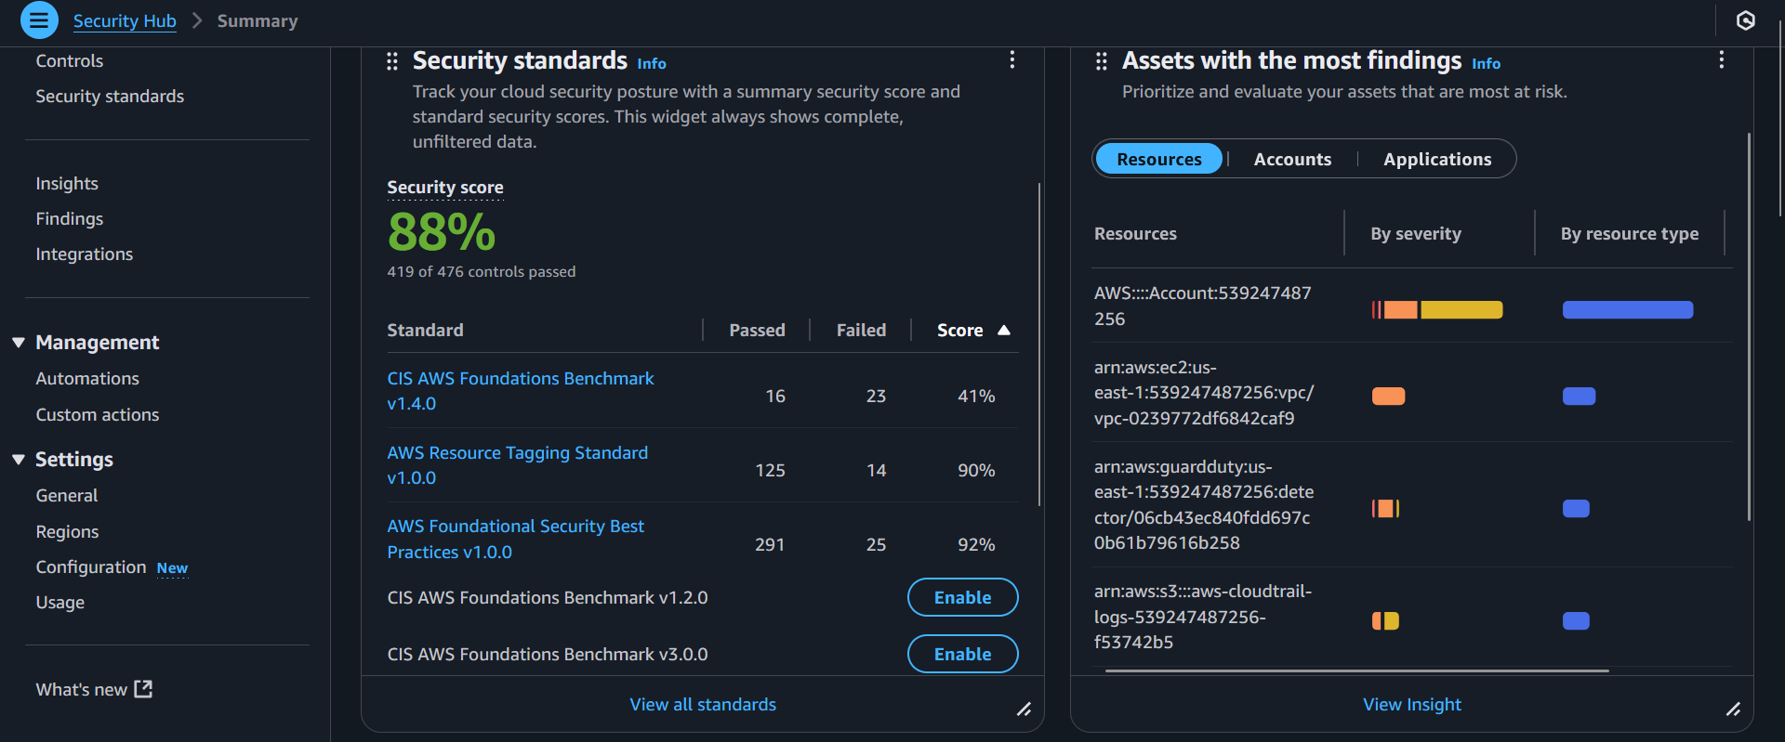

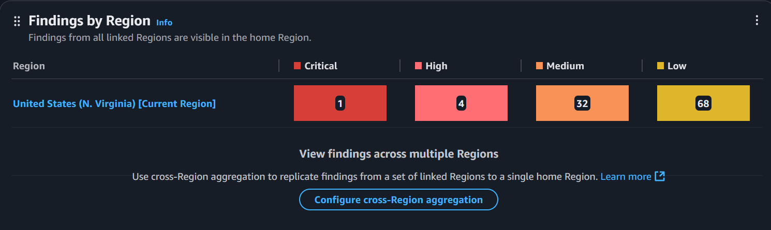

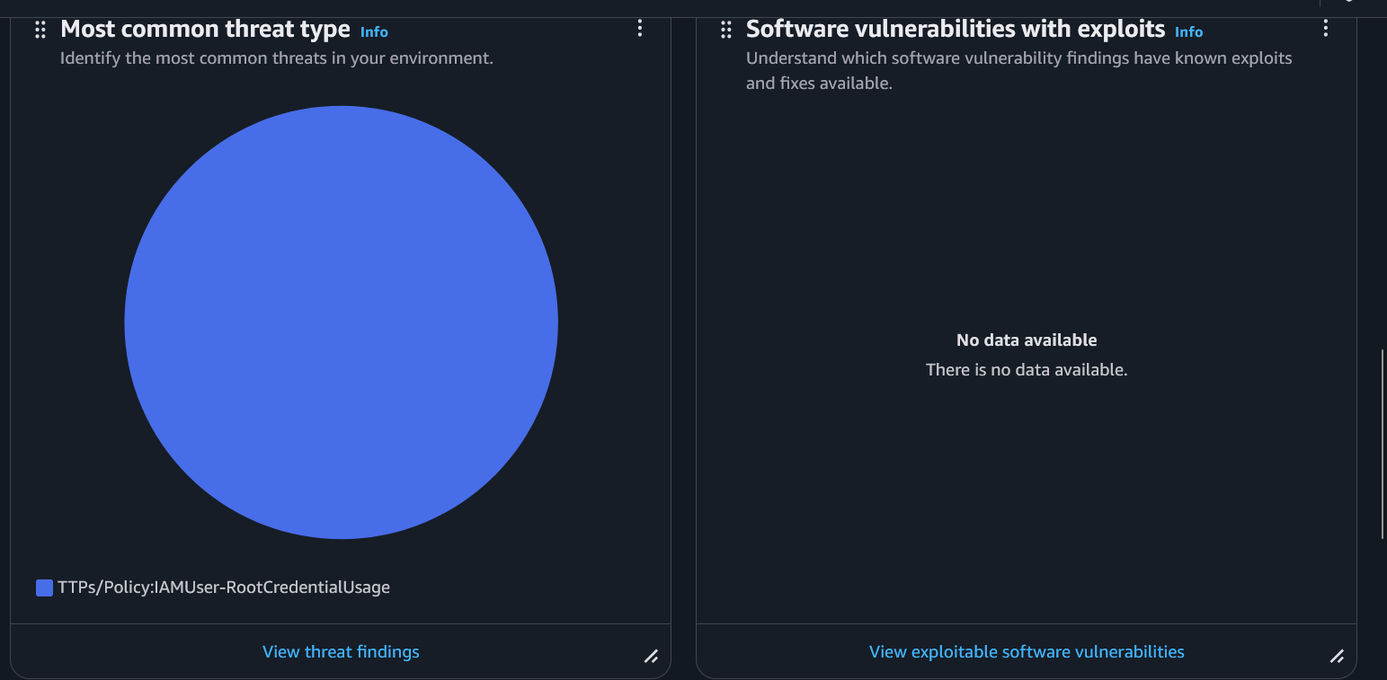

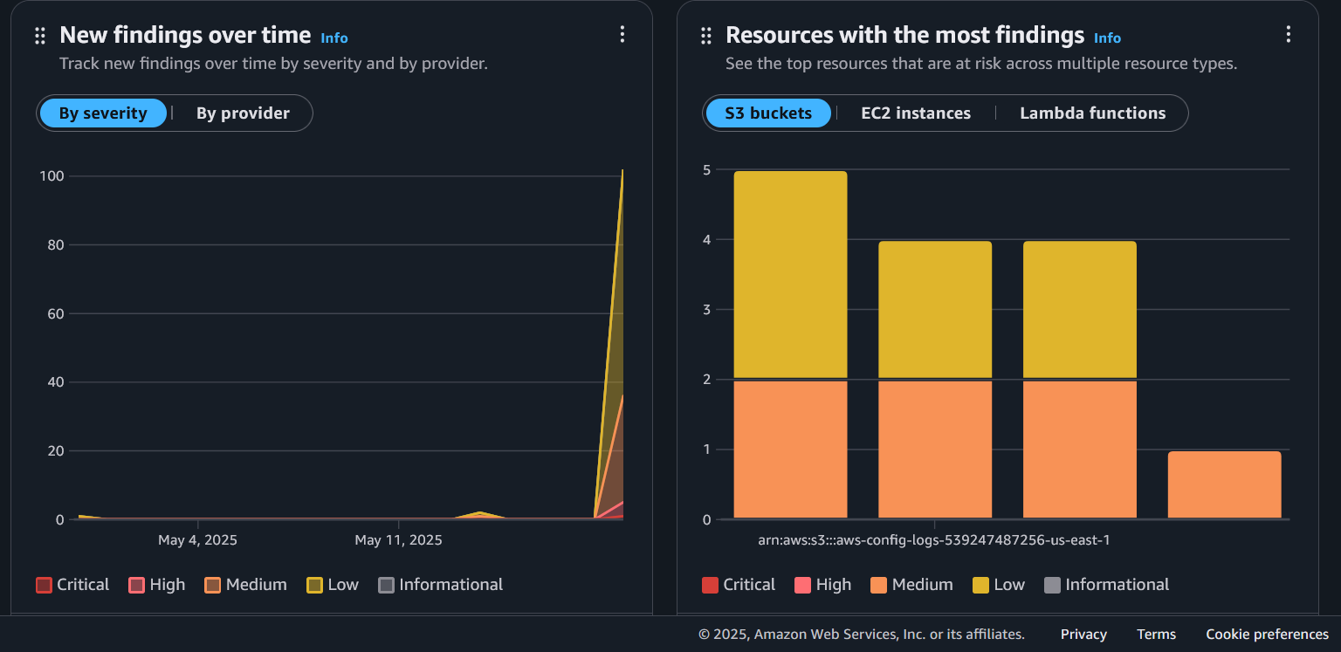

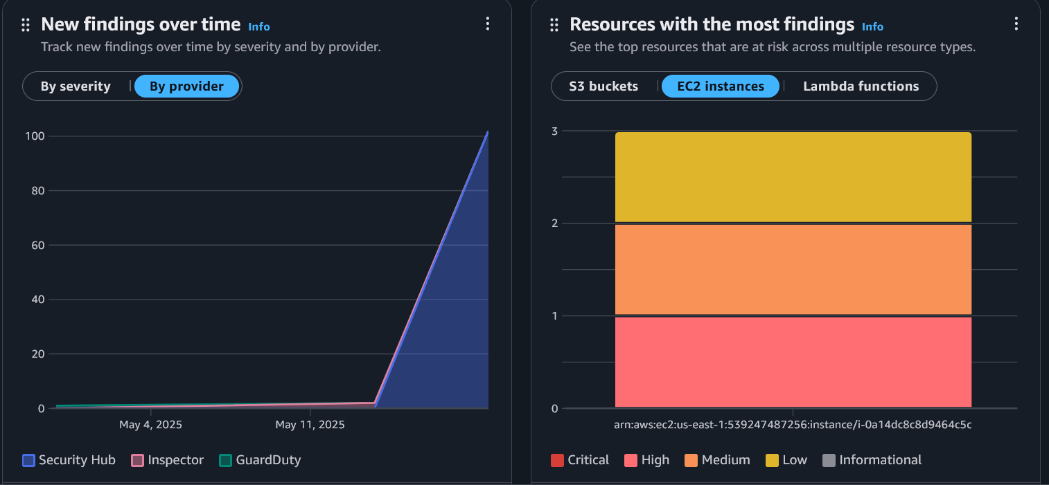

Now that we have generated a full report on what security hub has discovered we can dive deep specifically into the areas that need the most attention to be resolved. For simplicity purposes we will only be listing the descriptions and remedies for each of the control failures listed from the CIS benchmark due to how sophisticated it is to resolve them without causing any misconfiguration issues stem from the settings that were already configured based on what our needs were to complete the previous steps. Based on what we have uncovered, we have enabled AWS Config, Security Hub, as well as enabling the three standards. The AWS Foundational Security Best Practices (Passed: 291 and Failed: 25, 92% Score), AWS Resource Tagging Standard (Passed: 125 and Failed: 14, 90% Score) and CIS AWS Foundations Benchmark v1.4.0 (Passed: 16 and Failed 23, 41% Score). The overall security score is an 88% based on 419/476 controls that have successfully passed. Since our CIS AWS Foundations Benchmark has the lowest score we will focus on resolving that. If we select that benchmark, we can see the list of failed controls that was uncovered by the security hub. This list contains critical, high and medium level severity findings. The Control ID IAM.6 is a critical severity because it says, “Root user should have hardware MFA enabled”, the solution for this would be to attach a physical MFA device such as a physical key. The EC2.2 Default security group allows all traffic, this is labeled a high severity risk. To resolve this, remove the 0.0.0.0/0 rules from default security group and replace with a custom security group. For the Medium severity risks, there are five different findings. The EC2.7 means that EBS encryption is not enabled, resolve by enabling EBS default encryption under EC2 settings. The S3.1 Block public access not enabled, resolve by enabling block all public access in bucket permissions. The S3.5 SSL not required for S3 buckets (3/4 resources affected), resolve by adding S3 bucket policy enforce HTTPS-only access. The KMS.4 key rotation not enabled which affects ½ resources, remediate by enabling automatic key rotation for KMS keys. The IAM.15 password length is less than 14 characters, resolve by updating the IAM password policy to require at least or more 14 characters. The low severity findings are summarized in three areas: CloudWatch logging, S3 logging and IAM hygiene. CloudWatch logging can be strengthened by creating metric filters and alarms for sensitive changes and log analysis. Under S3 logging, we see that CloudTrail bucket lacks access logging, just enable logging towards a separate log bucket. To provide adequate IAM hygiene, we will need to update IAM policies to prevent password reuse.

**Automated Compliance and Remediation**

The purpose of this step is to set up automation to detect, alert and maybe auto remediate security misconfiguration based on findings from Security Hub and AWS Config. Even though we previously enabled both security hub and AWS config, we still need to deploy any managed config rules that align with CIS controls. We will be going through the manual process of deploying a full AWS Solution Deployment which should be the fastest and best option. The process includes creating IAM role for lambda or SSM, creating a remediation lambda function, setting up an EventBridge rule to be able to detect security hub findings, enabling security hub custom actions and testing the remediation. Keep in mind that the security hub, AWS config and CIS v1.4.0 from security hub must all be enabled. Additionally, ensuring that you are operating in the same region where the security hub is currently analyzing and reporting any new findings or sudden changes in the AWS environment within your AWS account. Begin by creating a remediation IAM role for Lambda by heading to IAM roles and creating role, select lambda as a trusted service, this allows lambda functions to call AWS services on your behalf and set the trusted entity type to AWS service which allows AWS services like EC2, lambda or others to perform actions in this account. Skip the add permission policies, then ensure the following Json policy matches the one automatically shown when you select lambda as a service for the IAM role:

{"Version": "2012-10-17", "Statement": [{ "Effect": "Allow", "Action": "*", "Resource": "*" } ] }

Next add the name to the role as LambdaSecurityRemediationRole and create the role. Once that is done, go to roles and click on the new role we just created. What needs to be done next is adding a permission policy that needs to be done through copying and pasting this JSON: {

"Version": "2012-10-17",

"Statement": [

{

"Effect": "Allow",

"Action": [

"ec2:DescribeSecurityGroups",

"ec2:RevokeSecurityGroupIngress",

"ec2:RevokeSecurityGroupEgress"

],

"Resource": "*"

},

{

"Effect": "Allow",

"Action": [

"logs:CreateLogGroup",

"logs:CreateLogStream",

"logs:PutLogEvents"

],

"Resource": "*"

}

]

}

Click on add permissions and create inline policy under permissions policies for that role. Copy pastes that Json and set the name of the policy as LambdaSecurityRemediationPolicy, press create policy. What we need to do next is creating a remediation lambda function, this is to ensure that lambda will auto remediate any security misconfigurations that it finds, such as security groups containing more permissions than it actually needs. Such as auto detecting security groups that have open port 0.0.0.0/0. Head to lambda, create function, select author from scratch, set the function name as SecurityGroupRemediationFunction, set the run time as either python 3.13 or Node.js as preferred, set the architecture to x86_64. Then under Execution role select use an existing role and select LambdaSecurityRemediationRole sine that one specifies EC2 and logging permissions which is what remediation logic needs. Additionally, skip code signing, KMS encryption, function URL, tags and VPC access since they are not needed for what we are doing. Press create function, then under the function of SecurityGroupRemediationFunction for code source, replace then copy and paste this python script: import boto3

def lambda_handler(event, context):

ec2 = boto3.client('ec2')

group_id = event['detail']['findings'][0]['Resources'][0]['Id'].split('/')[-1]

ec2.revoke_security_group_ingress(

GroupId=group_id,

IpPermissions=[

{

'IpProtocol': 'tcp',

'FromPort': 22,

'ToPort': 22,

'IpRanges': [{'CidrIp': '0.0.0.0/0'}]

}])

return {"message": "Remediation applied."}

then press Deploy to save changes to your python script under that function. Now that we have completed the steps needed to create a new IAM role and a function for it, this will allow us to be able to create a security hub that can detect an issue, trigger a custom action from security Hub User interface, the action may get logged through Event bridge and the lambda should run automatically to remediate the problem. The next part that we need to complete is creating security hub’s custom action, the purpose of this is to allow us to manually trigger remediation directly from security hub findings. Head over to security hub, Management and select custom actions and create custom action. The action name will be RemediateSG, description will be Automatically revoking 0.0.0.0/0 open SSH port from Security Group and the Custom Action ID will be remediateSG (Must match the EventBridge rule to avoid issues). Create Custom action, then the last piece should be to create the event bridge rule that connects the custom action to the lambda function. This rule monitors for any time you trigger the custom action RemediateSG in Security Hub and sends the event to the lambda remediation function. Begin by heading over to the Amazon event bridge, under rules press event bridge rule (rule matches incoming events and sends them to targets for processing). Set the name as TriggerSGRemediation, description should be Triggers Lambda for SG remediation, set the event bus to default then enable the rule on the selected event bus and rule type should be set as rule with an event pattern (This means that a rule that runs when an event matches the defined event pattern. EventBridge sends the event to the specified target. The event pattern that we will be entering is this:

{"source": ["aws.securityhub"], "detail-type": ["Security Hub Findings - Custom Action"],

"detail": {"actionName": ["remediateSG" ]}}.

Under build event pattern, set the event source as “other” to be able to perform a custom event. Next set the creation method under event pattern as custom pattern (JSON editor). Next enter the JSON as previously mentioned. Then continue, note: When using the EventBridge console, EventBridge will automatically configure the proper permissions for the selected targets. If you're using AWS CLI, SDK, or CloudFormation, you'll need to configure the proper permissions. The target configuration will be the following settings: set the target type AWS Service, set target as lambda function, the target location will be in this account, set function as SecurityGroupRemediationFunction, set permissions as use execution role (recommended), The execution role means that an EventBridge needs permission to send events to the target specified above. AWS will automatically generate a custom name for the execution role so leave it as is and AWS will automatically create and attach the lowest required number of permissions needed for the execution role so that way the eventbridge can call and run your lambda function on your behalf. The reason we need the execution role, in regard to setting up automated compliance and remediation, is because AWS services are secured by default and require explicit permissions. The event bridge is a service that listens for events then triggers targets such as lambda function. In order for it to call on the lambda function automatically, it must have permissions granted through an IAM role which is what the execution role is for. The execution role attached to the eventbridge rule allows eventbridge to invoke the lambda function securely without exposing the lambda to the public nor broad permissions. Press next then create the new event bridge rule. Now that the rule is created this means that in any time that the security hub triggers the custom action remediateSG, the eventbridge will catch the event then call and run the lambda remediation function. The lambda will receive the event payload and be able to perform the remediation such as revoking the SSH port rule. Now that this is done the other parts we would need to complete are CloudTrail.7 (enable access logging on the cloudtrail S3 bucket), EC2.2 (remove 0.0.0.0/0 Inbound on default Security group) and Cloudwatch.5 (Metric Filter + Alarm for cloudtrail Config change). The purpose of enabling access to logging on the CloudTrail S3 bucket is to allow the S3 bucket that is used by CloudTrail to be able to have server access logging enabled. In order to do this we would need to create a target logging bucket. Head over to S3 Console, create new bucket and name it AWS-CloudTrail-logs-<Account-ID>-<region>. Set Bucket type to general purpose, set object ownership to ACLs disabled, under settings block all public access, enable bucket versioning, choose encryption type as server side encryption with Amazon S3 managed keys SSE-S3, object lock disabled, save and create. After the bucket is created, what we need to do next is to configure cloudtrail to use the bucket for delivering its logs and enable access logging onto the bucket itself for monitoring. Head over to AWS cloudtrail console, create a new trail since the other one is already linked to a different S3 bucket. Under the settings for the new trail, set the name as CloudTrail-Main, disable all accounts in my organization since we are only working with a single AWS account. Under choose an existing S3 bucket selectawscloudtraillogs-accountID-region. Enable log file SSE-KMS encryption, select existing customer managed AWS KMS key, select the AWS KMS alias as Cloudtrail-KMS-keys, enable log file validation, enable SNS notification delivery, select existing SNS topic as aws-cloudtrail-logs-ID, enable cloudwatch logs, choose existing log group, set log group name as aws-cloudtrail-logs-for-trail-and-eventbridge, set IAM role as existing and choose the role name Cloud-trail-role-for-cloud-watch-logs-monitoring-trail. Press continue, under event type choose management events, API activity choose read and write, continue and create the trail. When trying to create the trail, If you are prompted with this message: InsufficientEncryptionPolicyException Insufficient permissions to access S3 bucket awscloudtraillogs539247487256useast1 or KMS key then edit and disable log file SSE-KMS encryption. Once that is done, verify the trail is created and logging properly by heading to cloud trail’s trail, the “CloudTrail-main” should be logging status. Under that same new S3 bucket we just created check for logs by heading to awscloudtraillogs/539247487256/useast1/AWSLogs/539247487256/CloudTrail/us-east-1/2025/06/16/ if you are seeing a ton of objects then we have completed CloudTrail.7 because we not only created an S3 bucket linked to it’s own cloud trail for logging but ensure that it is capable of being able to automatically track activities relating to (Who - IAM Users, Roles, Federated Identities), (What - API Calls ~ create, modify, delete, describe, list, etc) (What - exact timestamp of API calls), (When), (Where – Source IP, Region, AWS Account ID) and (How – AWS Service used, request parameters and response elements).

Now that we have finished CloudTrail.7 we will move on to EC2.2 (remove 0.0.0.0/0 inbound from default security group. To resolve this, we just need to ensure that the default security group in a VPC does not allow inbound traffic coming from 0.0.0.0/0 which means all IP source, it is considered insecure. Begin by heading to security group’s page and find the one with default, press on it then under inbound rules we can see that type all traffic, protocol all, port range all, source type custom, source: sg-029aca59e8e34cec0. This indicates that all traffic is only allowed from a specific security group as specified. This should be compliant with CIS EC2.2 because instead of allowing all traffic from the internet we are only allowing all traffic from a custom source type as the security group.

Next move on to CloudWatch.5 – log filter + alarm for CloudTrail config changes. The first thing we need to do is identify the cloudtrail log group. Head to cloudwatch’s log group, find the log group that has /aws/cloudtrail/… which in this case would be aws-cloudtrail-logs-539247487256-7b329c13. The next thing we need to do is create a metric filter. Head to cloudwatch, logs, log group and select the log group: aws-cloudtrail-logs, under action press create metric filter. Under create filter pattern we will enter “{ ($.eventName = "StopLogging") || ($.eventName = "DeleteTrail") || ($.eventName = "UpdateTrail") }” as the filter pattern and select use for that pattern. This should catch any attempt if someone tries to stop cloudtrail logging, delete the trail and update the trail (example: change bucket destination or KMS keys). Press next, set the filter name as CloudTrail-Config-Change-Filter, metric name to CloudTrailConfigChanges, set the metric namespace to CISBenchmark and enter 1 for metric value. Press next and create metric filter. Once that is done under the same log group: aws-cloudtrail-logs-539247487256-7b329c13 go to metric filter and select that same metric filter we just created and press create alarm. In the new alarm’s configuration page we will be implementing the following configurations: Threshold type is static, whenever metric is >= 1, consecutive periods (Datapoints to alarm) 1 out of 1 (default is fine), treat missing data as missing and press next. Under notifications, set alarm state trigger to in alarm, send a notification to the following SNS topic: select an existing SNS topic as Security-Alert-Topic. The endpoints will be the email tied to the main account. Press next and set alarm name to “CloudTrailChangeAlarm” then set the description to be this “trigger an alarm whenever any cloudtrail configuration changes are detected. Monitoring any changes to trails, including creating, deleting and updating the trail’s configuration to help ensure that audit logging remains intact and compliant with CIS Benchmark CloudWatch.5”. Press next and create alarm CloudTrailChangeAlarm.

**Final Testing and Validations**

Before we begin this step let’s recap everything we have done so far: for step 1 IAM configuration, we completed the process of creating IAM roles, trust policies and a policy for lambda remediation. Step 2 Data Protection in S3, we applied encryption block public access and configuring logging. Step 3 AWS CloudTrail for API Activity Logging, we enable CloudTrail and logging to an S3 bucket. Step 4 AWS Config for Compliance enforcement, we enabled AWS Config and recording resources. Step 5 GuardDuty for Threat Detection, we enabled it and it is actively monitoring the entire AWS environment of our main account. Step 6 Amazon Inspector, the inspector is enabled and runs EC2 scans while analyzing all findings as well. Step 7 SNS for alerting, we enabled SNS topics and email subscriptions which runs directly with the CloudWatch alarms. Step 8 AWS Key Management System, we configured customer managed KMS keys and enabled encryption. Step 9 CloudWatch for Security Monitoring, we created metric filter and alarms for unauthorized activities, root usage, etc. Step 10 security Hub is enabled and will report any findings across all of the selected standards based off of our AWS account. Step 11 Automated Compliance and remediation, we completed the process of resolving what needs to be done with Cloudtrail.7 CloudTrail Bucket logging, EC2.2 Default Security Group Inbound Traffic Restriction and CloudWatch.5 Metric filter and alarm for CloudTrail Configuration changes. Based on everything we did so far we should have created IAM roles, S3 Data Protection, CloudTrail, AWS Config, Guardduty, EC2 Inspector, SNS for alerts, KMS for encryption, CloudWatch alarm and monitoring, Security Hub and automated compliance configured through lambda + EventBridge. We just need to do one test for each service that we would like to verify that it is doing exactly as they are intended to be. The first one will be the IAM Configuration. We will begin by heading over to the IAM’s account settings and verify what the password policy is being configured as. Head to edit and select Custom for password policy. Set the password minimum length of 14 characters, set the password strength to Require at least one uppercase letter from the Latin alphabet (A-Z), Require at least one lowercase letter from the Latin alphabet (a-z), Require at least one number, Require at least one non-alphanumeric character ( ! @ # $ % ^ & * ( ) _ + - = [ ] {} | ' ), Turn on password expiration as expire password in 365 days, Allow users to change their own password and prevent password reuse from the past 2 changes, then press save changes. Next head to Users under IAM and create a user. Keep in mind we will need to ensure that MFA is enabled for them. Upon creating a user, set permissions options to add user to group in which we will create a group to be able to select policies to attach to the group. Press create group, set user group name to SecurityAuditorGroup, then attach the following policies SecurityAudit (read-only access to most AWS services for auditing) and AmazonS3ReadOnlyAccess (enable S3 access). Press create user group. Then under creating that new user, select the same user group we just created and continue. Add the following for a new tag for that user: Key – Purpose and Value – IAM-Validation. Press create user and go to the configuration page of that same user we just created. Under security credentials tab, press enable console access and press autogenerate password and press user must create new password at next sign in and press update. In a separate browser enter https://<account-id-or-alias>.signin.aws.amazon.com/console and the login password. In this case we would enter our main account ID then the IAM username testone then the temporary password which will prompt the user to create a new password. Sign out after that then in the root account page we will enable MFA. Enter authenticator-app for device name and the MFA device option will be the authenticator app which uses a code generated by an app installed on your mobile device or computer. The other options that we will not be selecting is passkey or security key which authenticates using your fingerprint, face or screen lock. This creates a passkey on either this device or another one like a FIDO2 security key. HardwareTOTP token authenticate using a code generated by a hardware TOTP token or other hardware devices. We will use a google authenticator app, just open the app on a mobile device and press show QR code on this page to scan it which you will be able to enter two consecutive MFA codes as shown in the app. It should be a total of 12 digits. A second set of 6 digits is entered after entering the first 6 digits as instructed. Press enable MFA and the following message is prompted MFA device assigned - You can register up to 8 MFA devices of any combination of the currently supported MFA types with your AWS account root and IAM user. With multiple MFA devices, you only need one MFA device to sign in to the AWS console or create a session through the AWS CLI with that user. The objective for the IAM configuration is done since we just created a test IAM user, assigned the IAM policies SecurityAudit and AmazonS3ReadOnlyAccess. Enable MFA for that user, the login credentials and new password creation works. User can login through the IAM sign-in URL and has limited access permissions. It can only view S3 buckets not create nor delete, if you try to create a bucket it will say failed to create bucket to create one the S3CreateBucket permission is required. Log out of that user and move on to the second part of the test validations.

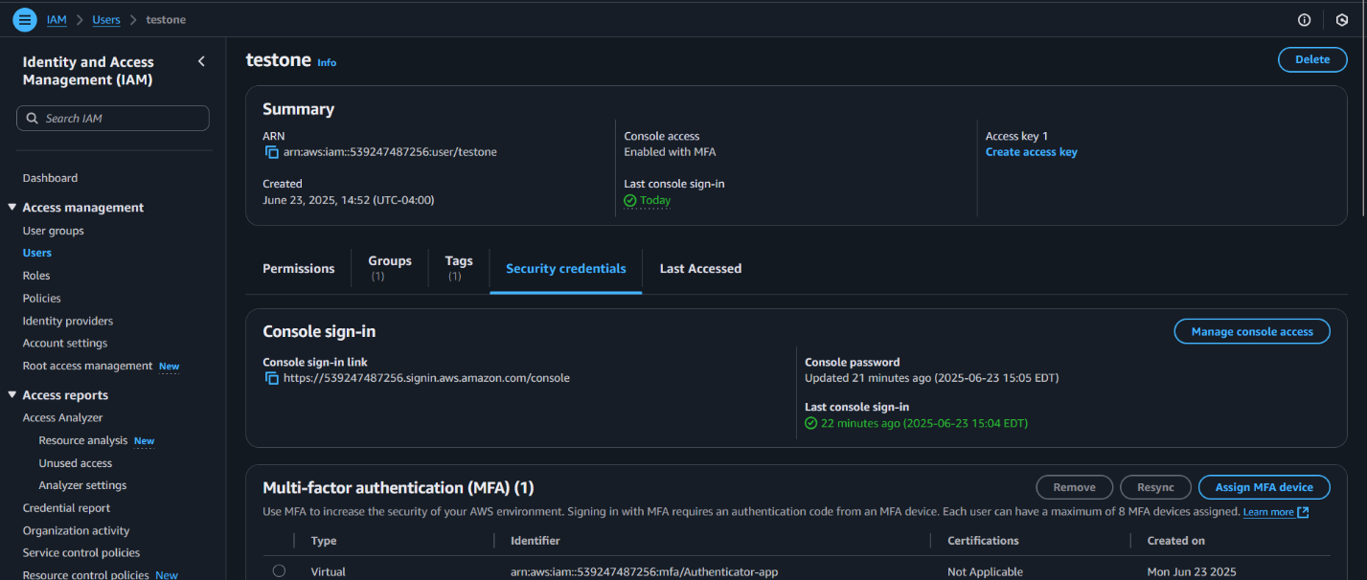

Keep in mind we will be skipping AWS Config for compliance enforcement, AWS Guard Duty, AWS Inspector and Security hub since we already conducted testing when we ran those services to demonstrate what the findings are in terms of compliance and noncompliance within the AWS Account. SNS will be skipped since we already confirmed that alarm emails are being sent.

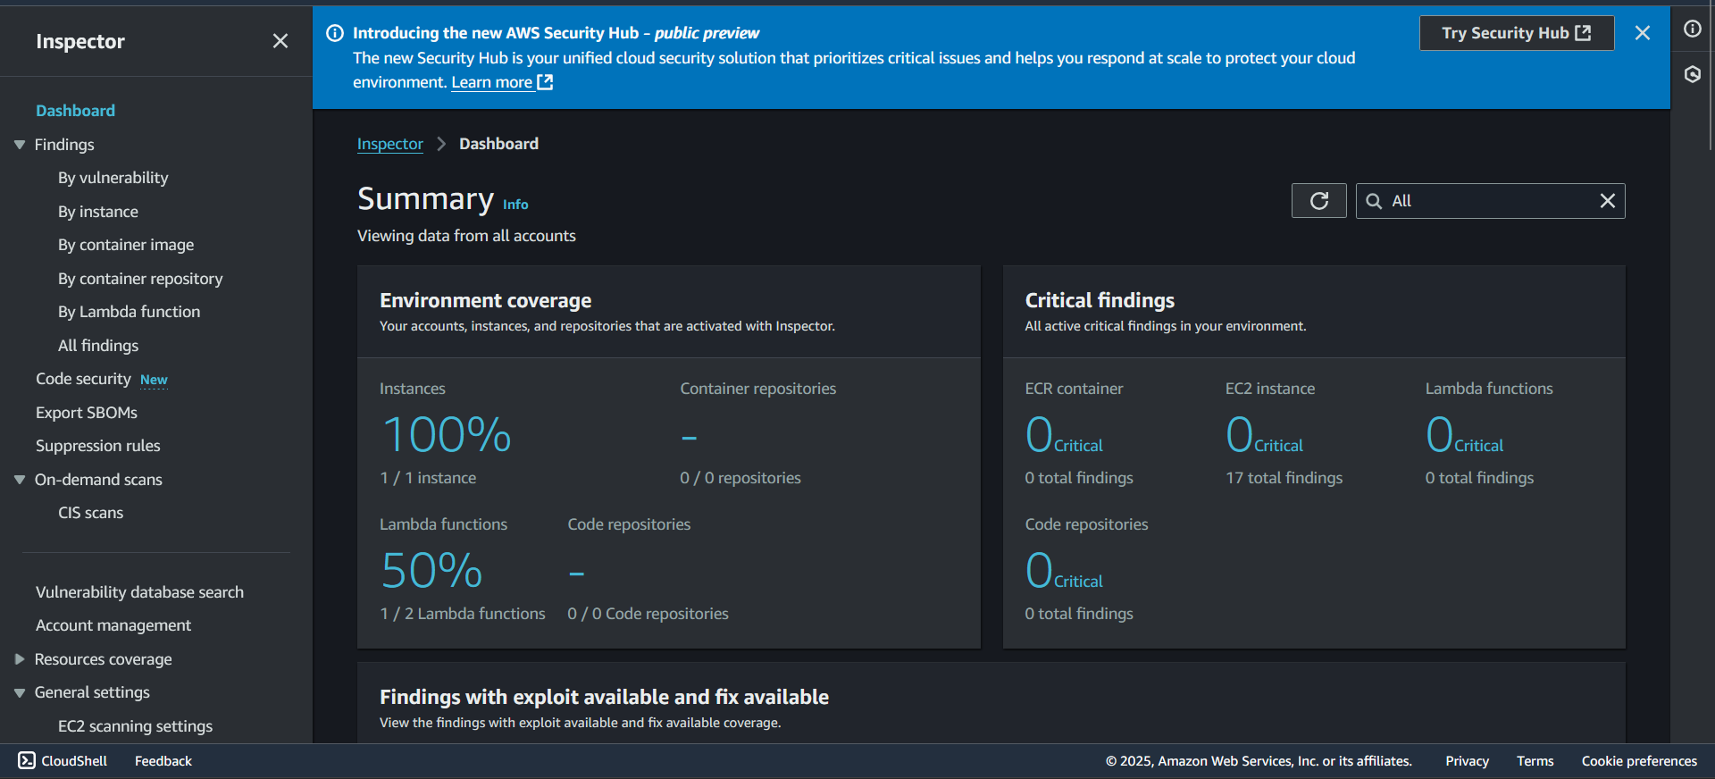

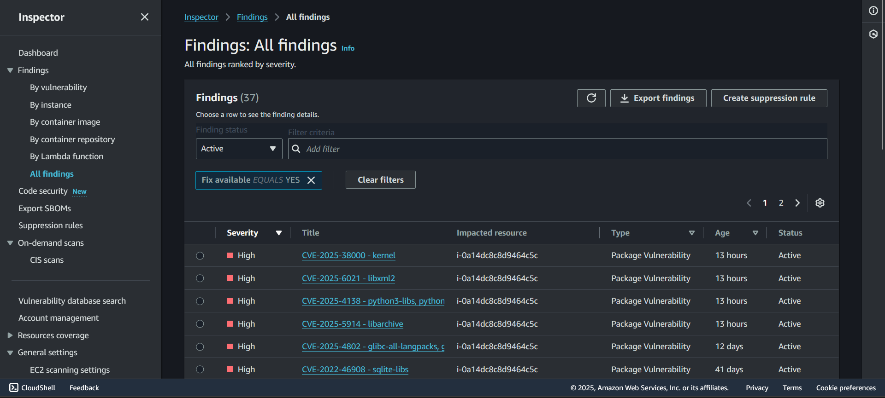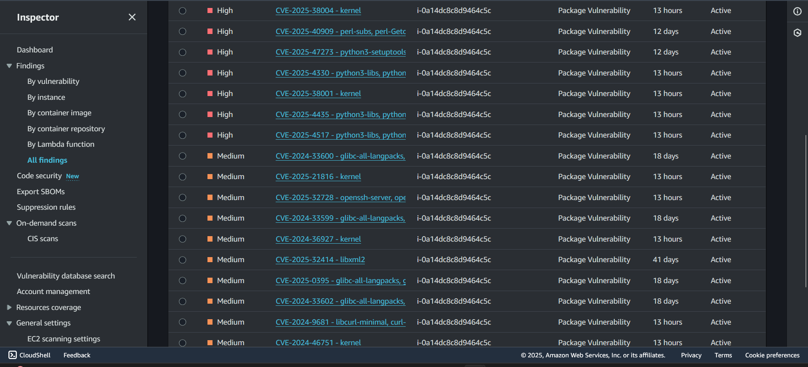

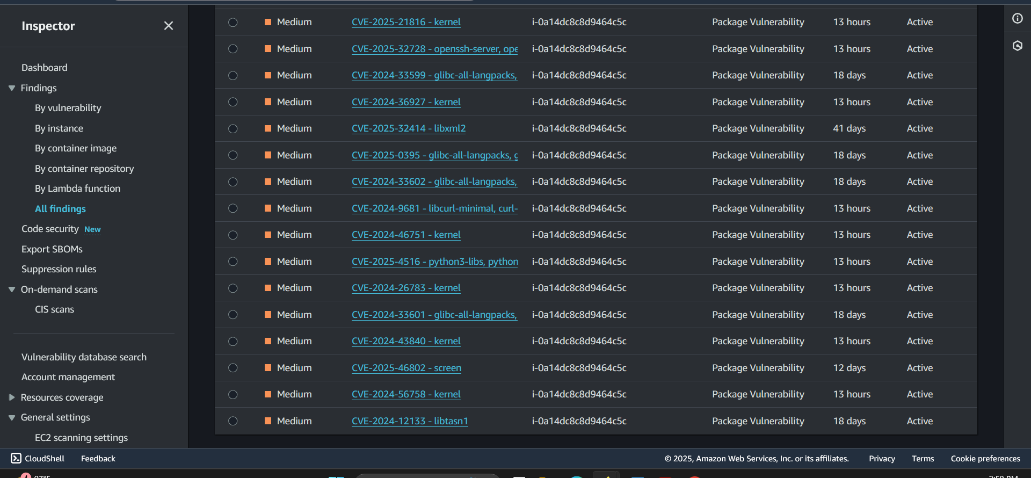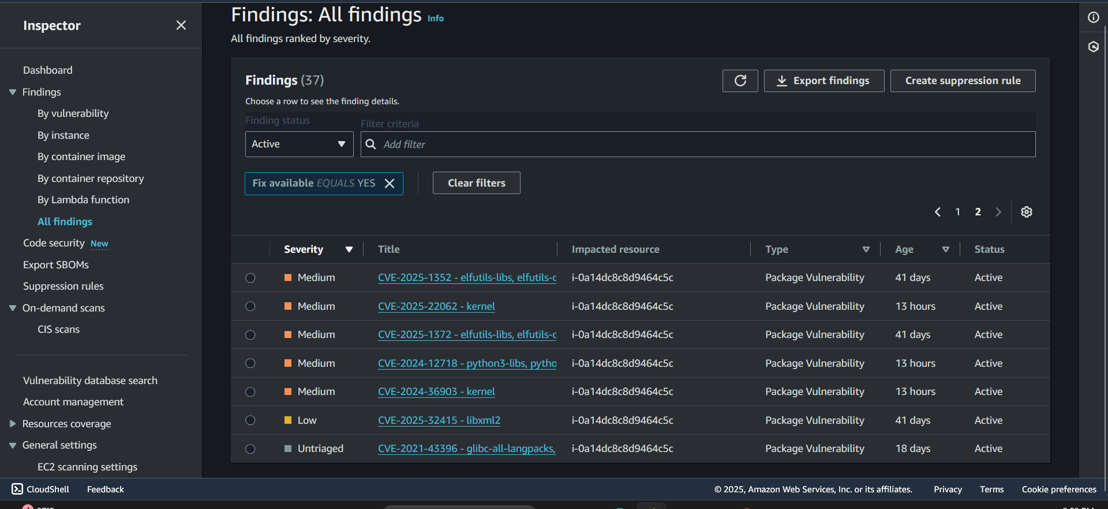

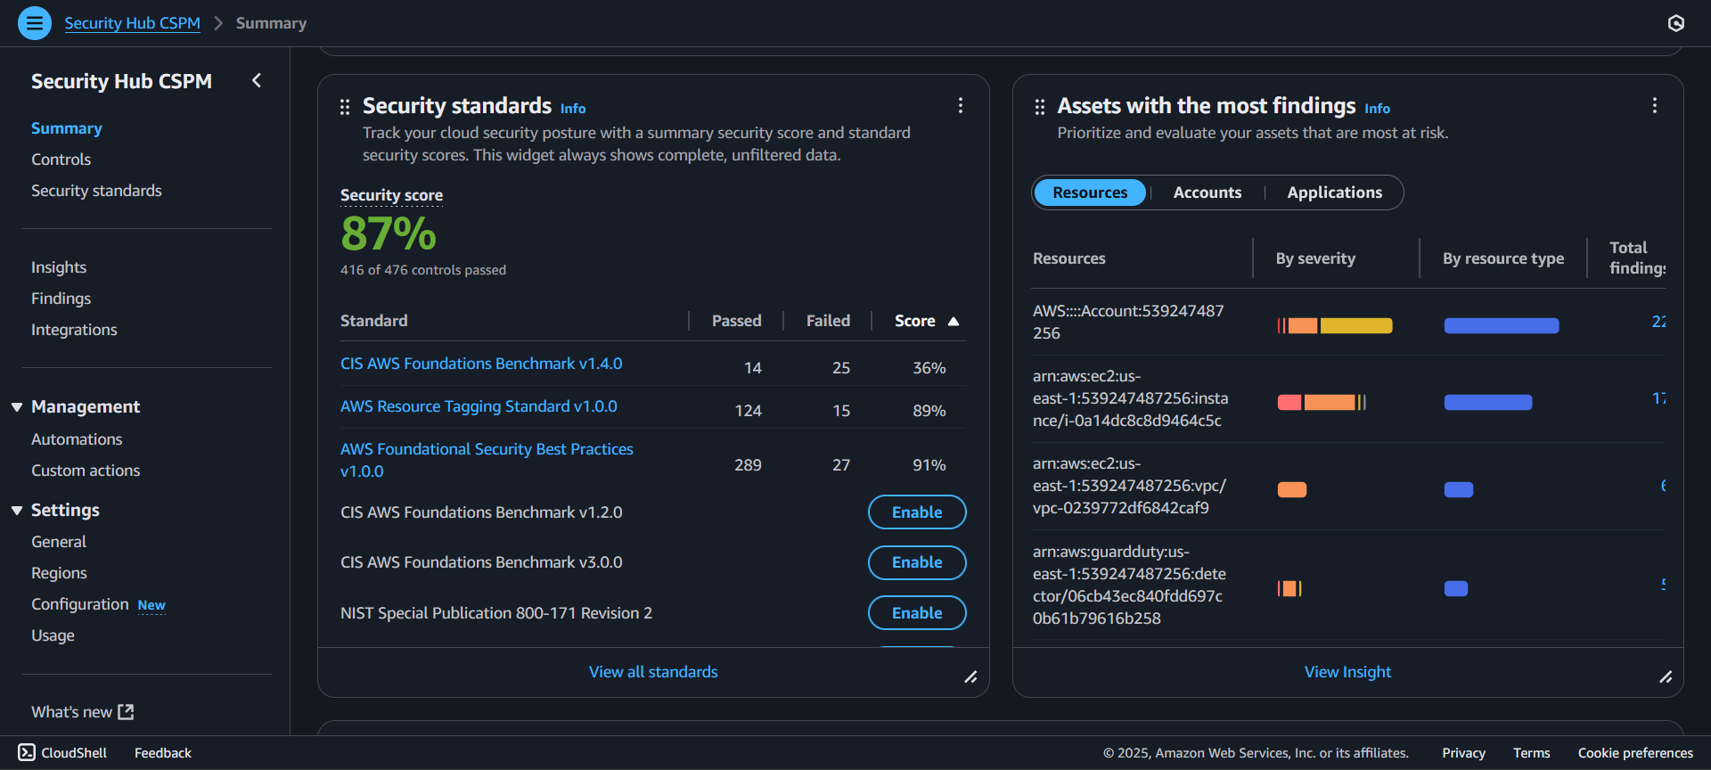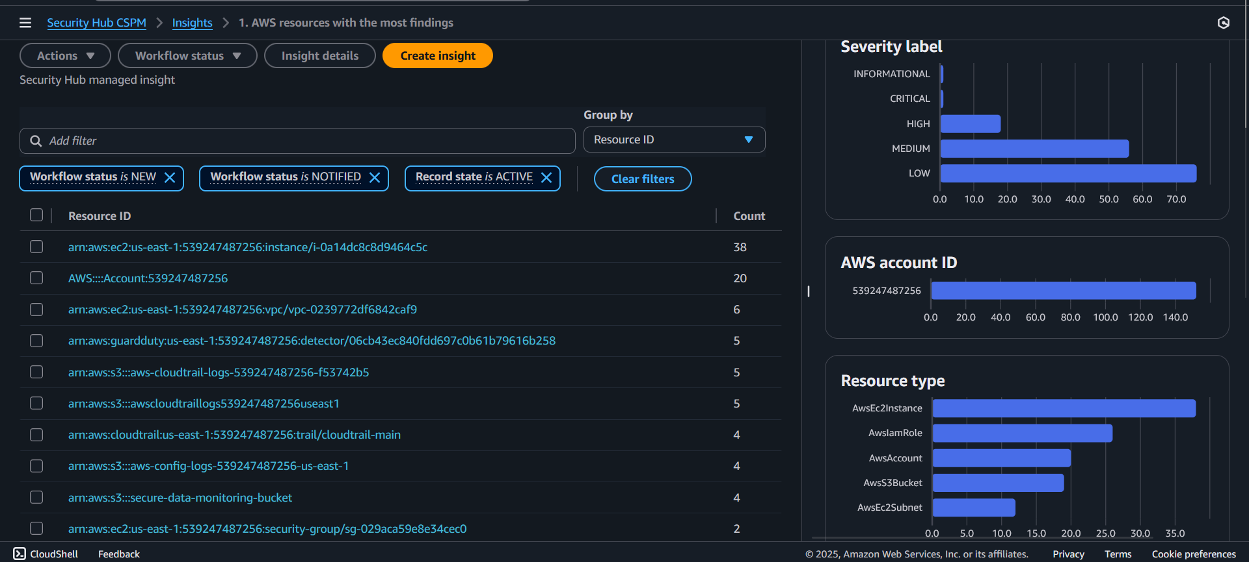

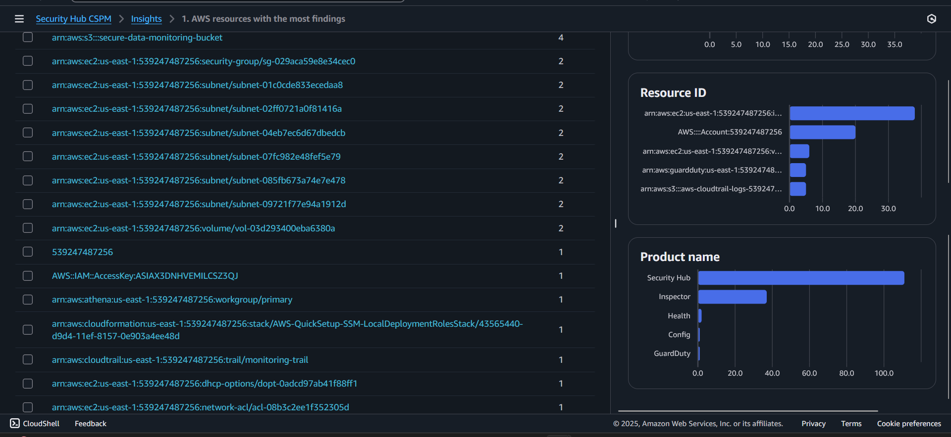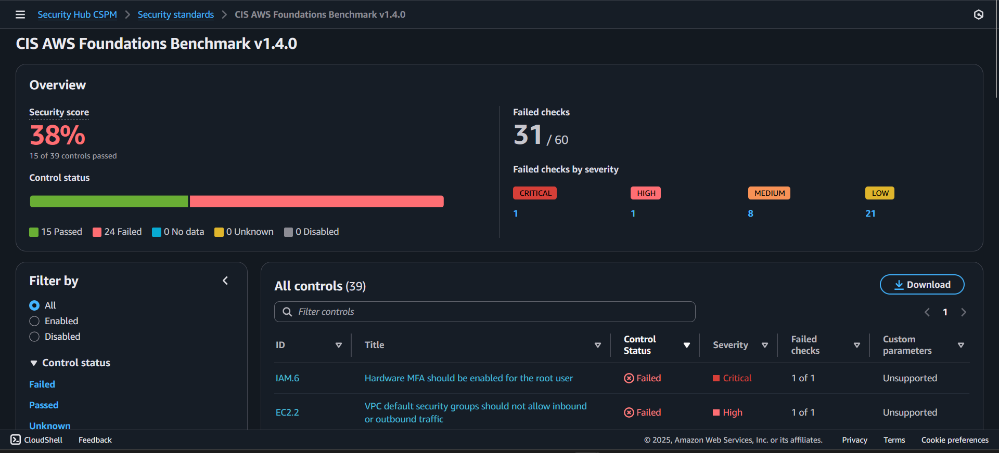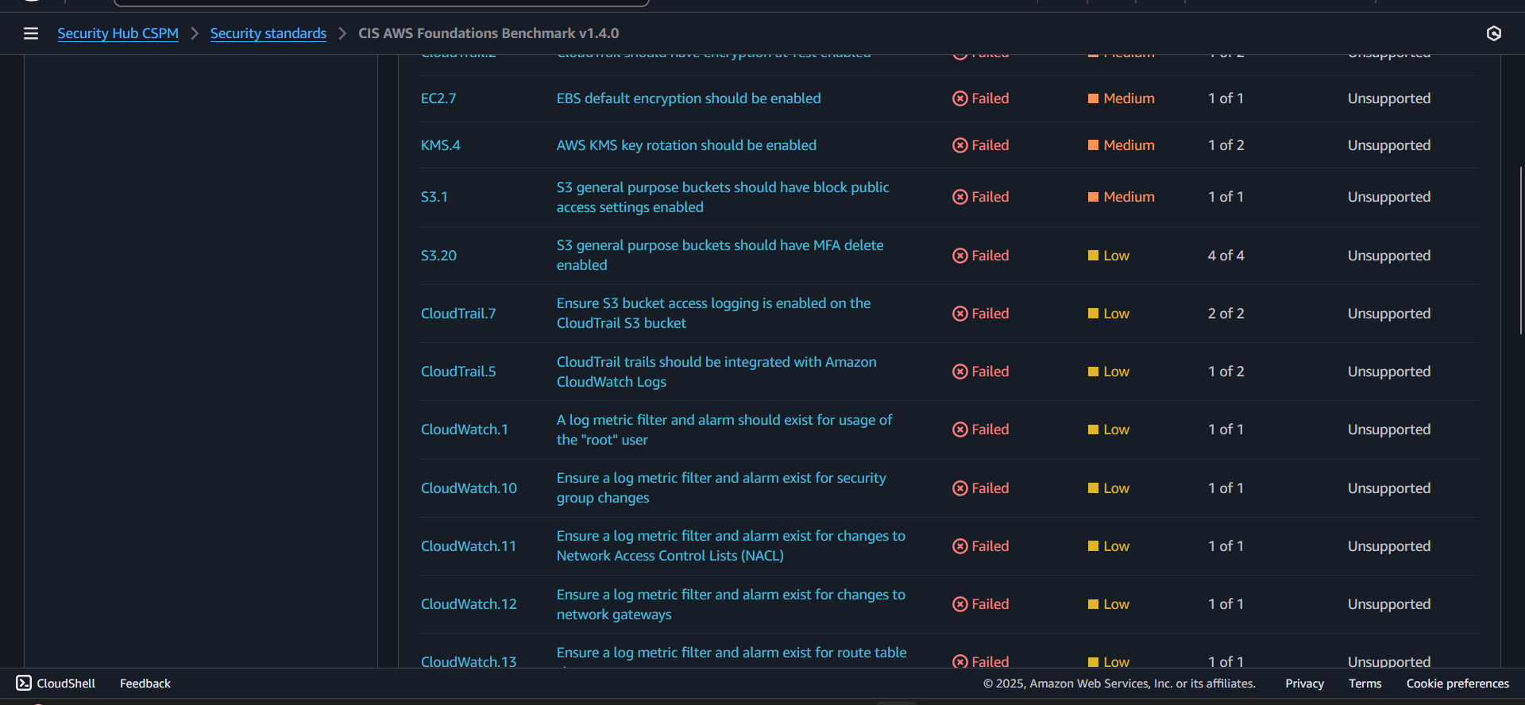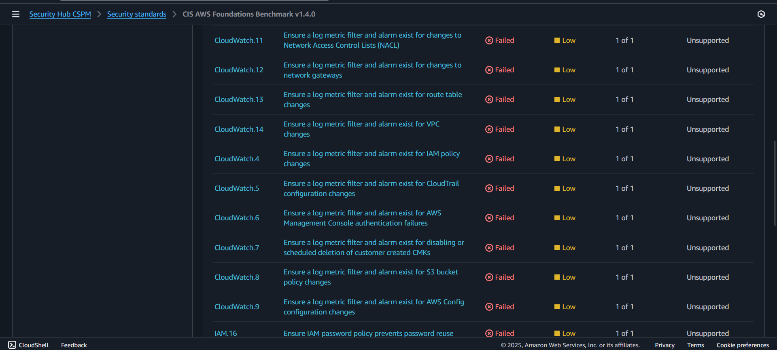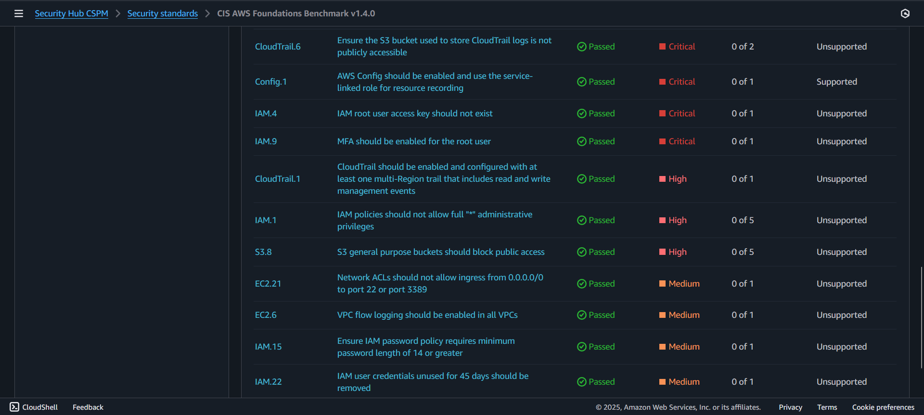

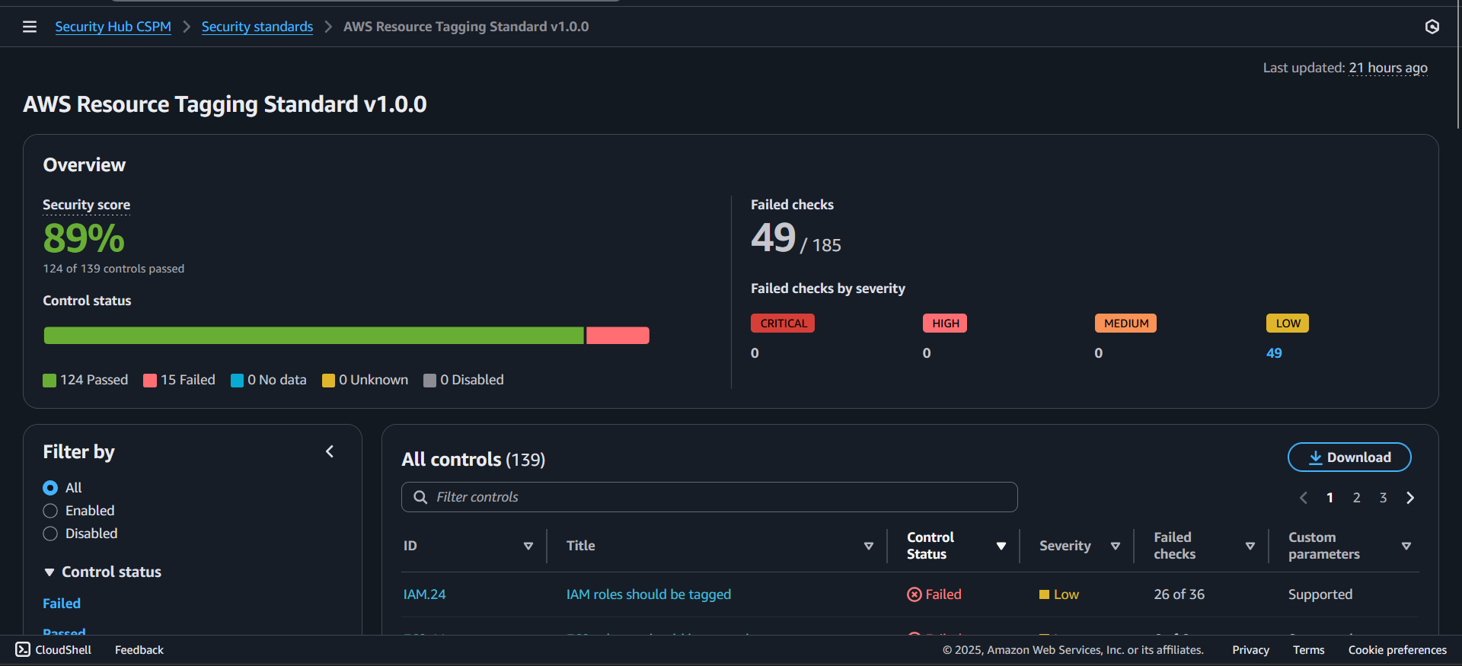

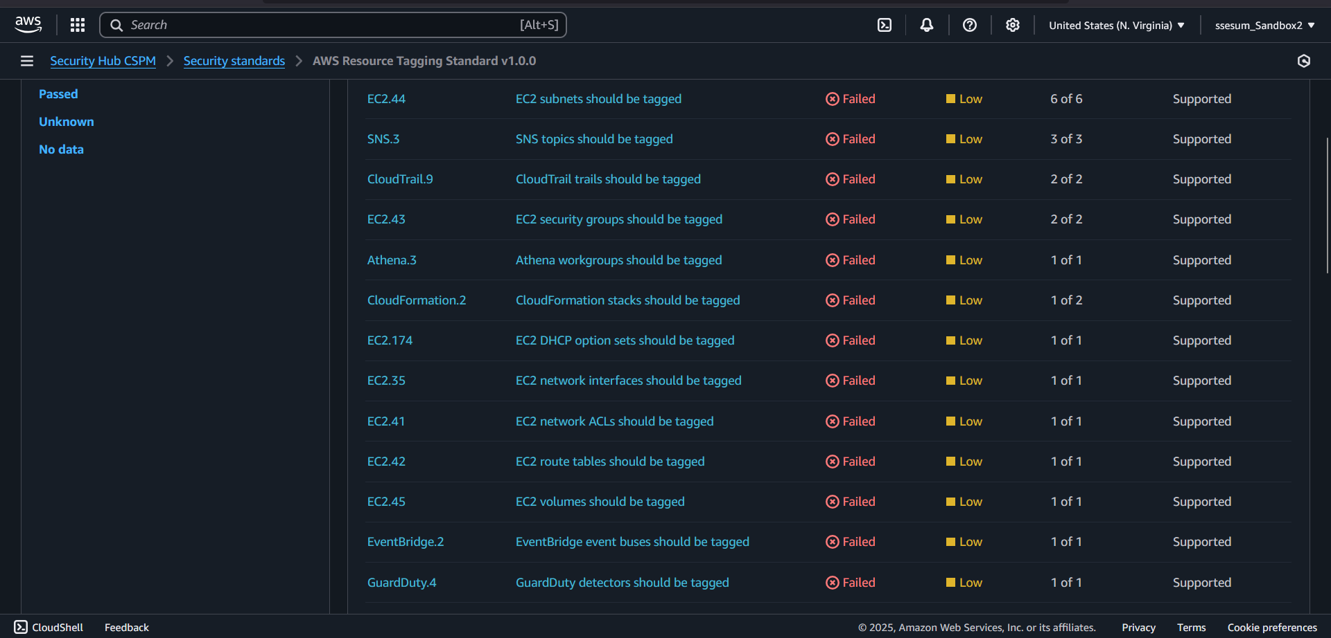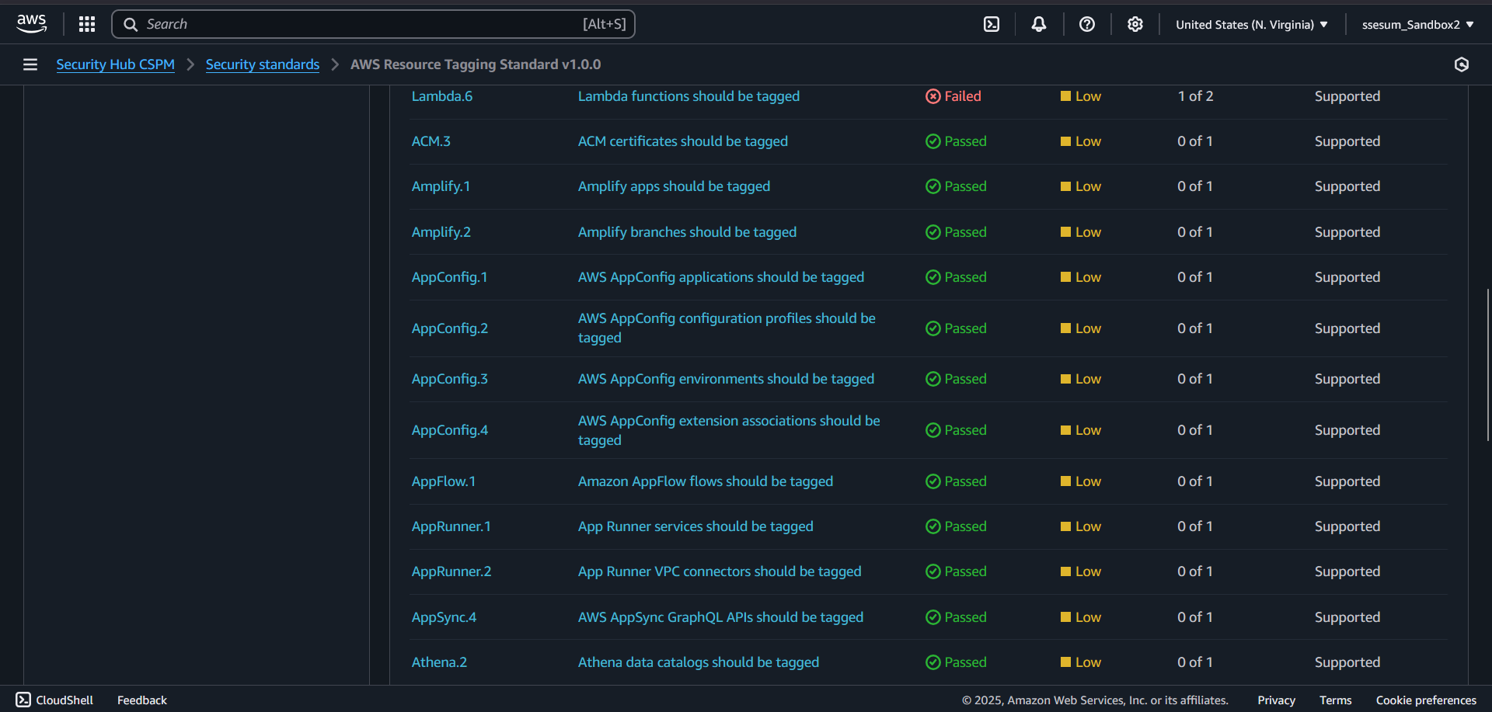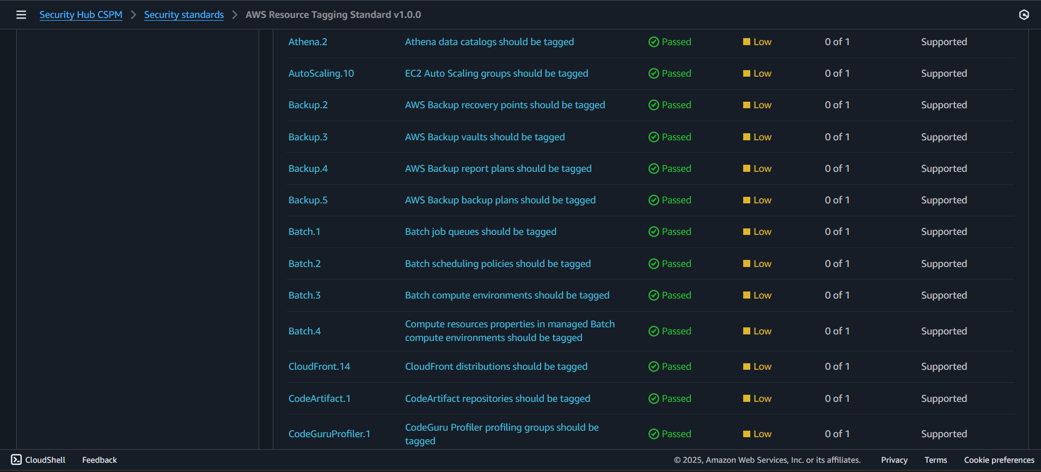

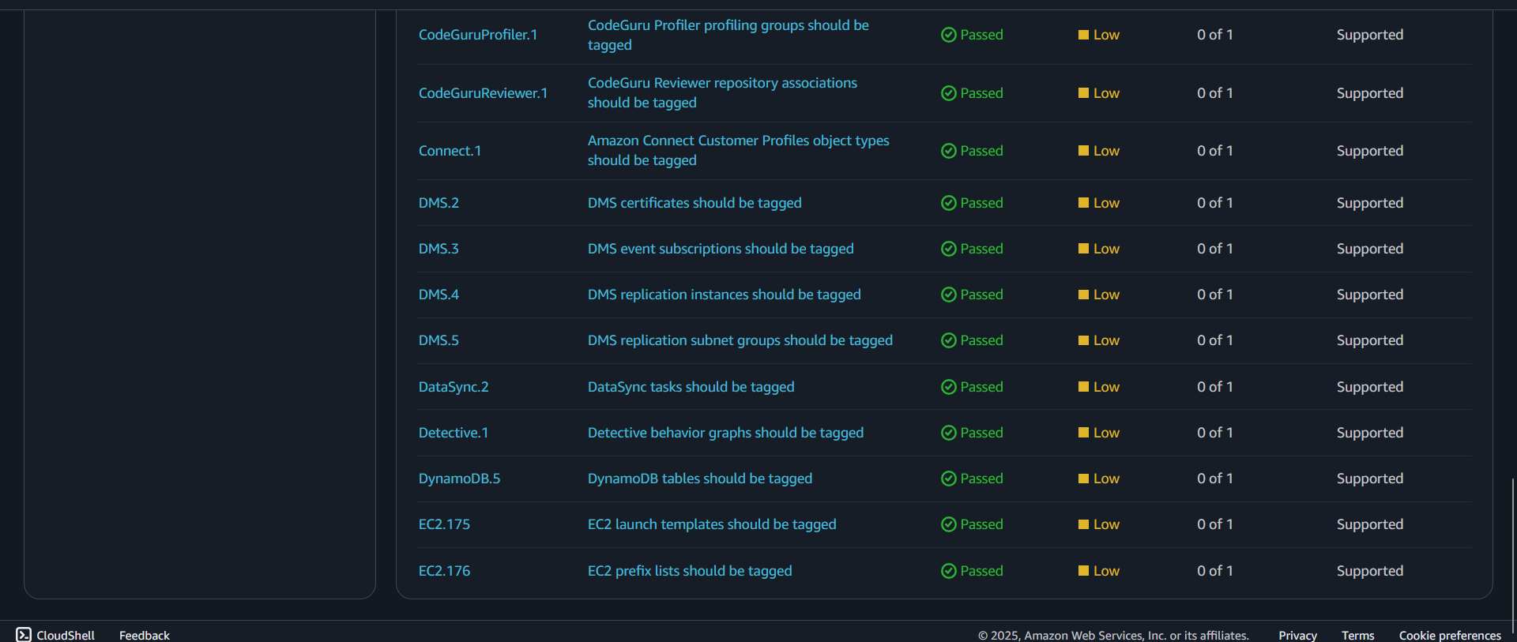

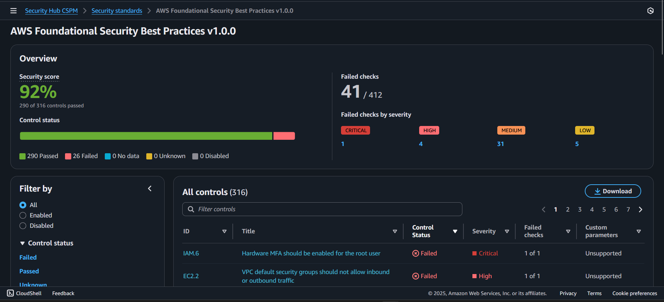

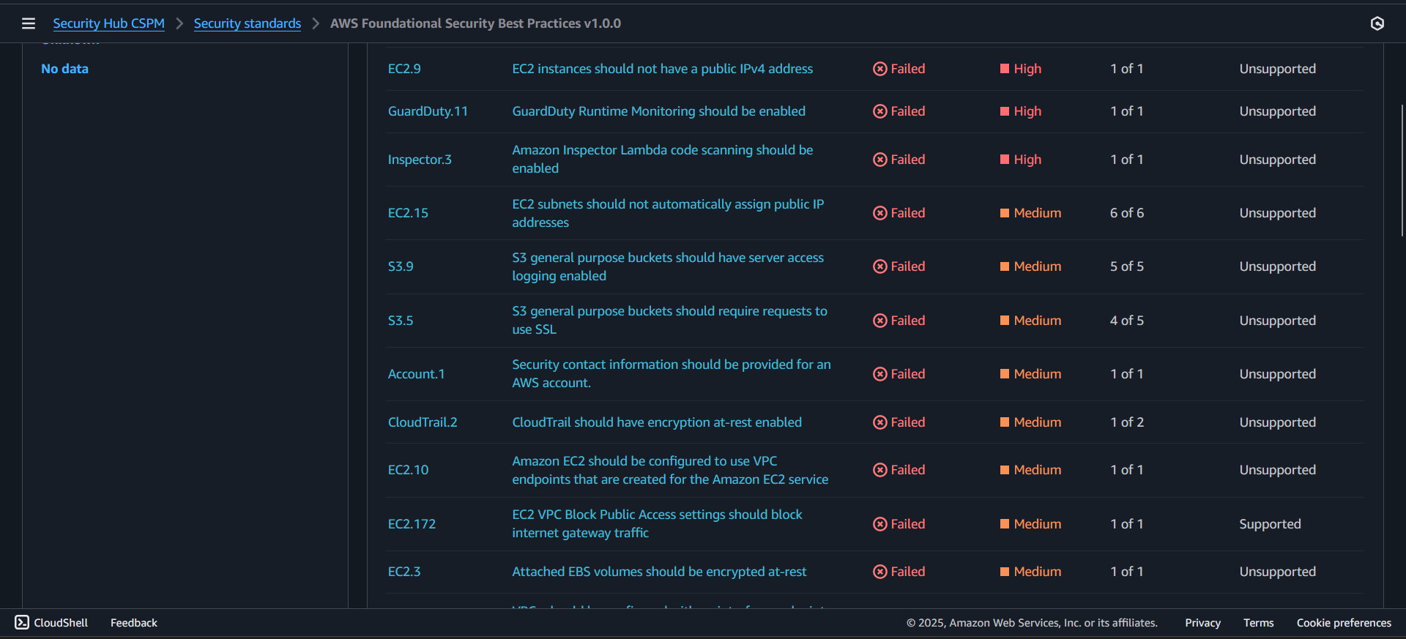

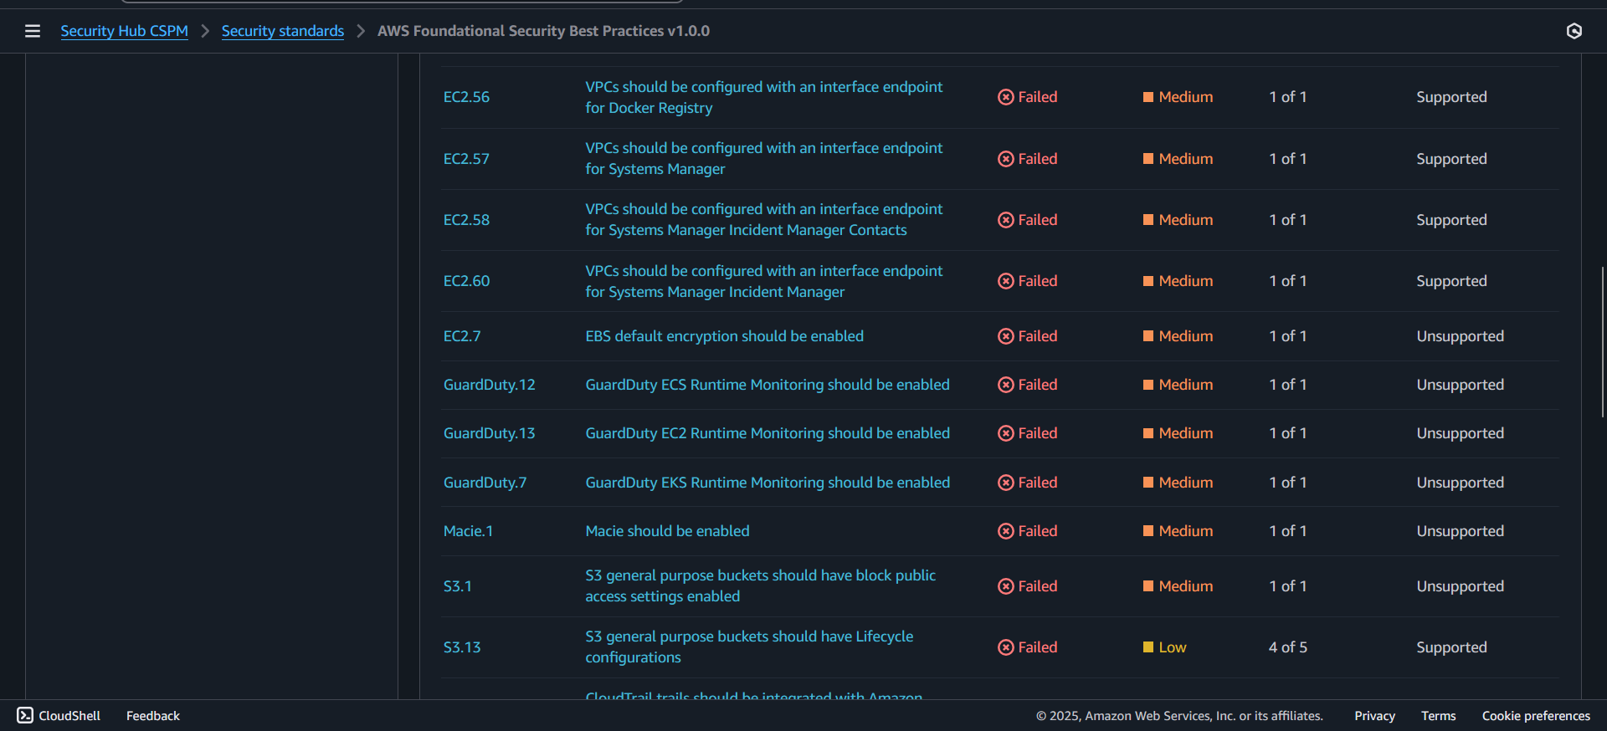

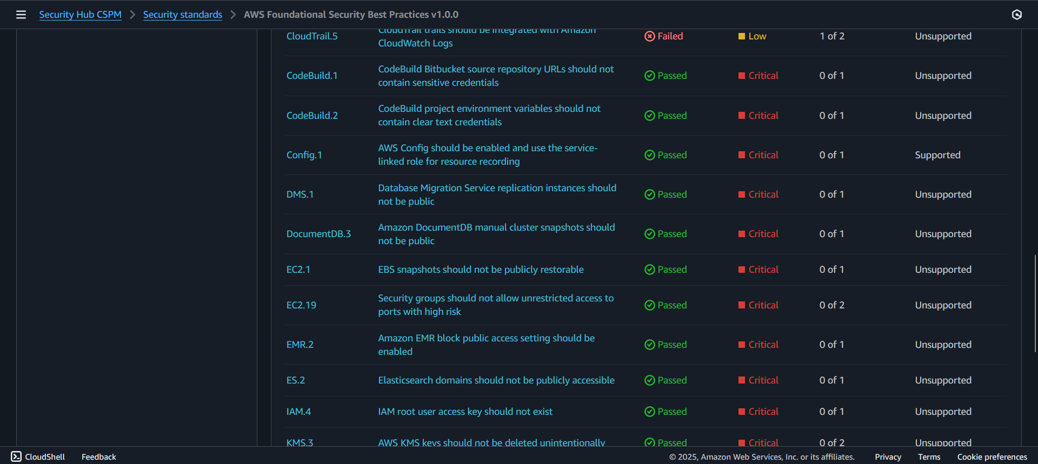

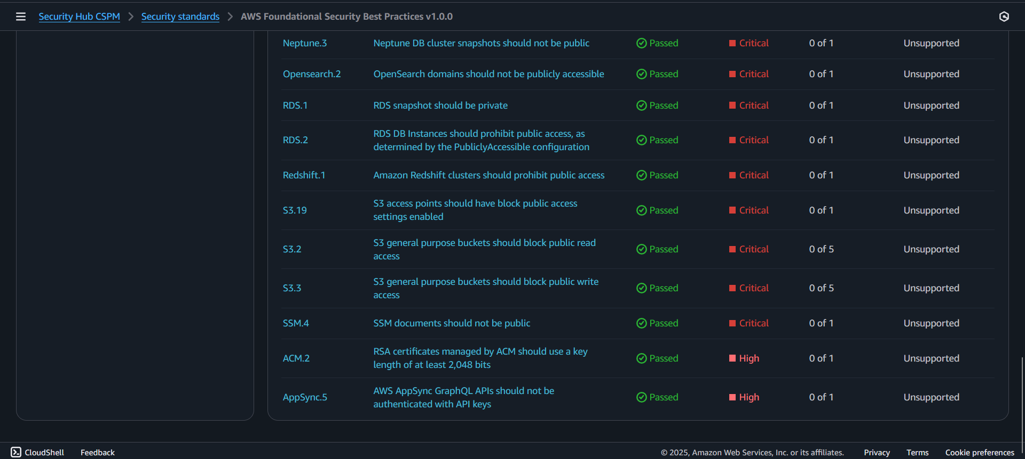

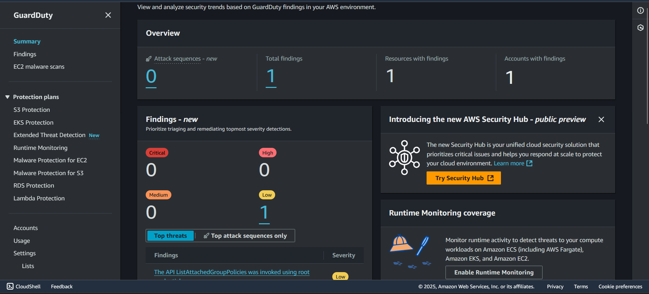

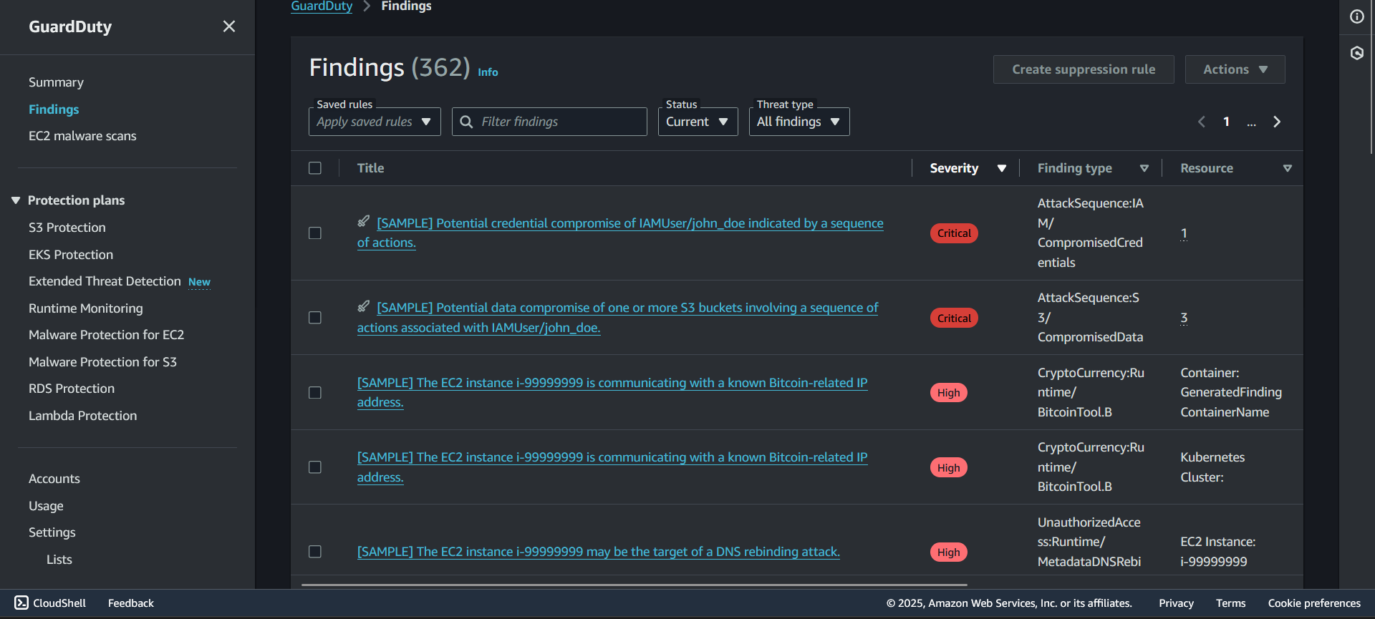

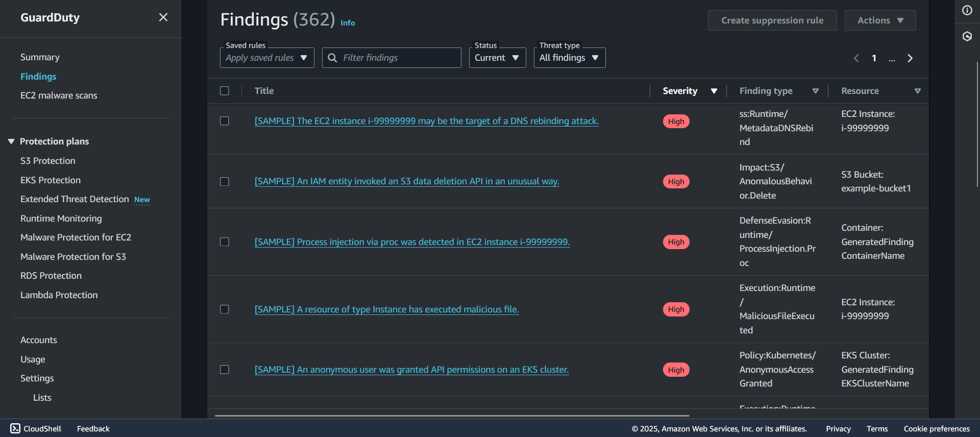

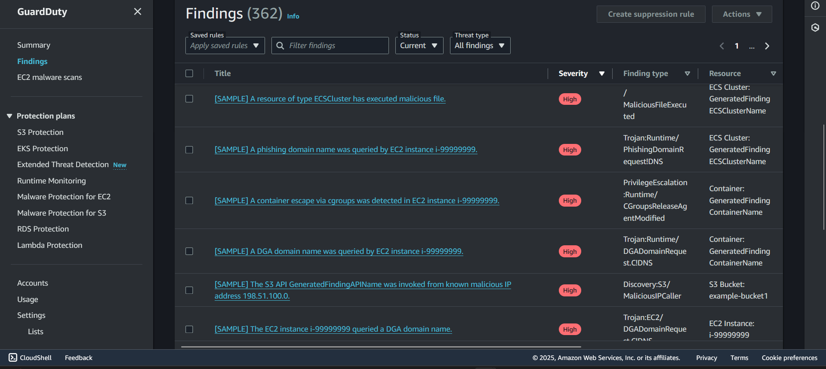

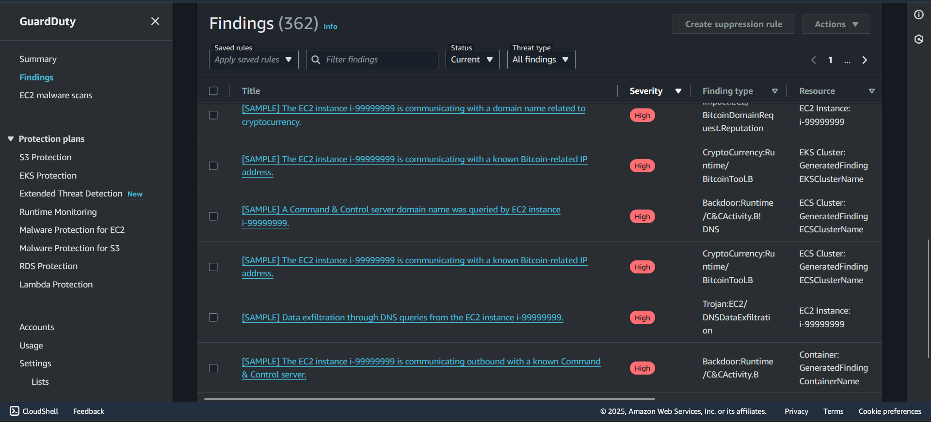

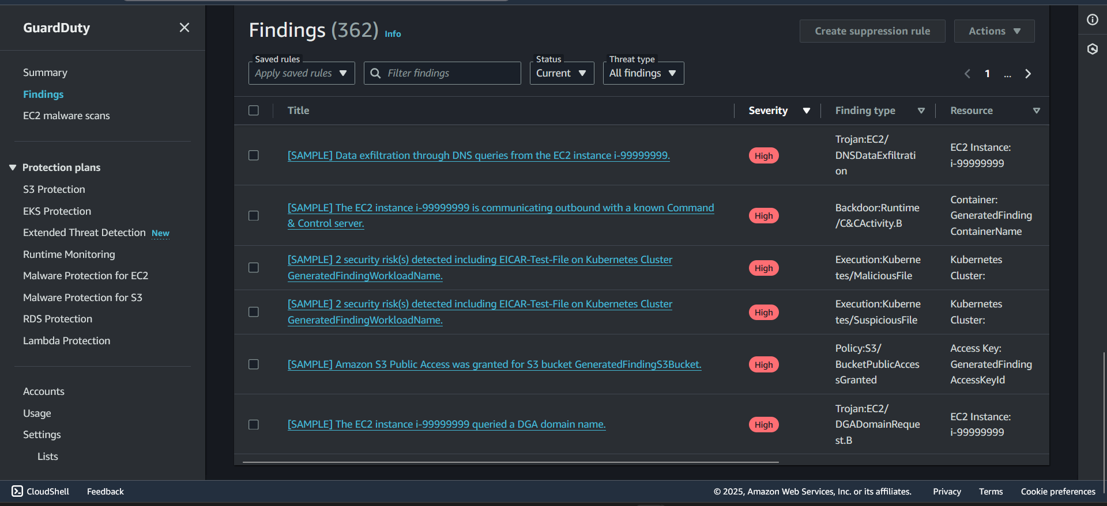

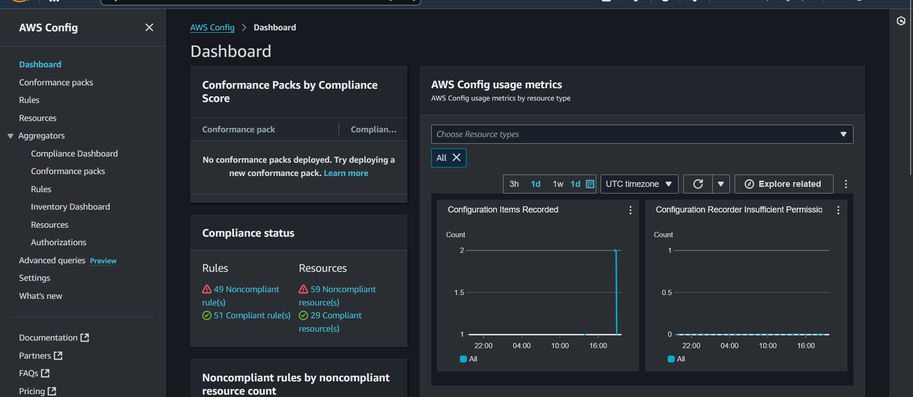

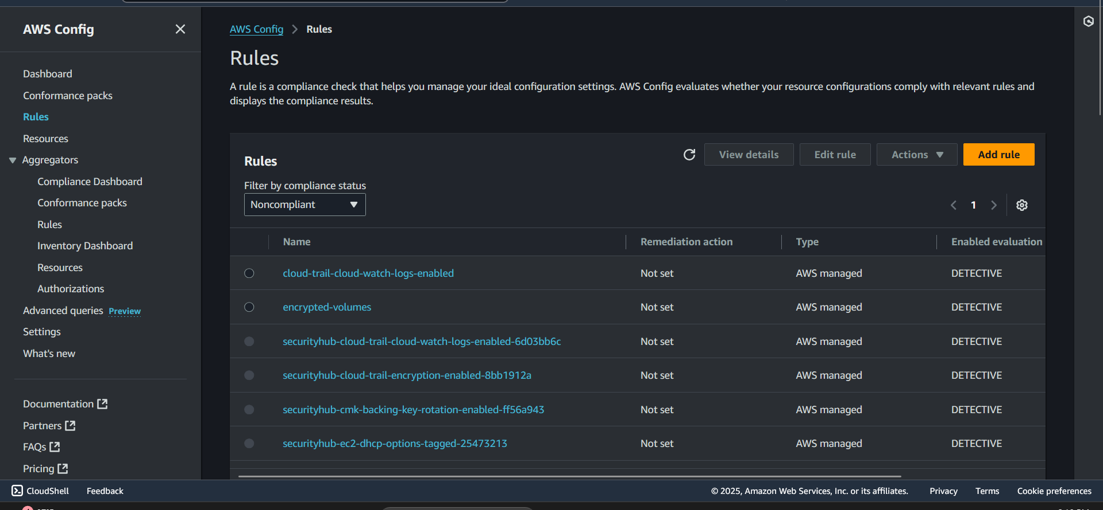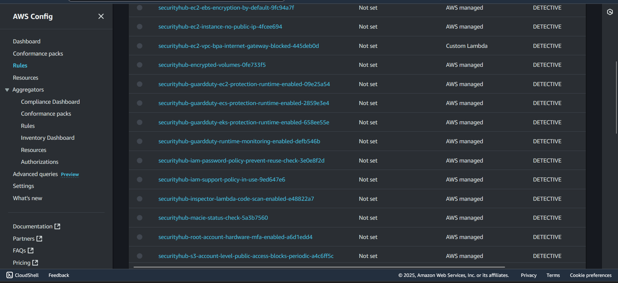

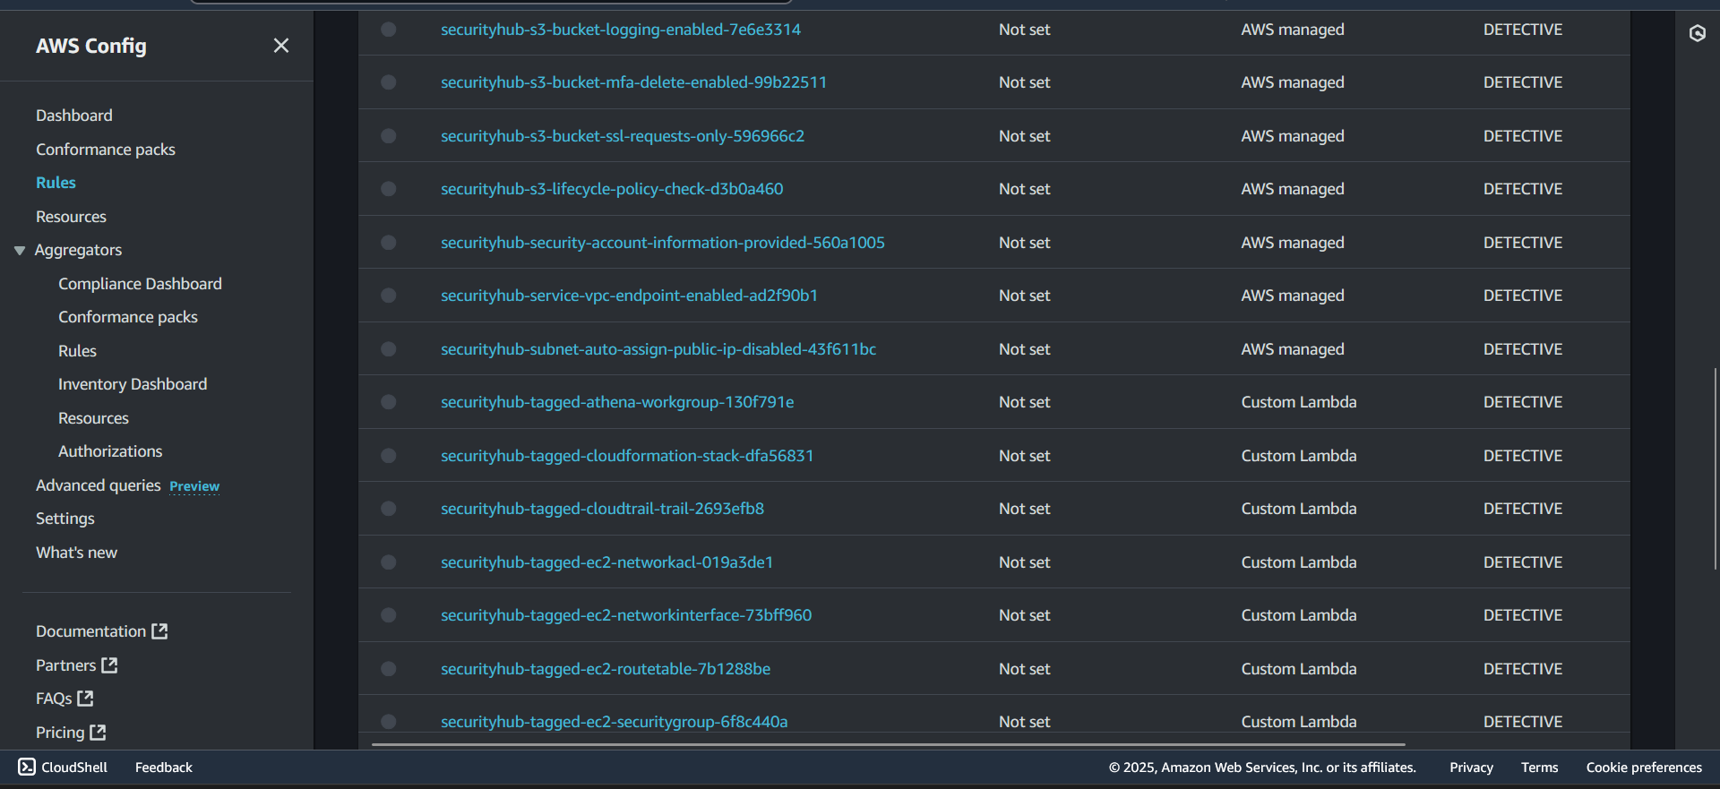

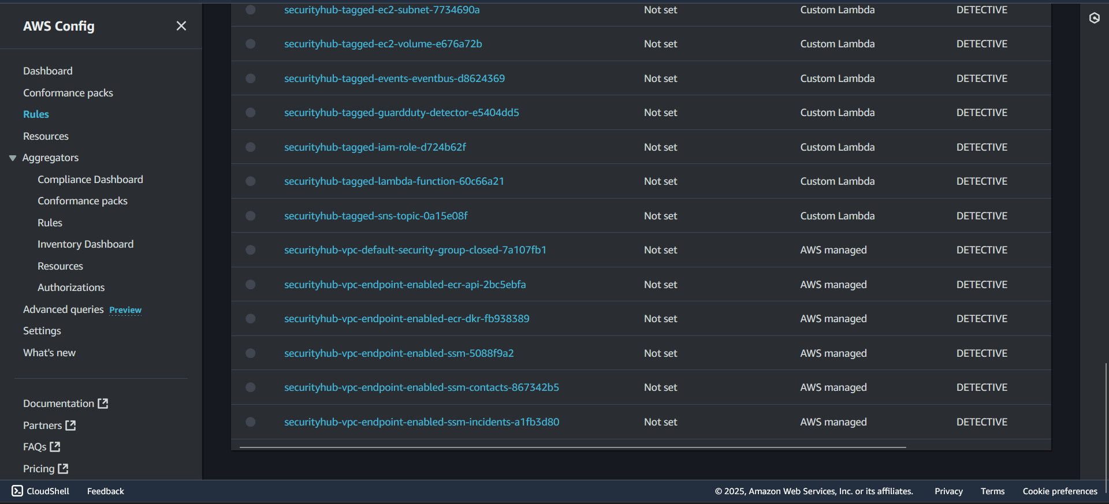

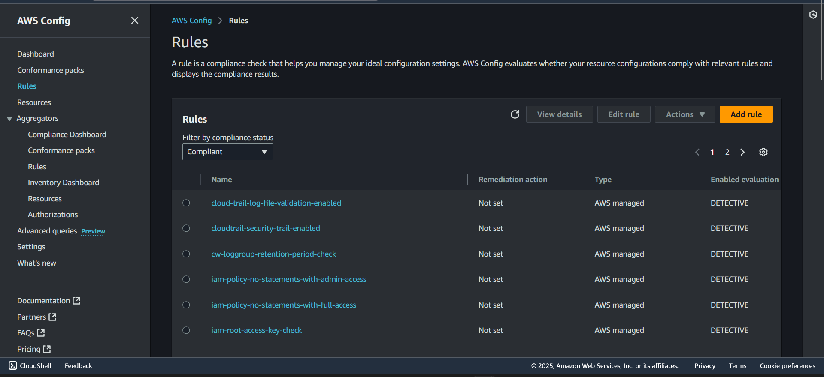

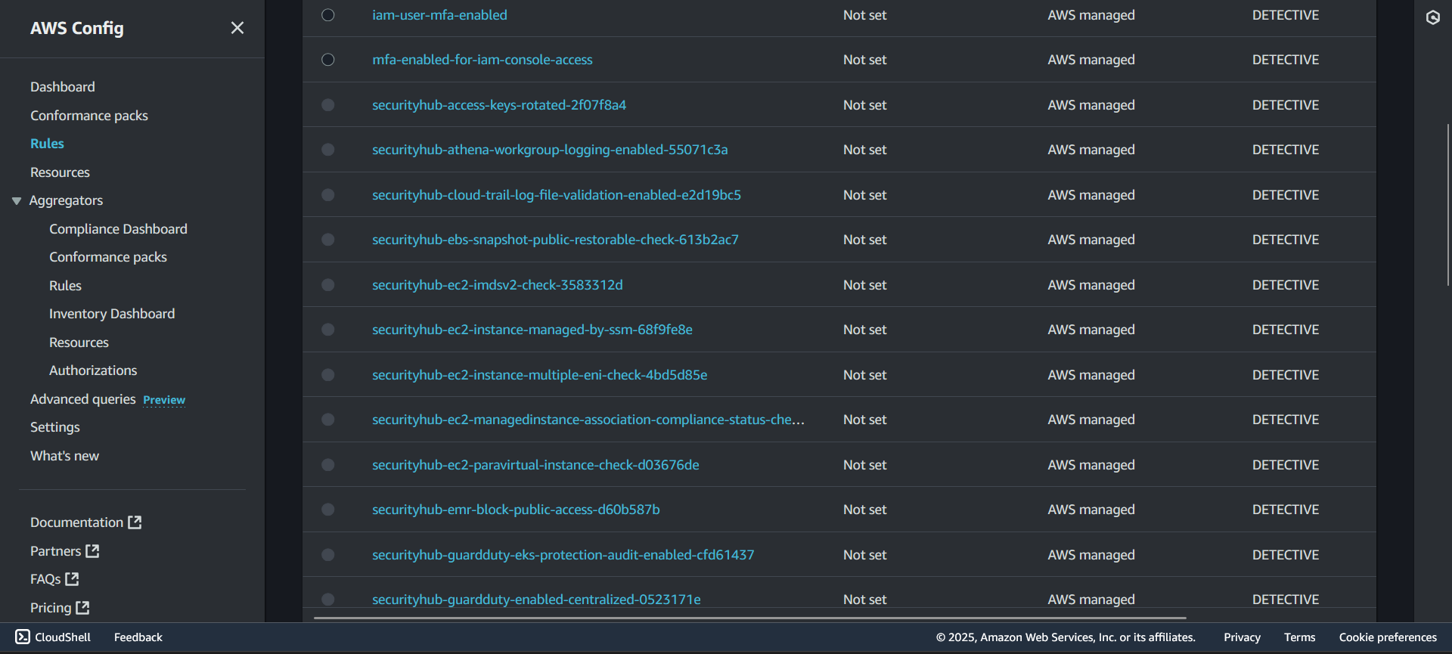

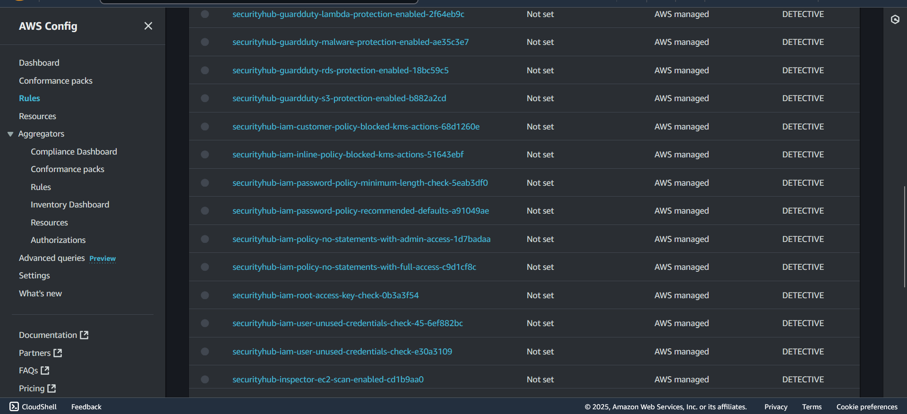

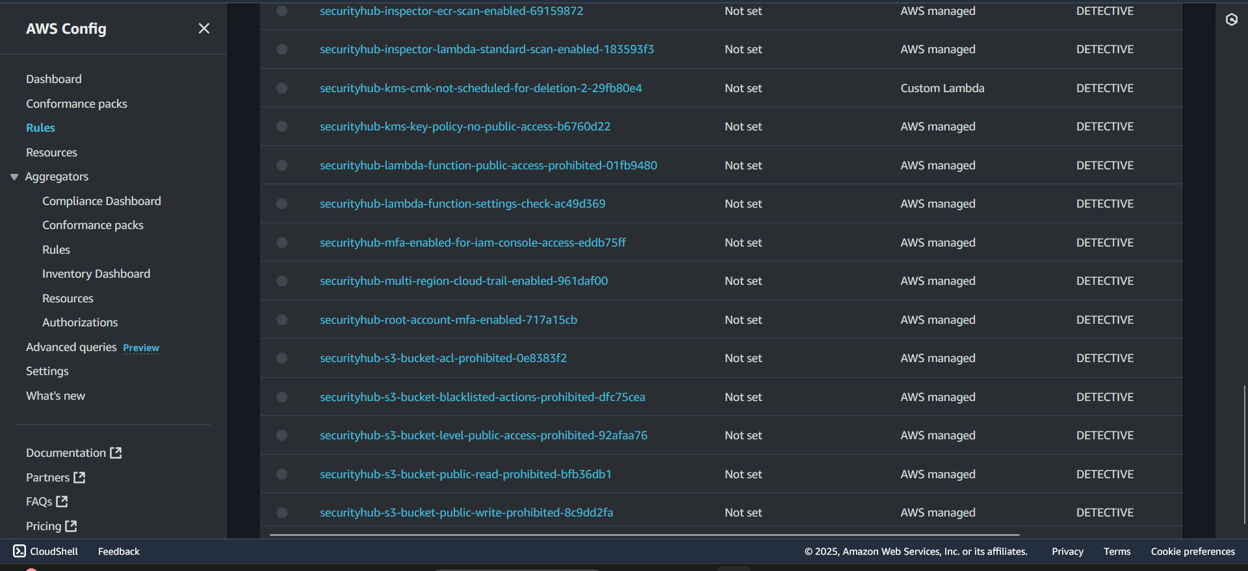

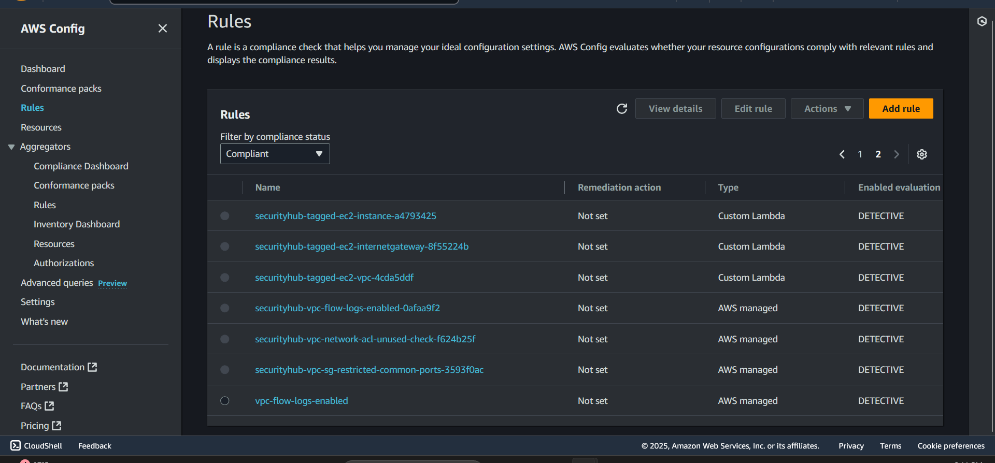

The second part of the testing validations for Data Protection settings in S3. Head to S3 console, open each bucket and ensure the following enable encryption as either SSE-S3 or SSE-KMS. When navigating to the S3 buckets ensure filter by newest creation date to be able to determine which buckets to review. Click on each bucket and check the encryption settings under properties before continuing. As we can see bucket versioning is enabled and the encryption type is set to server side encryption with Amazon S3 managed keys SSE-S3 while bucket key is enabled. Additionally, Block all public access for all Buckets should be enabled.

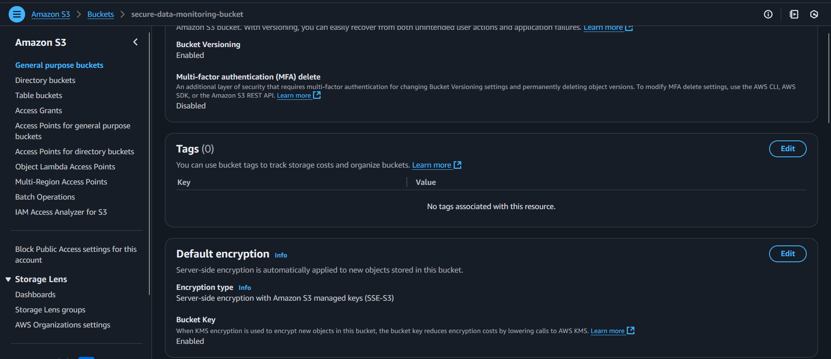

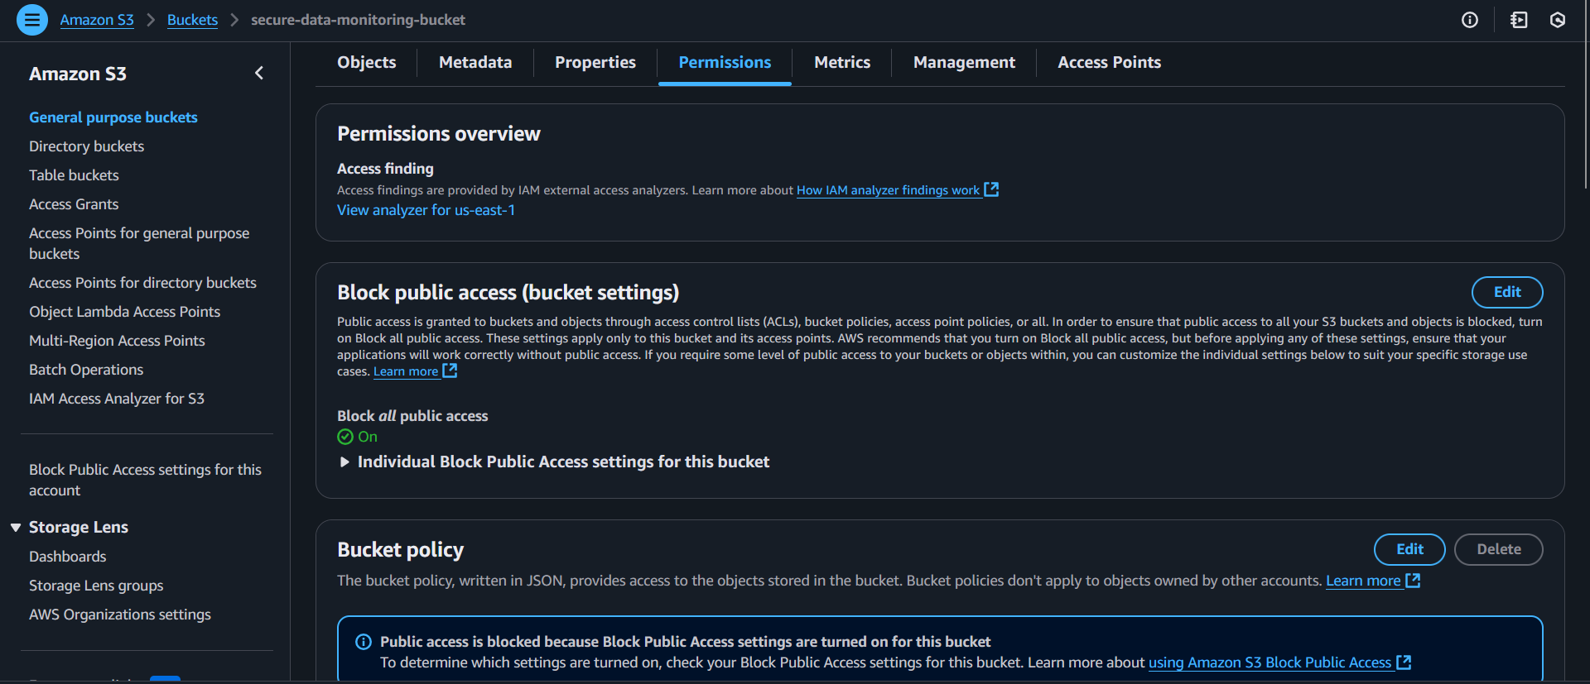

Next choose any bucket then under objects press upload a file to check to see what the configuration settings are for uploading anything. The bucket versioning, default encryption type and object lock settings should be the same. Under storage class we can set it to standard, frequently accessed data (more than once a month) with milliseconds access, bucket type is general purpose, availability zones is greater or equal to 3, the minimum storage duration is set to none, minimum billable object size is none, monitoring and auto tiering fees is set to none and there should be no retrieval fees for the standard storage class. As for server-side encryption If your bucket policy requires objects to be encrypted with a specific encryption key, you must specify the same encryption key when you upload objects. Otherwise, uploads will fail. As for our case we will choose to specify an encryption key which is used to encrypt objects before storing them in Amazon S3. The encryption settings will be use bucket settings for default encryption and the encryption type should still be server side encryption with Amazon S3 managed keys SSE-S3. Checksums are used to verify data integrity of any new objects. Checksum functions are used to calculate the checksum value. For objects smaller than 16 MB, only the full object checksum type is supported, for all checksum algorithms. For our case we will choose the checksum that is recommended by AWS which is the one with the only full object check sum is supported. Any other settings that says optional leave untouched and upload a sample file. After uploading the file under the page that says upload: status where it says configuration we can see that the grantees are object owner has read and write permissions for the ACL. If we click on the object we can see all of the information in regards to how AWS chooses to provide as much information as possible in regards to the configuration storage settings of an object.

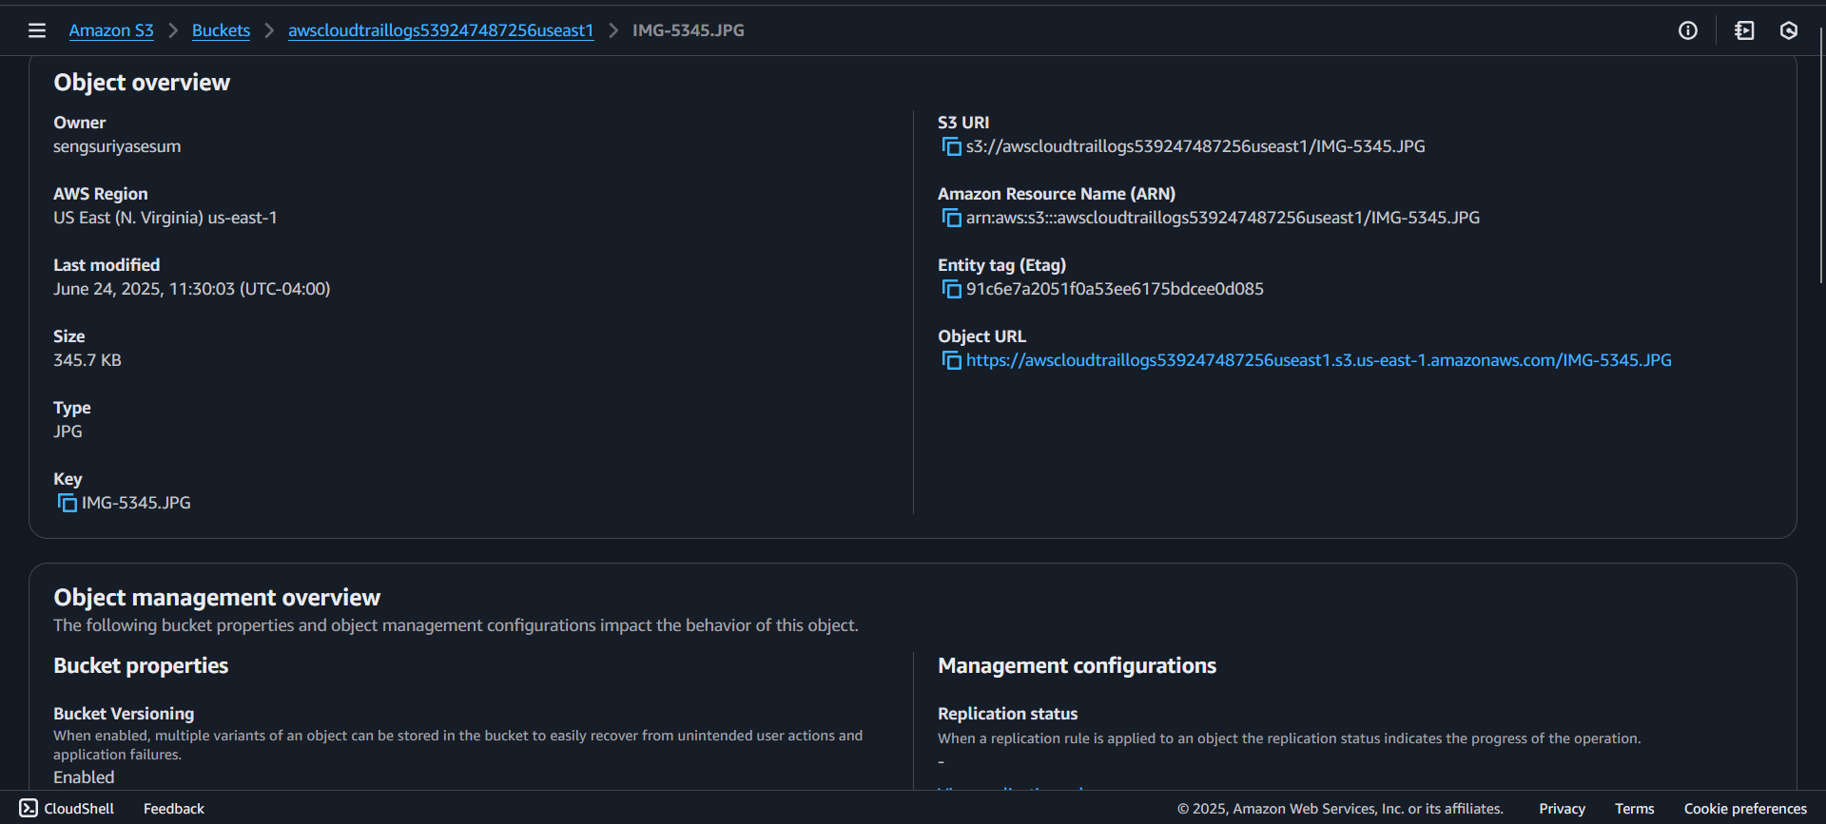

In the third part of the final testing validation, the AWS CloudTrail should be able to actively log across multiple services and regions. Head to CloudTrail under trails and we can see there are two trails, Cloudtrail-main and monitoring-trail both have the active status logging. If we click on each trail they should be actively logging, multi-region trail enabled, show the location of where the logging is stored in which S3 bucket it is designated and linked to while Cloudwatch logs integration is enabled. This is what the configuration should be:

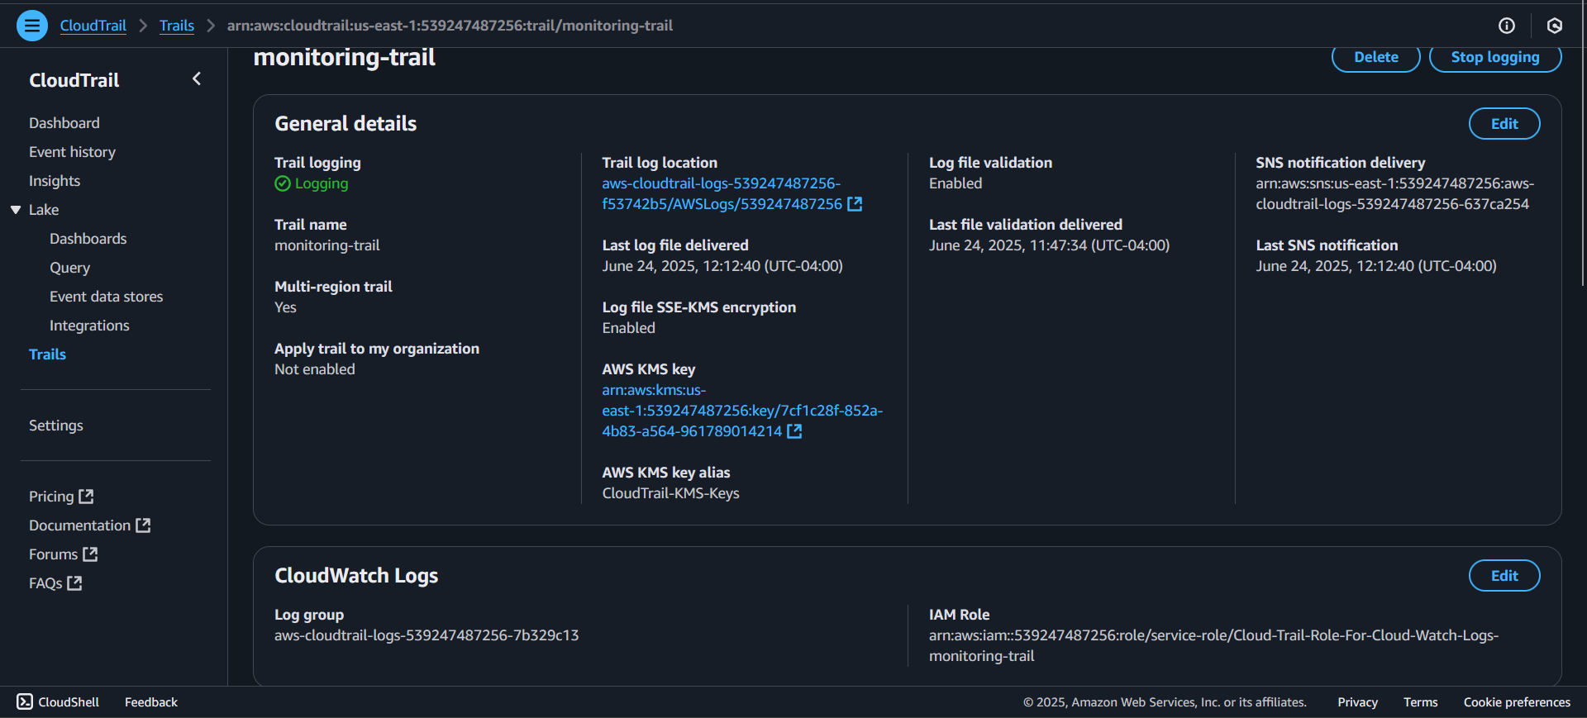

As we can see here if we check the file pathway for that trail in the S3 bucket we can see the following path: https://us-east-1.console.aws.amazon.com/s3/buckets/aws-cloudtrail-logs-539247487256-f53742b5?region=us-east-1&bucketType=general&prefix=AWSLogs/539247487256/CloudTrail-Digest/us-east-1/2025/06/24/&showversions=false

/AWSLogs/account-ID/CloudTrail/us-east-1/2025/06/24

CloudTrail-Digest 🡪 us-east-1 🡪 2025 (year) 🡪 06 (month) 🡪 24 (Day) 🡪 Objects (gz log files)

The JSON file types for the logs should be .gz, as we can see here the log contains multiple log files that are being generated on an hourly basis. The logs are divided by the year, month and days. The last folder is the day which shows how often the log files are created.

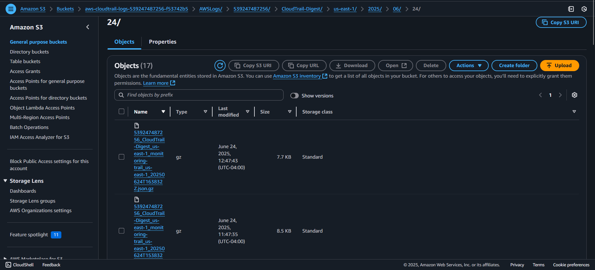

If we look for the exact log group under cloudwatch that is actively generating new logs it should match the one that we showed for cloud trail: aws-cloudtrail-logs-539247487256 and if we click on any of the log streams that matches our account region, it should contain multiple time stamps within the same current day. This tells us that new entries are actively being generated

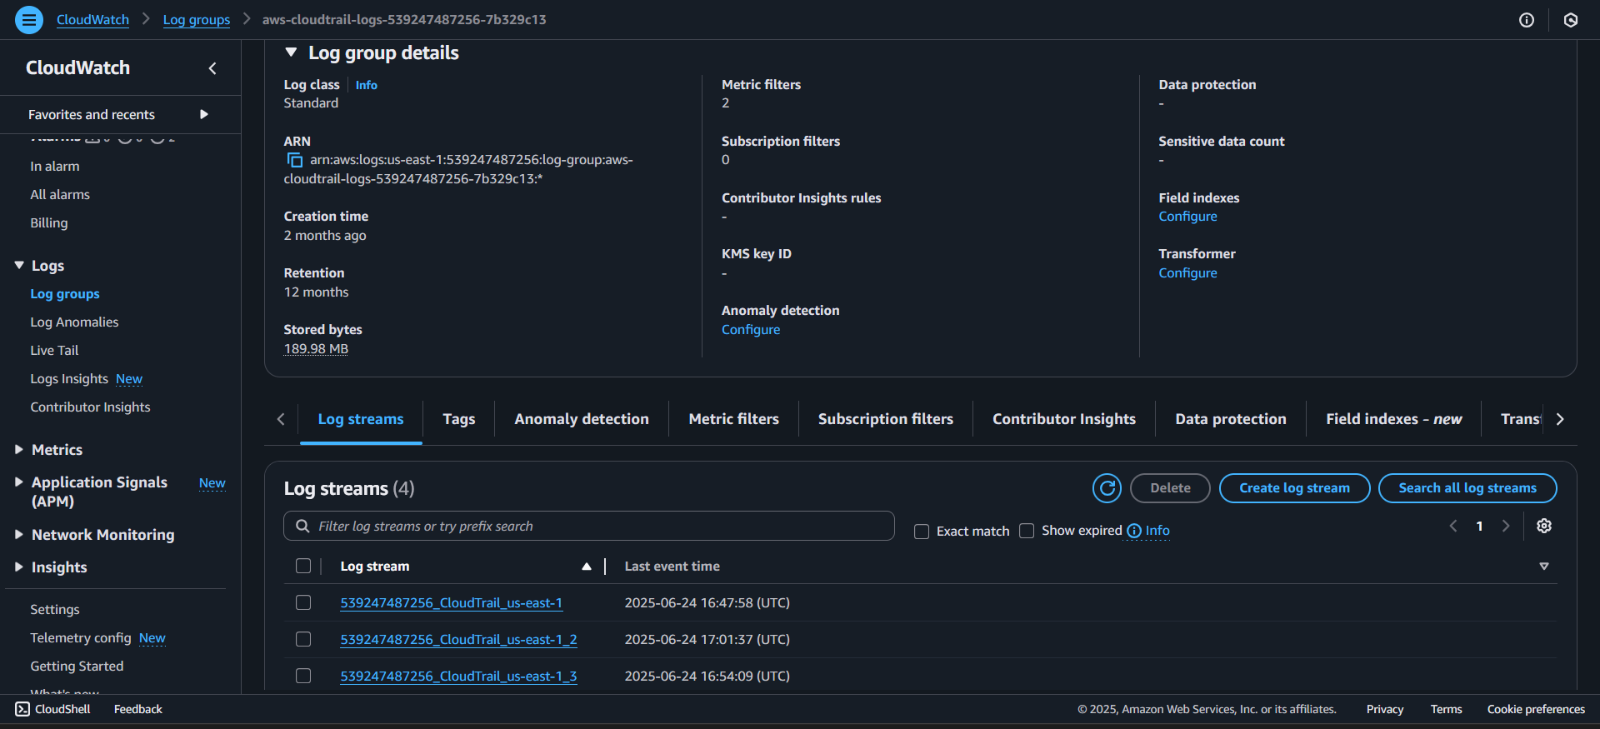

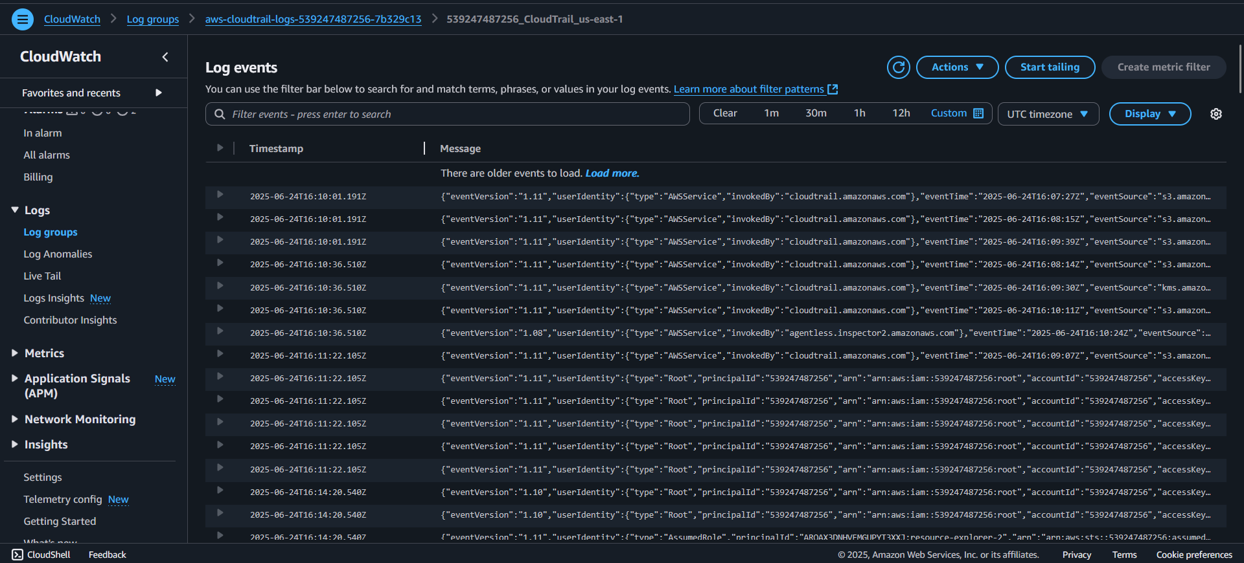

The fourth Final testing is AWS Key Management Service validation, we just need to confirm that encryption is active, and rotations are enabled. Head to the AWS KMS’s Customer managed keys page and click on each of the KMS keys to see the following information: we should see the key Alias, Key ARN, Key status and key spec. Given it is designed for cloudtrail.

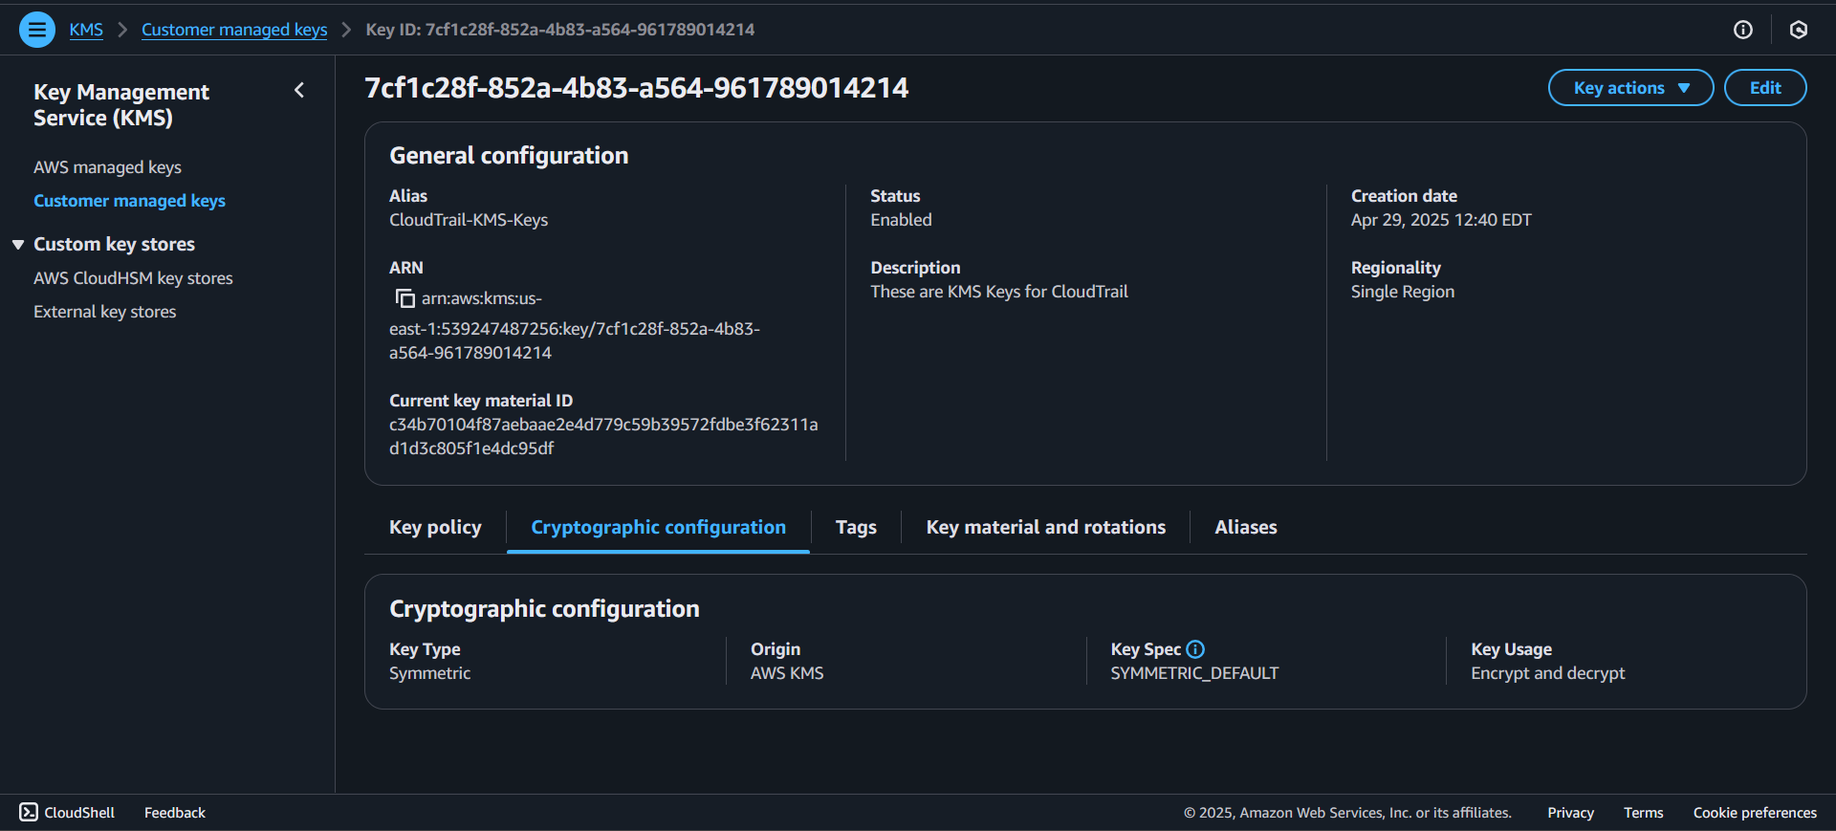

The key rotation can be configured in any possible way in terms of duration and timing:

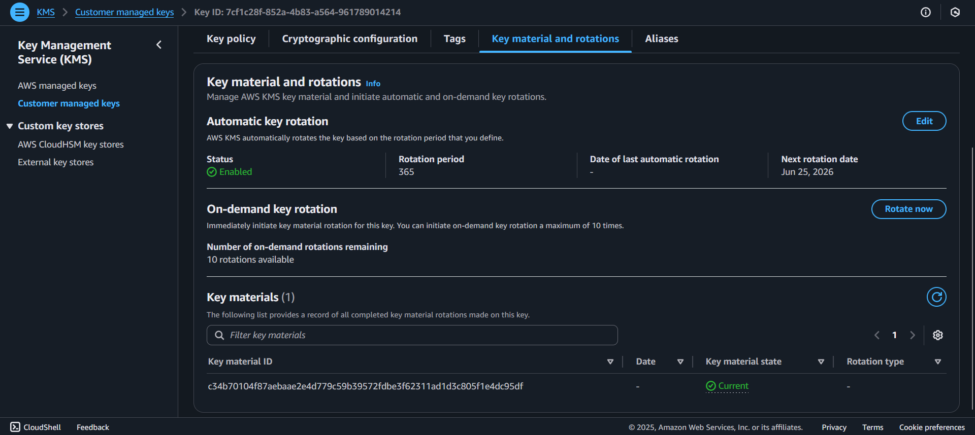

Here we can see that the automatic key rotation is enabled, and rotation period is set to every 365 days. If we head over to monitoring-trail we can see that trail is linked to the CloudTrail-KMS-Keys:

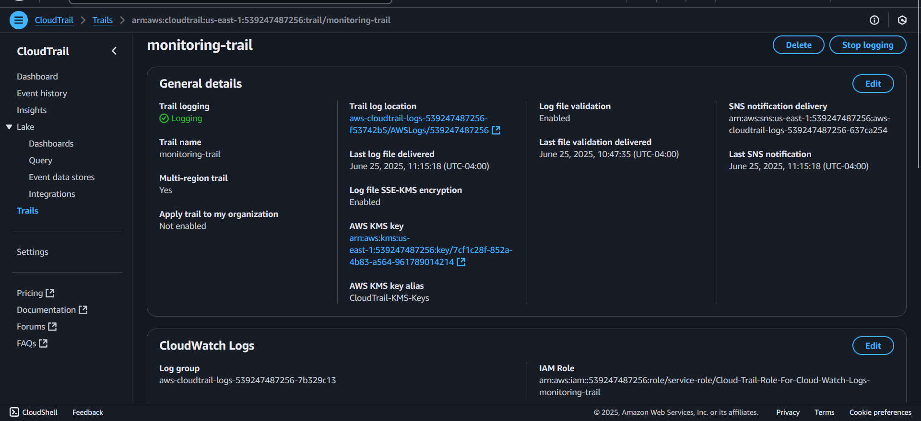

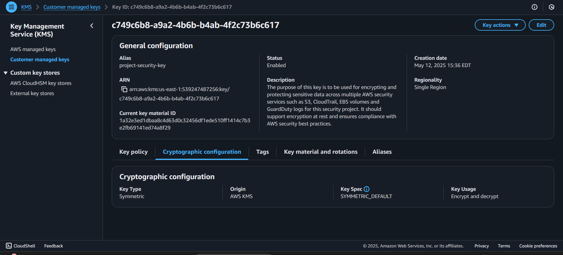

The follow JSON key policy for the CloudTrail-KMS-Keys is:

{

"Version": "2012-10-17",

"Id": "key-consolepolicy-3",

"Statement": [

{

"Sid": "Enable IAM User Permissions",

"Effect": "Allow",

"Principal": {

"AWS": "arn:aws:iam::539247487256:root"

},

"Action": "kms:*",

"Resource": "*"

},

{

"Sid": "Allow use of the key",

"Effect": "Allow",

"Principal": {

"AWS": "arn:aws:iam::539247487256:role/service-role/Cloud-Trail-Role-For-Cloud-Watch-Logs-monitoring-trail"

},

"Action": [

"kms:Encrypt",

"kms:Decrypt",

"kms:ReEncrypt*",

"kms:GenerateDataKey*",

"kms:DescribeKey"

],

"Resource": "*"

},

{

"Sid": "Allow attachment of persistent resources",

"Effect": "Allow",

"Principal": {

"AWS": "arn:aws:iam::539247487256:role/service-role/Cloud-Trail-Role-For-Cloud-Watch-Logs-monitoring-trail"

},

"Action": [

"kms:CreateGrant",

"kms:ListGrants",

"kms:RevokeGrant"

],

"Resource": "*",

"Condition": {

"Bool": {

"kms:GrantIsForAWSResource": "true"

}

}

},

{

"Sid": "Allow CloudTrail to use the key",

"Effect": "Allow",

"Principal": {

"Service": "cloudtrail.amazonaws.com"

},

"Action": [

"kms:GenerateDataKey*",

"kms:Decrypt"

],

"Resource": "*",

"Condition": {

"StringEquals": {

"kms:EncryptionContext:aws:cloudtrail:arn": "arn:aws:cloudtrail:us-east-1:539247487256:trail/monitoring-trail"}}}]}

The second key project-security-key is meant to be used for multiple services such as S3, Cloudtrail, guard duty, EBS volume and more.

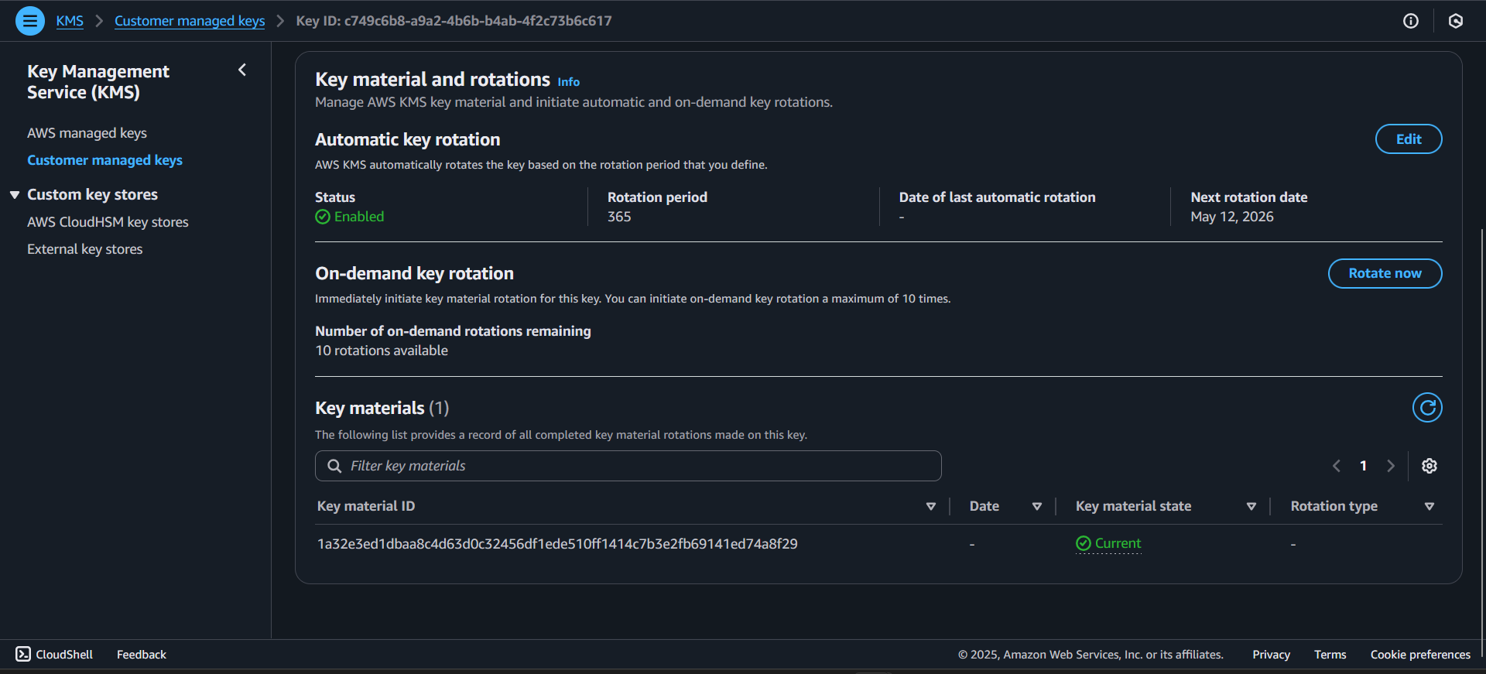

We can see here that project-security-key is linked to an S3 bucket aws-config-log’s default encryption:

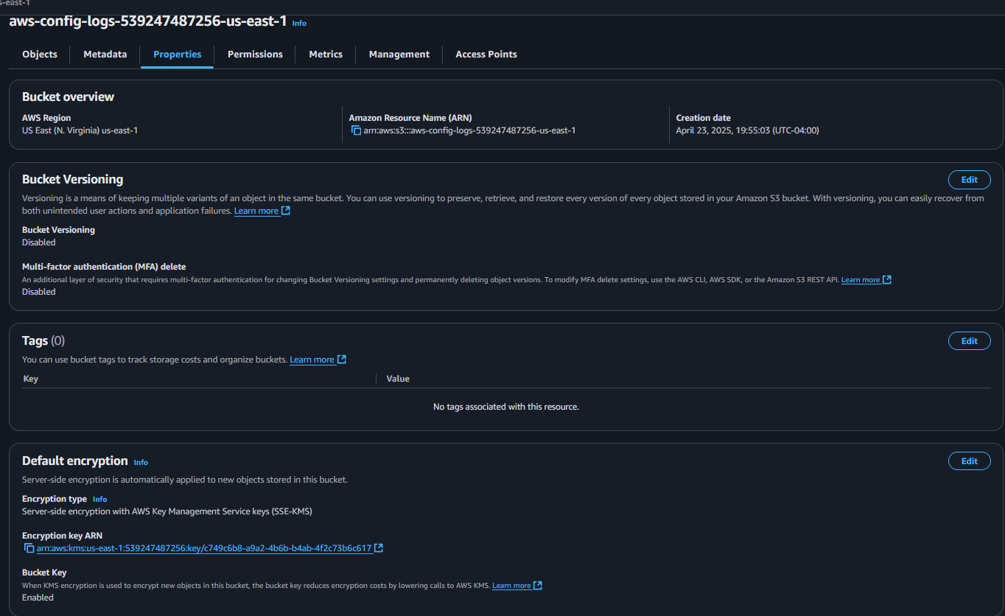

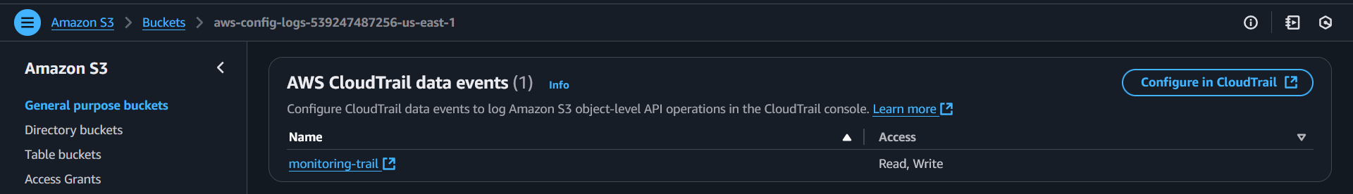

The Key policy for Project-Security-Key is:

{

"Version": "2012-10-17",

"Id": "key-default-1",

"Statement": [

{

"Sid": "AllowRootAccountFullAccess",

"Effect": "Allow",

"Principal": {

"AWS": "arn:aws:iam::539247487256:root"

},

"Action": "kms:*",

"Resource": "*"

},

{

"Sid": "AllowS3ReplicationToUseKey",

"Effect": "Allow",

"Principal": {

"Service": "s3.amazonaws.com"

},

"Action": [

"kms:Decrypt",

"kms:Encrypt",

"kms:ReEncrypt*",

"kms:GenerateDataKey*",

"kms:DescribeKey"

],

"Resource": "*",

"Condition": {

"StringEquals": {

"aws:SourceAccount": "539247487256"

}

}

}

]

}

The Fifth final testing is CloudWatch Monitoring, we just need to ensure it is doing exactly as intended to be. Since we already configured the log metric filters and alarms (Unauthorized API calls, configuration changes, root usage) verifying CloudWatch is working is what needs to be done. Head to CloudWatch Log groups, look for the log group that has metric filters. As we can see here aws-cloudtrail-logs has 2 separate metric logs:

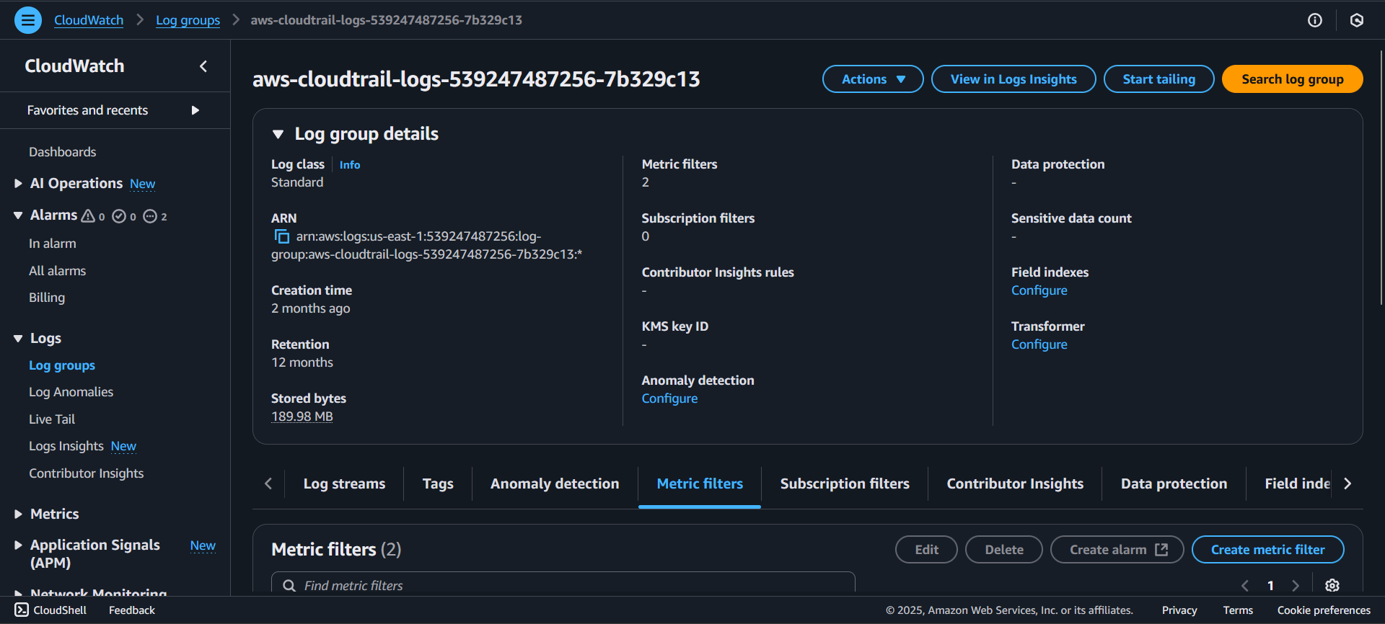

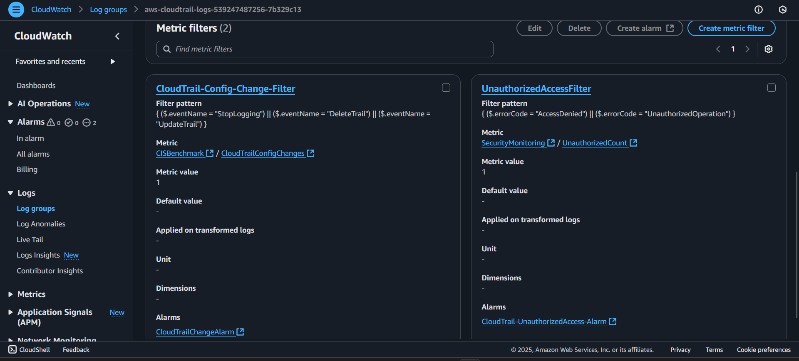

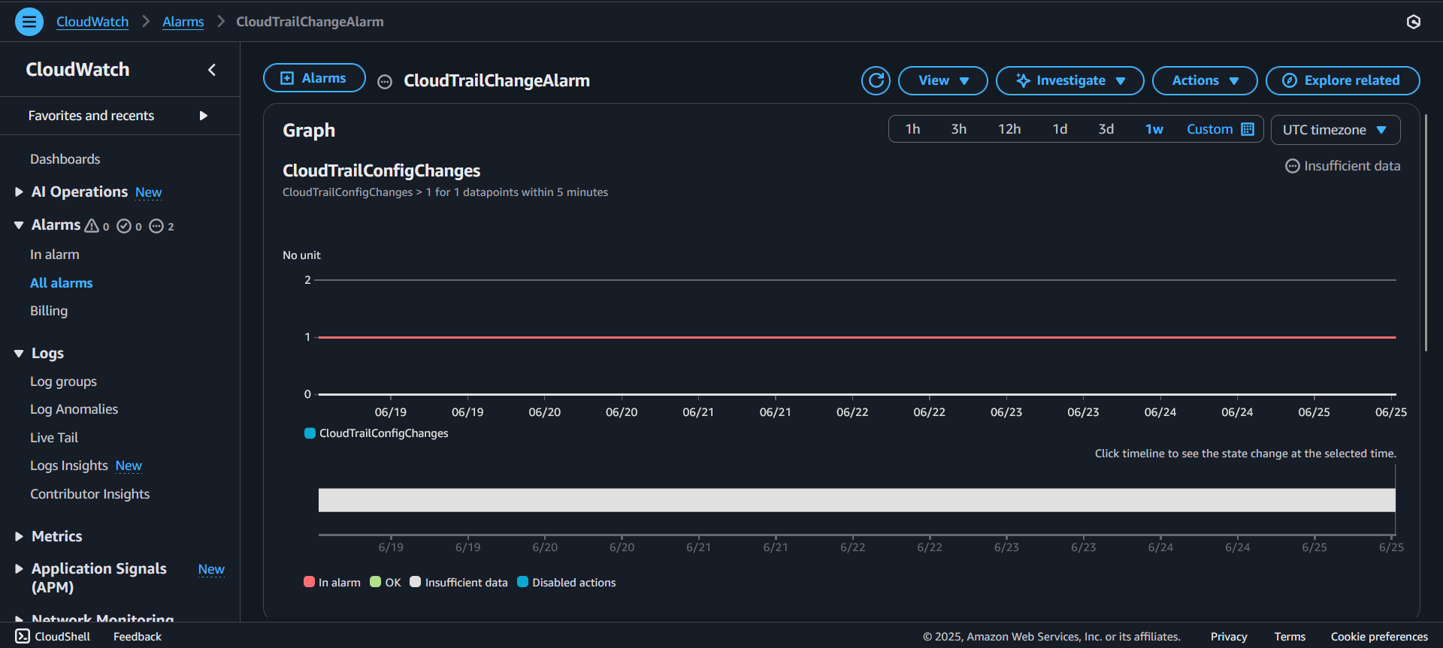

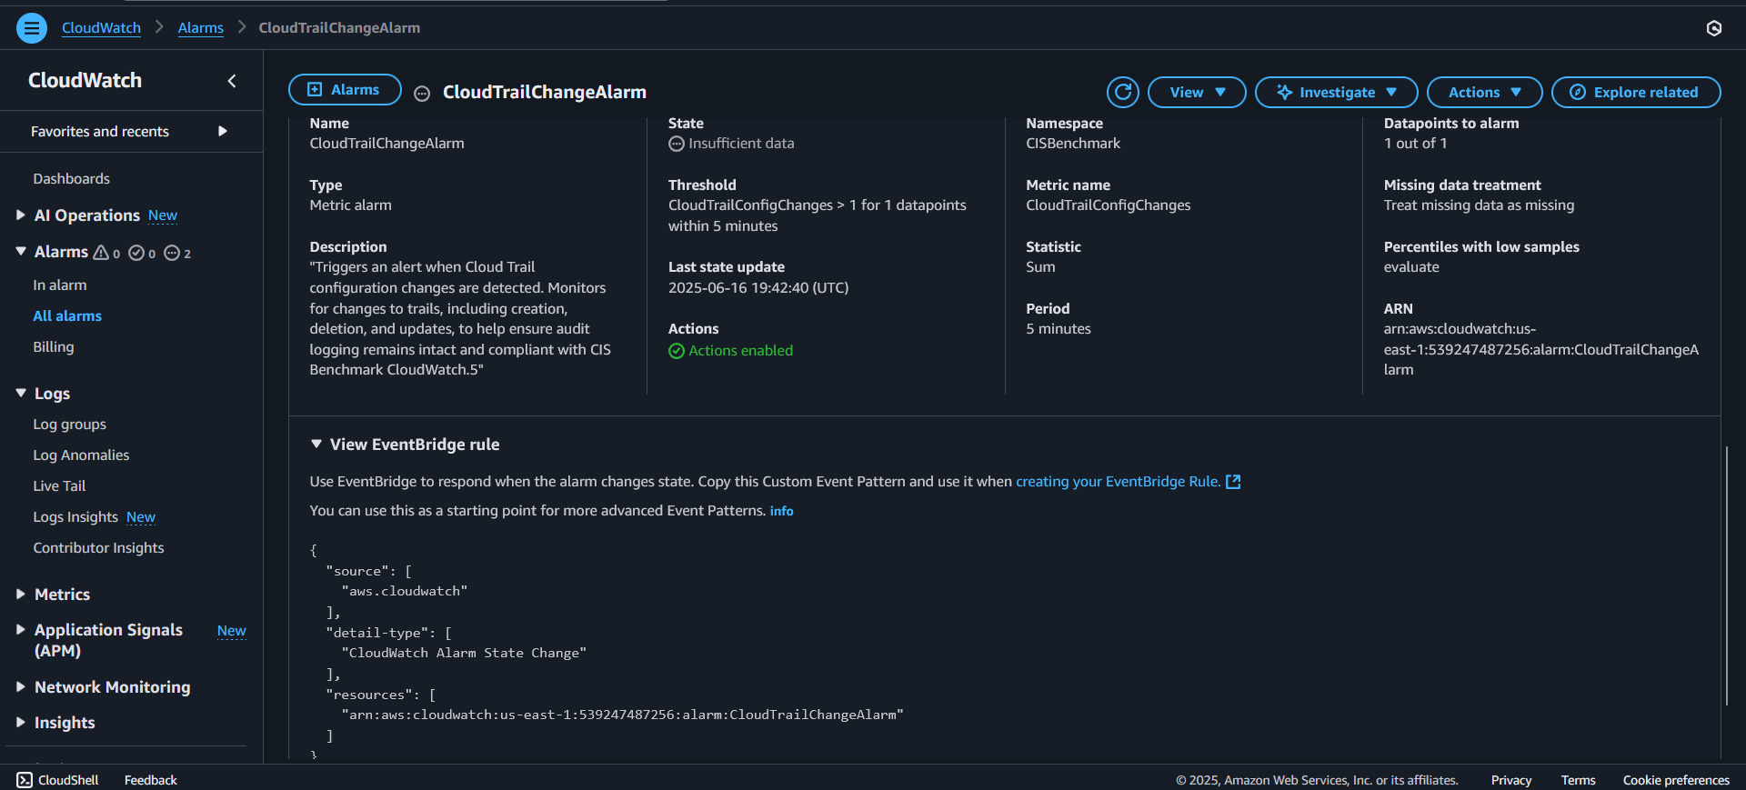

Actions Enabled - Type: Notification, Description: When in alarm, send message to topic “Security-Alert-Topic”

Date (UTC): 2025-06-16 19:42:40, Type: Configuration Update, Description: Alarm "CloudTrailChangeAlarm" created

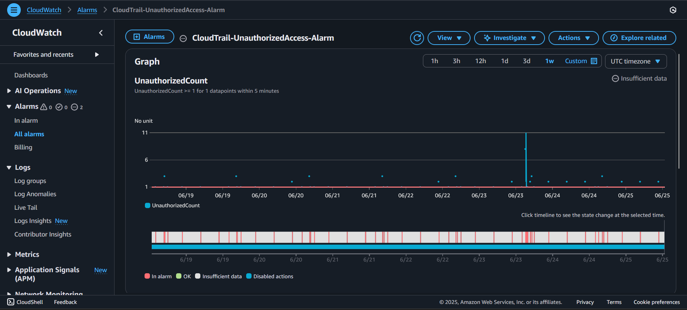

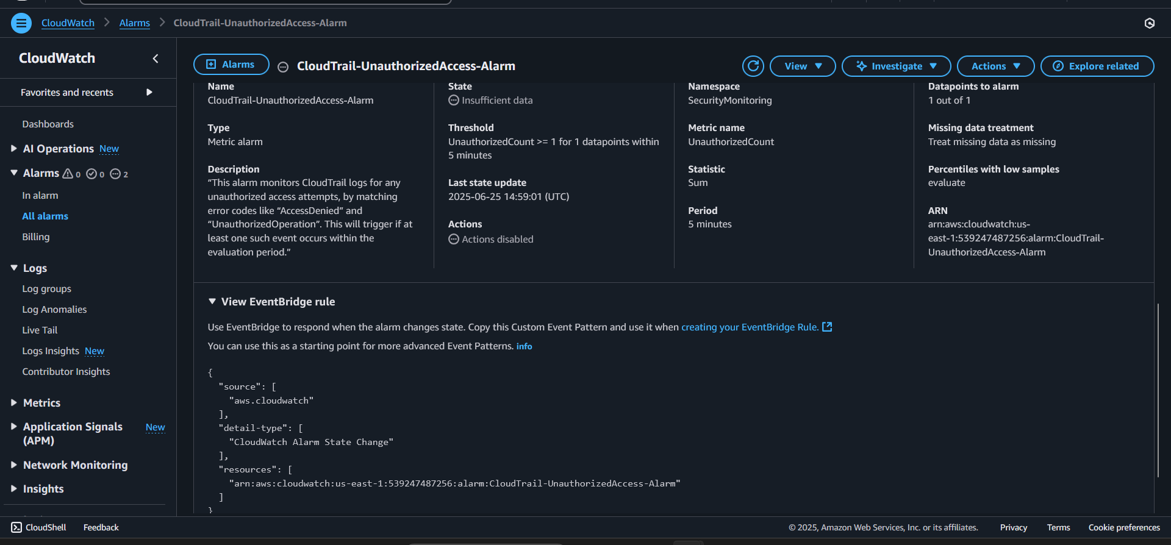

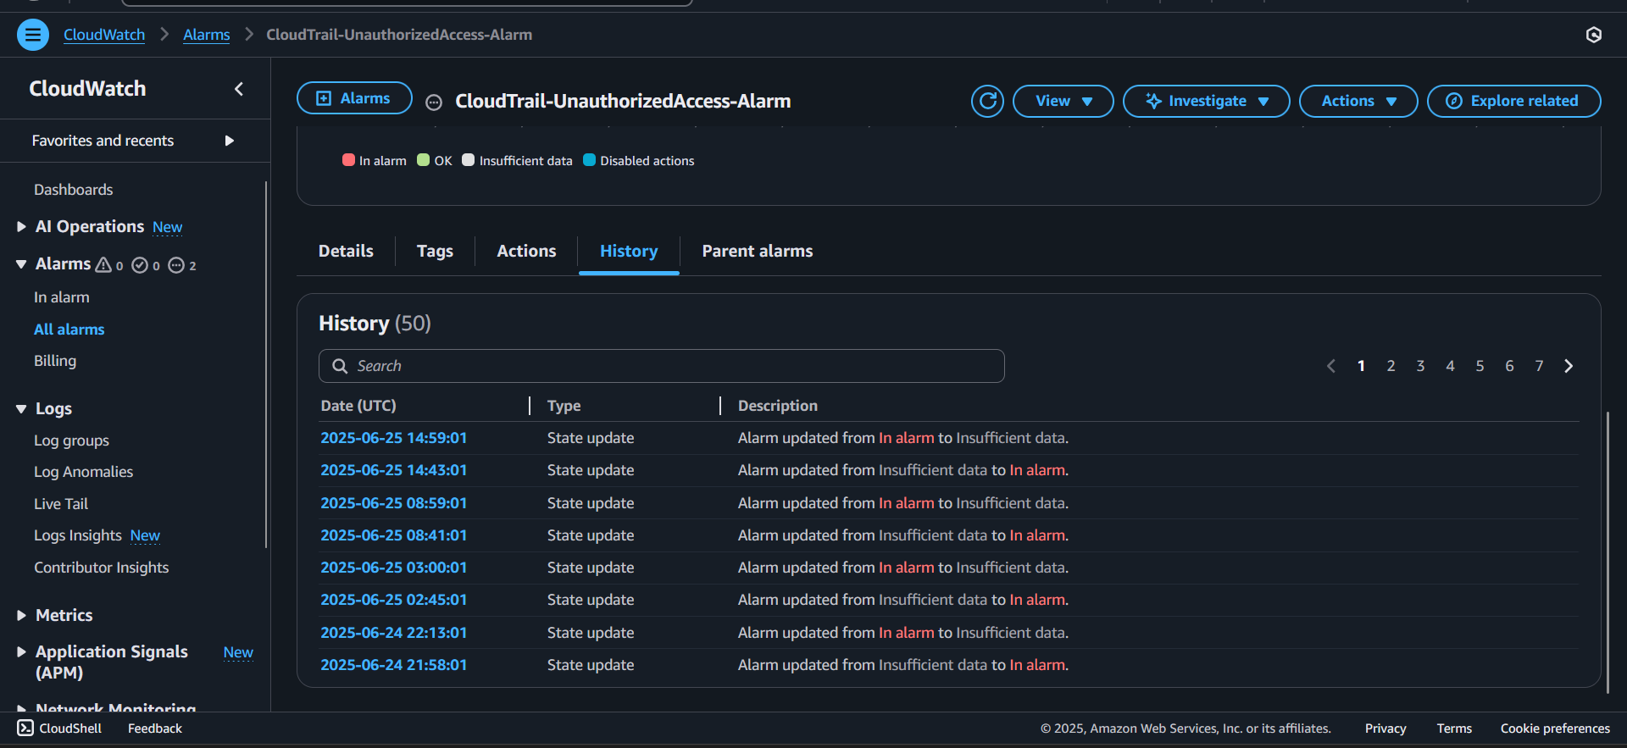

Type: Notification, Description: When in alarm, send message to topic "Security-Alert-Topic"

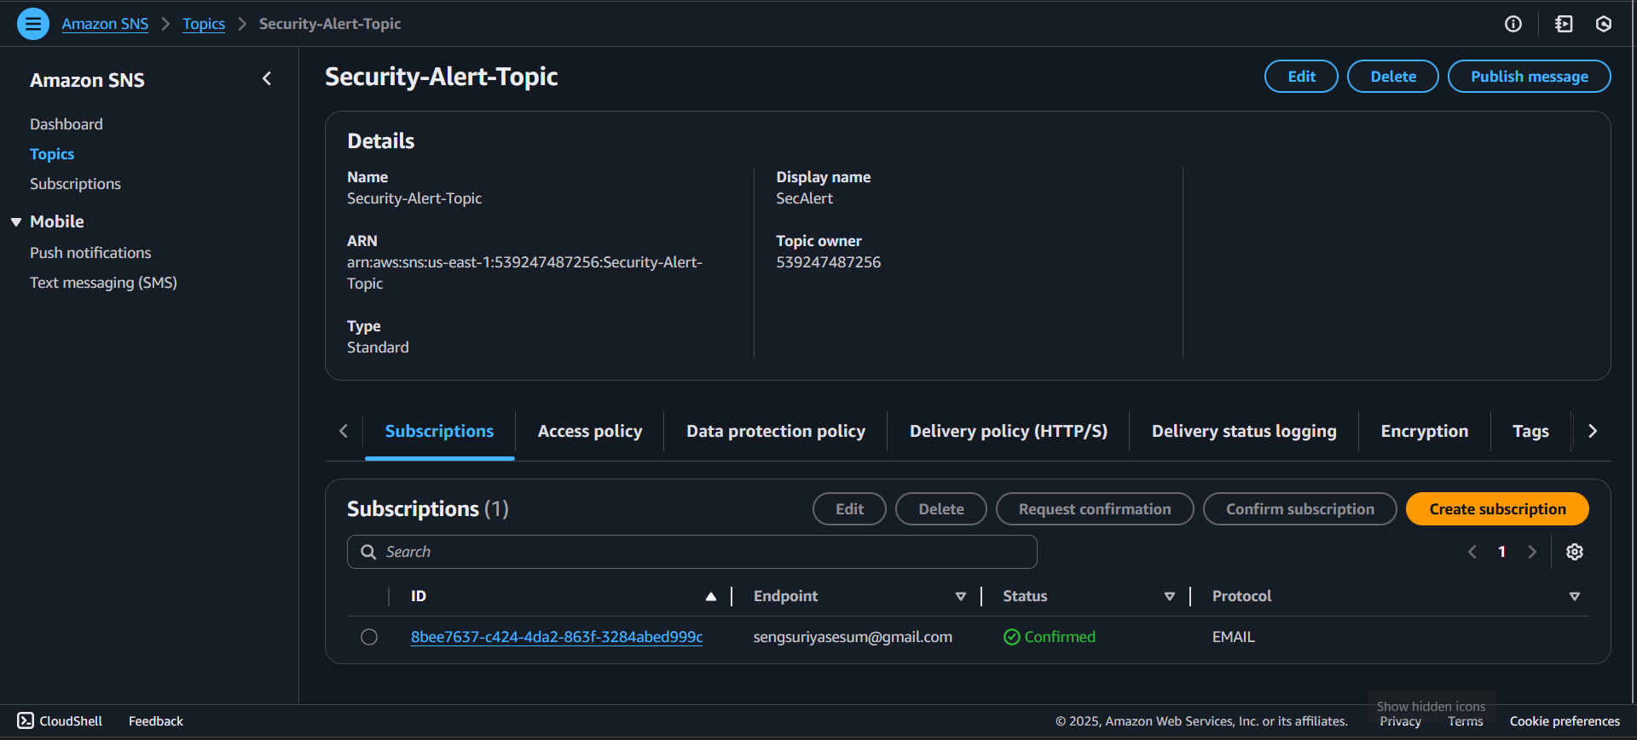

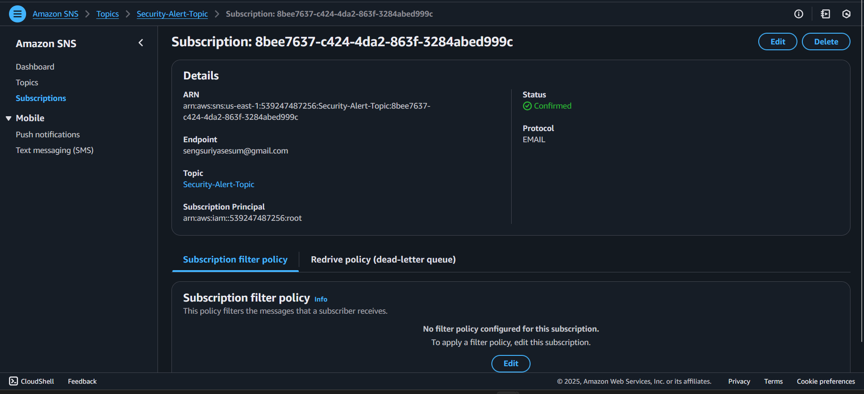

The sixth final testing is just doing snap shots for CloudTrail.7 and EC2.2

CloudTrail.7’s Snap Shots:

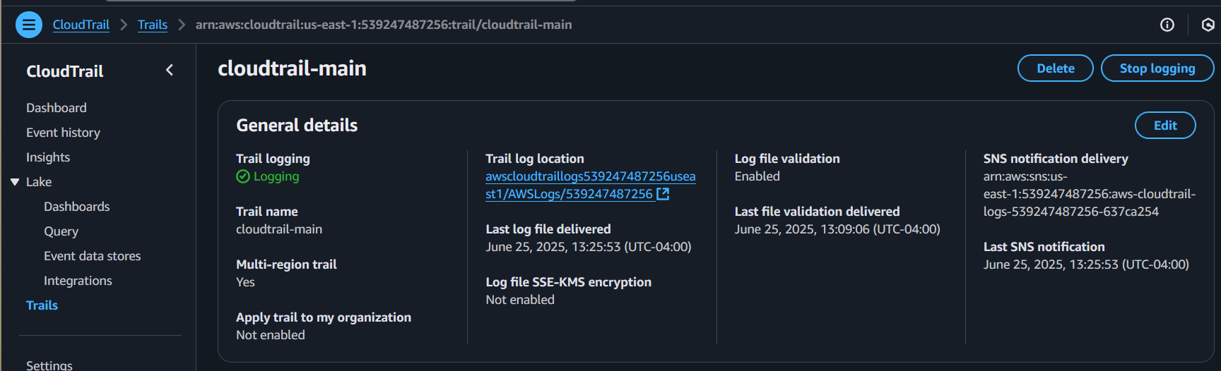

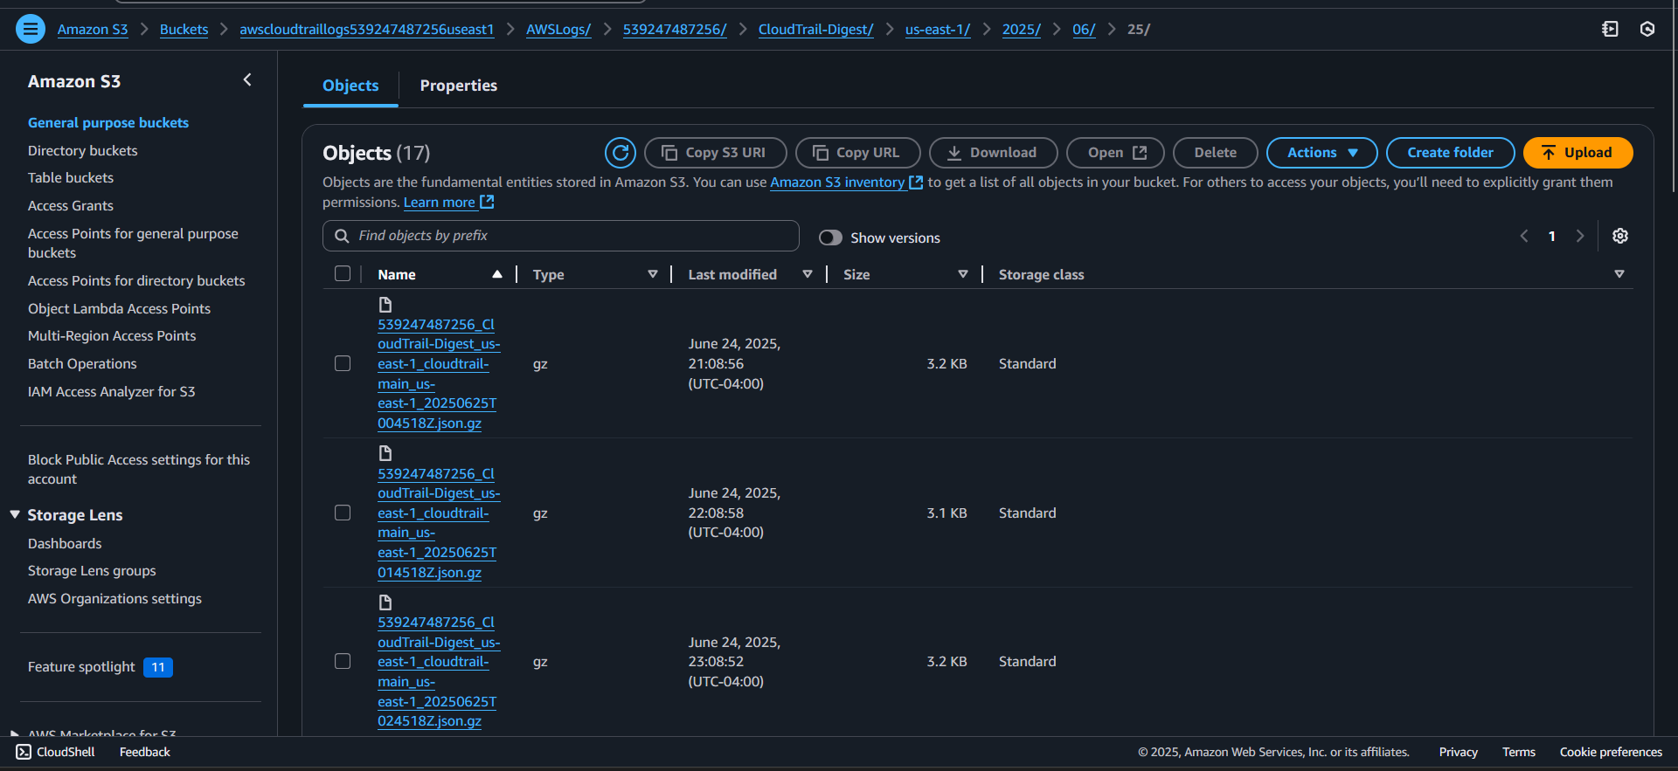

EC2.2’s Snap Shot: the inbound rule to accept all traffic 0.0.0.0/0 from custom source as the security group is fine since the source is Custom and is only designated to the security group ID. Although we are not allowing public traffic from the internet 0.0.0.0/0. We are allowing inbound traffic only from other resources associated with that same security group. The self referring security group rule has no public access, mostly used for internal service to service communication within the same group of instances is compliant with AWS CIS benchmarks and security compliance if no public access.

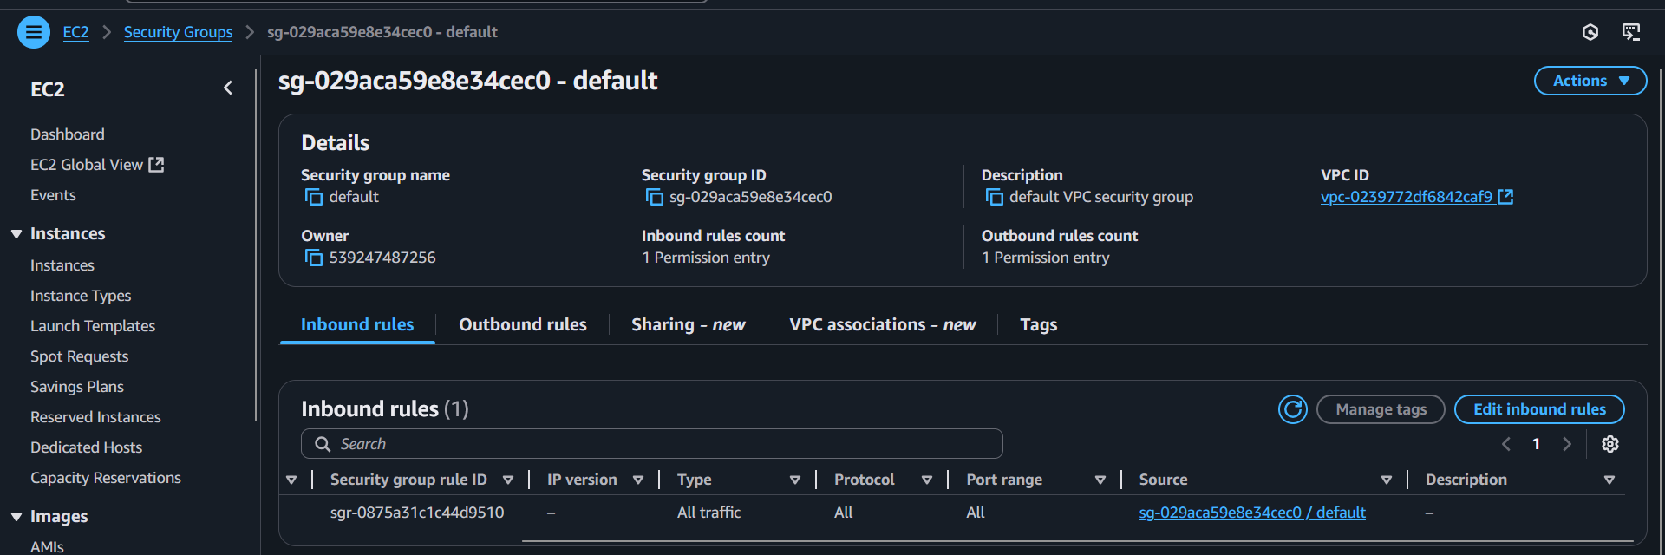

CloudWatch.5: log metric filter, alarm exist for CloudTrail configuration changes and find matching log entries

CloudTrail should already be logging to CloudWatch log group

CloudTrail: **monitoring-trail**, CloudWatch’s Log Group: **aws-cloudtrail-logs-539247487256-7b329c13** and IAM Role: arn:aws:iam::539247487256:role/service-role/**Cloud-Trail-Role-For-Cloud-Watch-Logs-monitoring-trail**

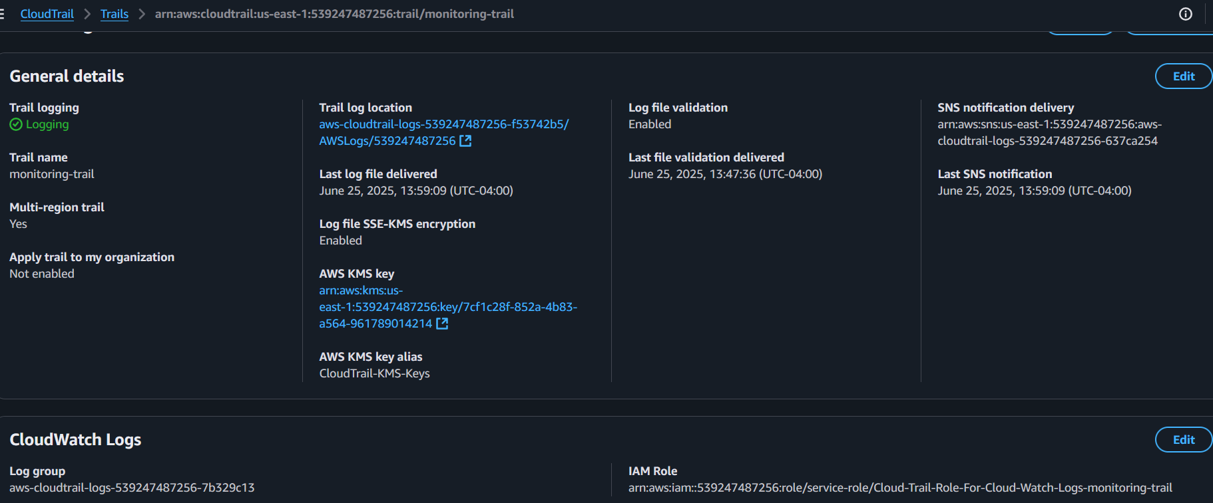

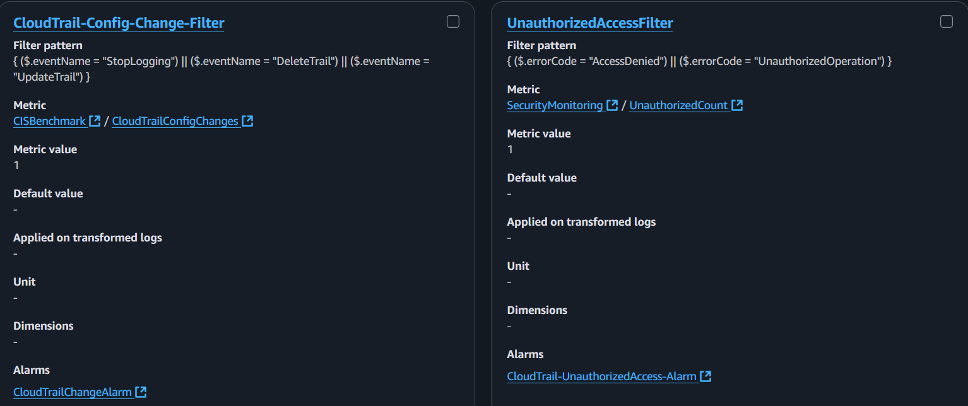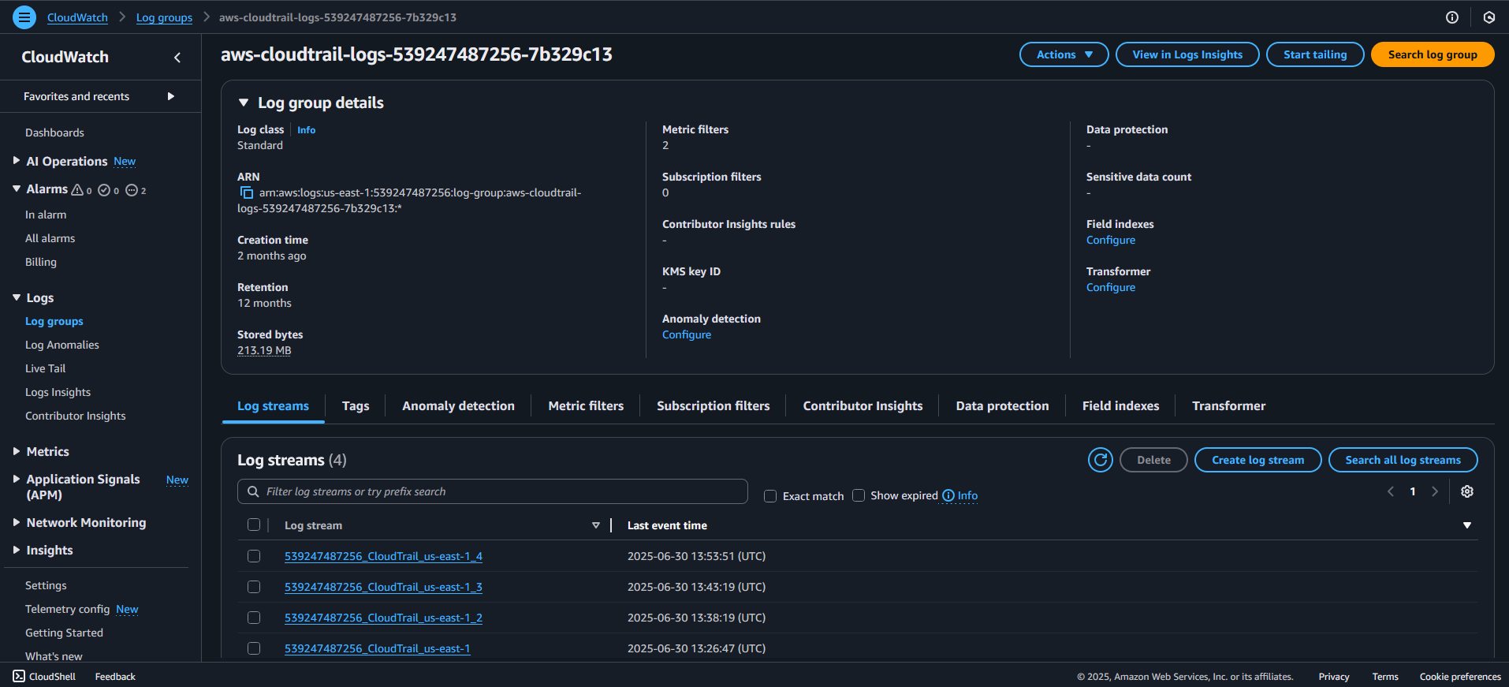

Since we already have the CloudTrail linked to the CloudWatch log group, metric filters with filter patterns, metrics and alarms configurated along with the access to find the folders of the log streams, all we need to do is search for any matching log entries that are tied to the event patterns that was listed, such as StopLogging, DeleteTrail, UpdateTrail which is for CloudTrail-Config-Change-Filter or AccessDenied and UnauthorizedOperation for the UnauthorizedAccessFilter. To search for log entries in CloudWatch logs head to CloudWatch, under logs insights, Select log groups by log group name, Selection Criteria up to 50 log groups, select aws-cloudtrail-logs-539247487256-7b329c13 as the main log group we will be looking into the log entries. Based on each of the following tabs: Logs Insights QL, OpenSearch PPL and OpenSearch SQL, we will be selecting Logs Insights QL. Press the time stamp range and select Absolute within the past 90 days regardless of the time and press apply then wait for it to complete fetching results until it shows the total number of logs recording those events as listed in each query below.

Under the text entry box that allows you to enter queries, paste this query:

fields @timestamp, eventName, userIdentity.arn, requestParameters

| filter eventName in ["UpdateTrail", "DeleteTrail", "StopLogging"]

| sort @timestamp desc

| limit 50

This is the result we should find based on whatever you have done to the CloudTrail.

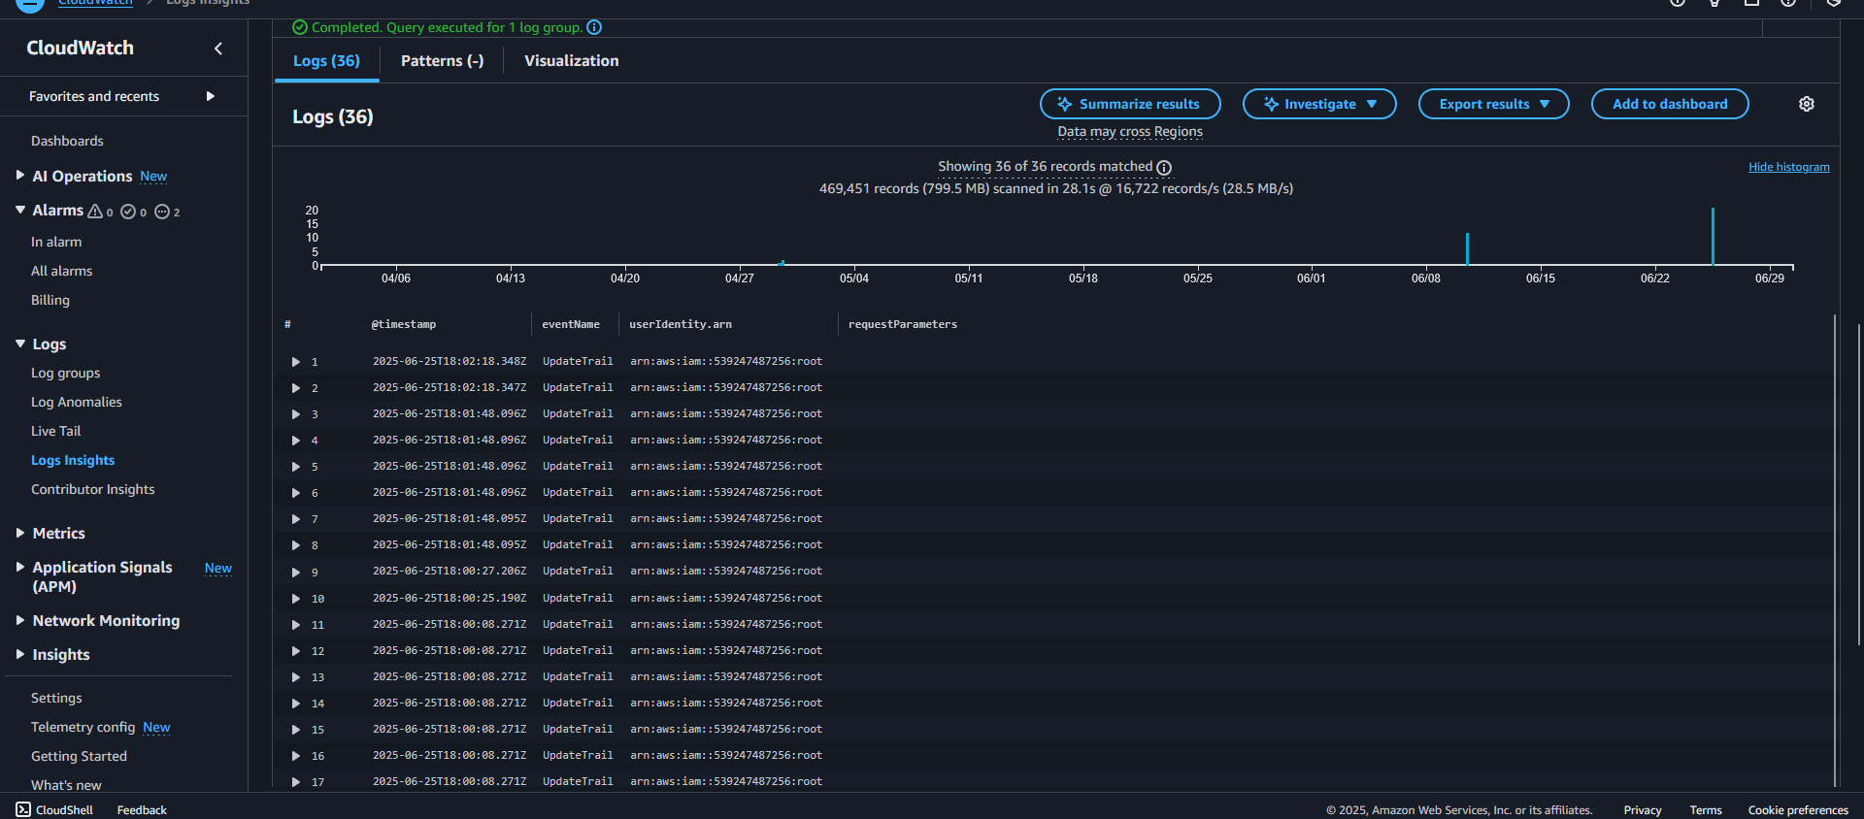

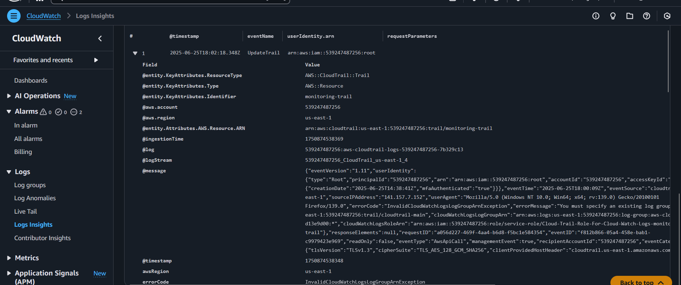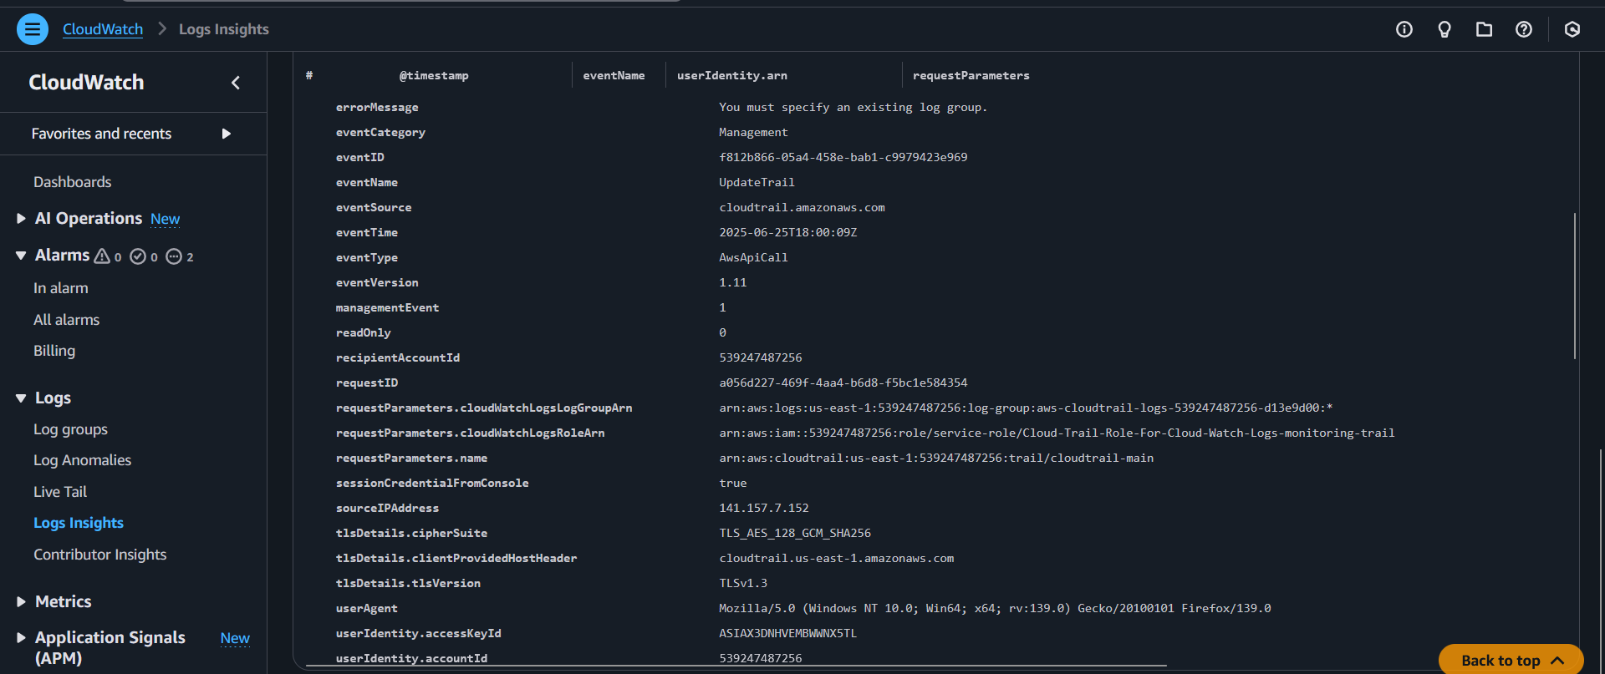

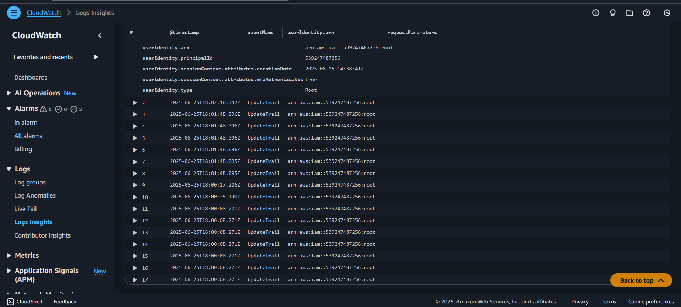

This query will identify any changes taken towards the CloudTrail such as Updates, deletions or disabling actions. Press run query to get some results:

fields @timestamp, eventName, errorCode, userIdentity.arn, sourceIPAddress

| filter errorCode in ["AccessDenied", "UnauthorizedOperation"]

| sort @timestamp desc

| limit 50

This query can show access violations such as any failed attempts to use AWS services without proper permissions.

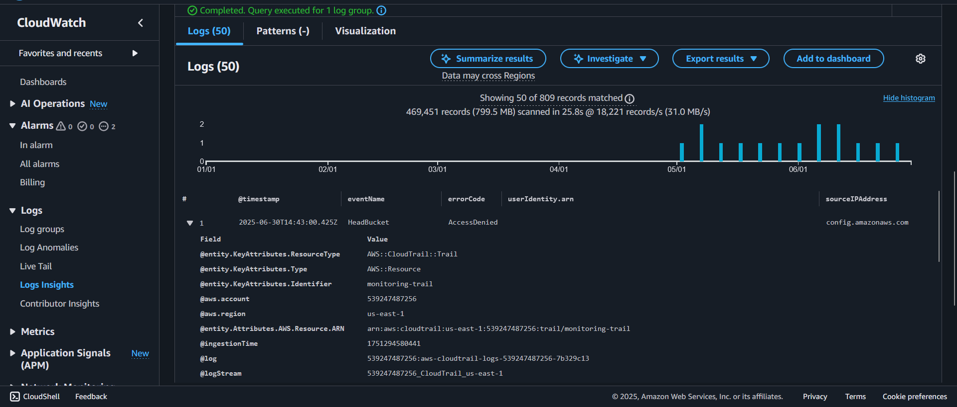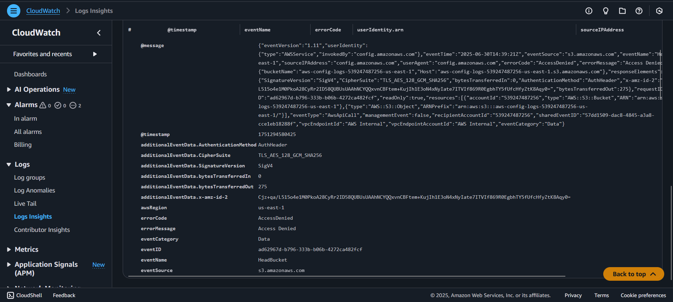

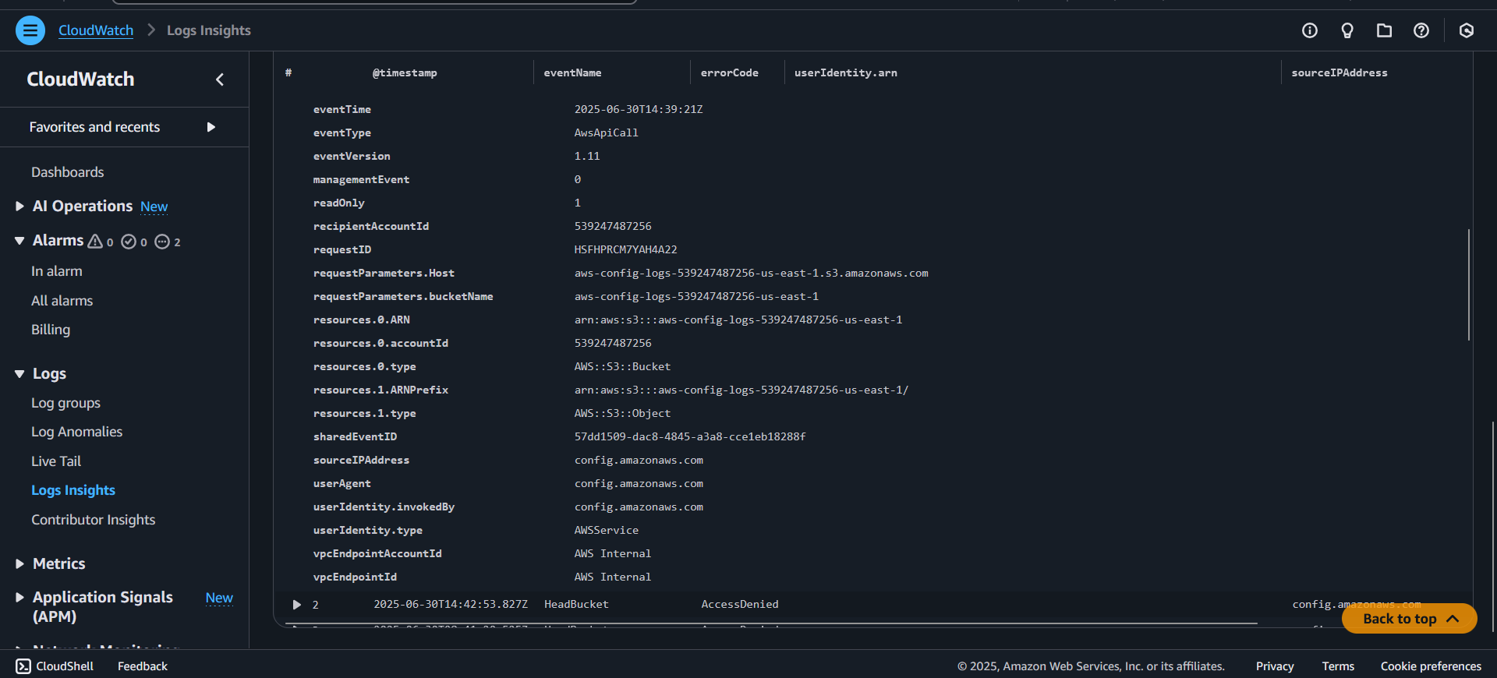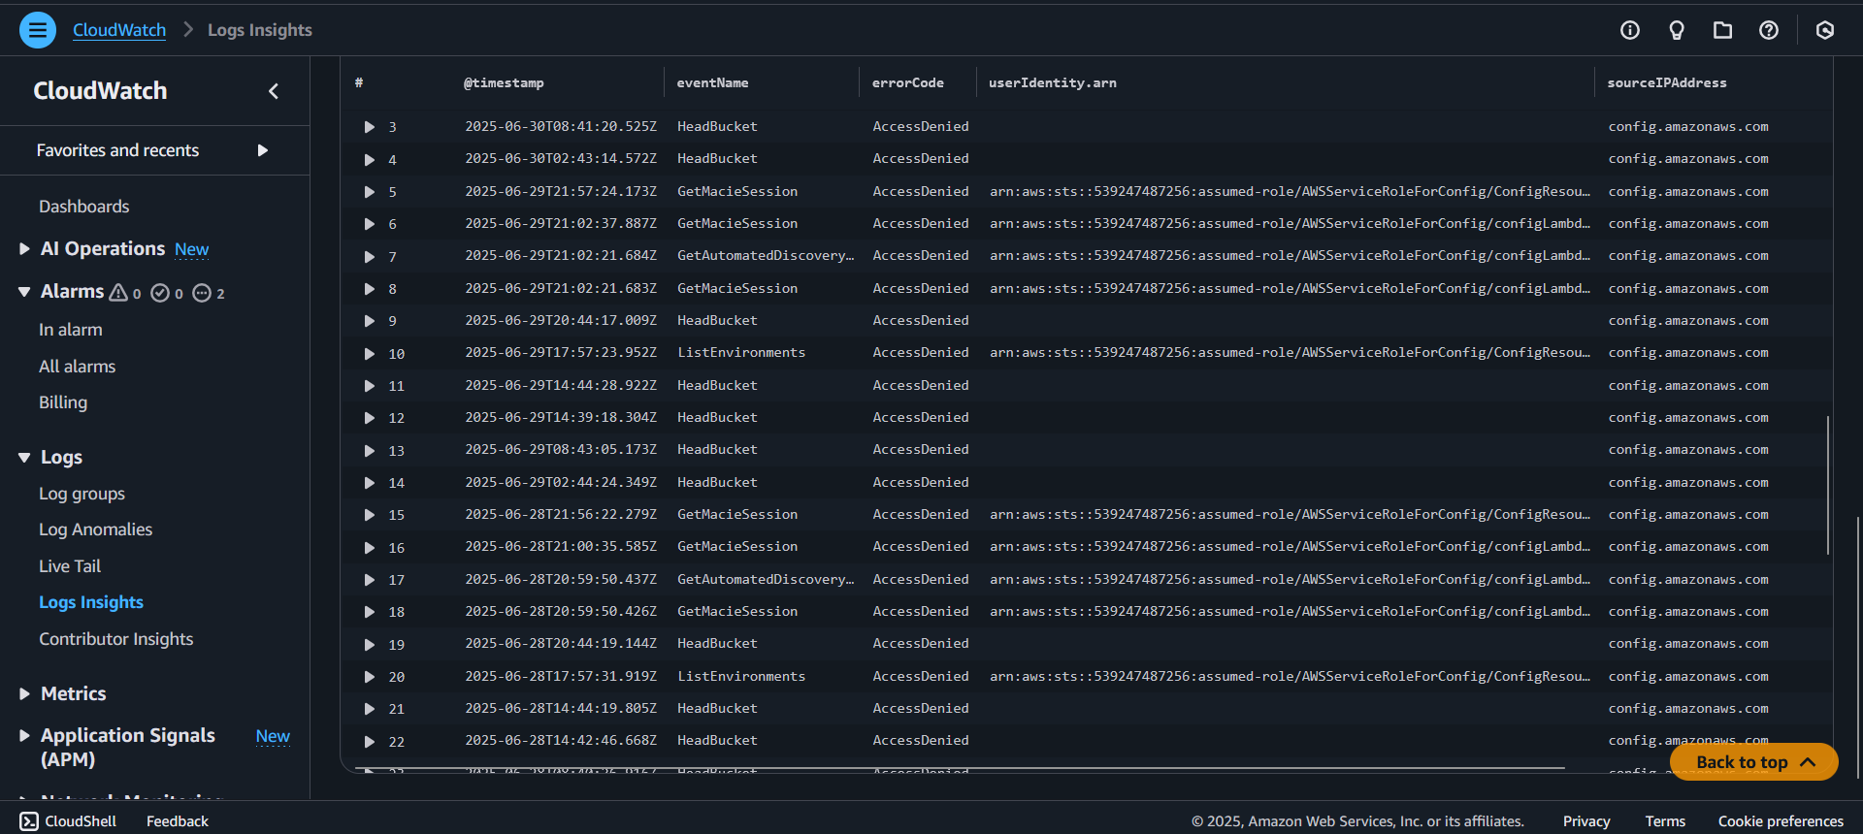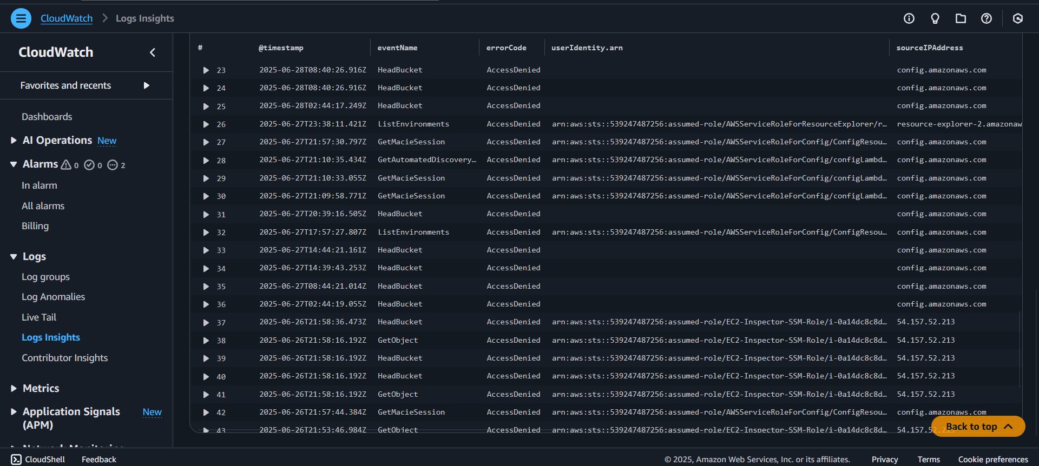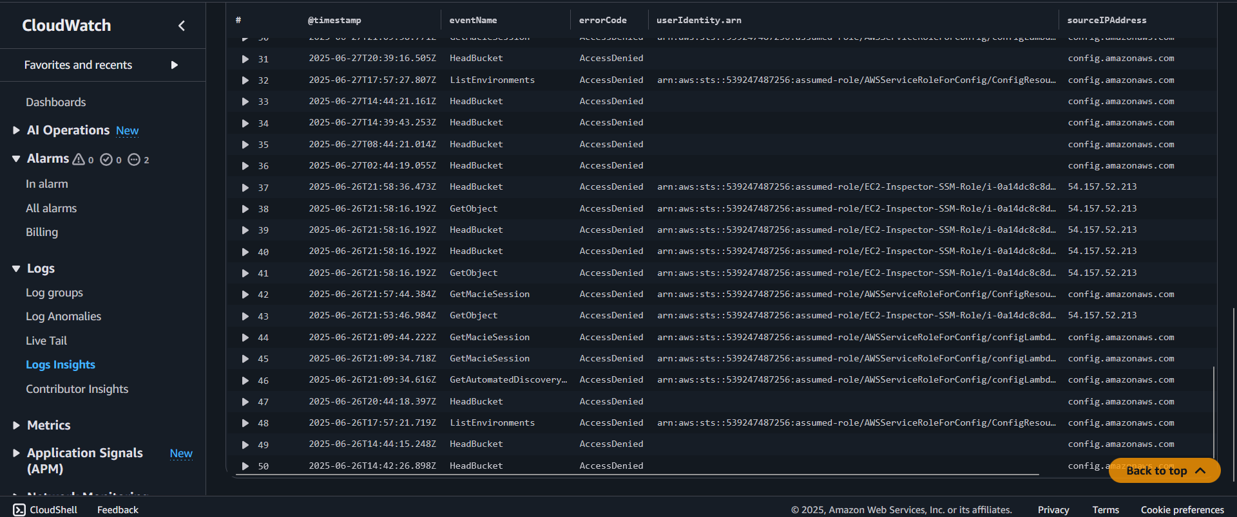

This concludes CloudWatch.5 since Cloudtrail actively logs events, metric filters are correctly matching the patterns, CloudWatch Log group is receiving entries and CloudWatch alarms will activate and send email notifications through the SNS topic configurations we have done. Additionally, to be able to navigate to the CloudTrail log stream to the exact S3 location. Head to S3 console and press on an S3 bucket aws-cloudtrail-logs-539247487256-f53742b5**,** Under Objects press AWSLogs 🡪 Account ID 🡪 CloudTrail-Digest 🡪 us-east-1 🡪 2025 🡪 June (6) 🡪 Day (25) 🡪 Log files 🡪 download any json.gz file 🡪 Right click Press show more options 🡪 unzip with 7-zip or WinRaR 🡪 open with VS Code, Notepad++ or JSON Viewer to inspect the file 🡪 find the fields “eventName”: “UpdateTrail”, “StopLogging” or “AccessDenied” depending on the date those events occurred if they do.

**Snapshot of every AWS Services**

IAM Configuration

S3 Configuration

CloudTrail Logging

AWS Config

GuardDuty

Amazon EC2 Inspector

SNS Alerting

AWS KMS

CloudWatch Monitoring

Security Hub

Automated Compliance & Remediation (CloudTrail.7, EC2.2 and CloudWatch.5)

**Cleaning up All Resources**

The list of items that will be deleted or disabled are IAM test users, groups or roles if created, S3 buckets, CloudTrail, AWS Config, GuardDuty, Amazon Inspector, SNS Topics, CloudWatch, Key Management System, Security Hub, Lambda functions & Remediation roles and lastly check the billing dashboard under cost explorer to ensure no services are generating any more incur costs or charges. To begin cleaning up start by navigating to the IAM console, check user group and delete any user group that is no longer needed, do the same for users as well. Under Roles, Select all of the roles with the most recent activities that are labeled as the service linked name on them and delete them if they are no longer required. But do not delete any role that has the name “do not delete”. If you receive an error message due to other AWS services being active then then disable those first. AWS will not let you delete roles that are tied to active AWS services. Head over to the S3 console, empty and delete the most recent buckets created for this project but do not delete any S3 bucket that says “do not delete”. AWS will not let you delete a bucket without emptying it first. If you are receiving logs being generated by CloudWatch and CloudTrail then disable and delete them as well. Head to CloudTrail and under trail delete any trails that we no longer need, this should ensure that no more logs are being generated. Head to AWS Config’s settings and press stop recording resources. Check to make sure there is no more recording from either customer managed recorder and service linked recorder. If you have manually created any Config rule or Config S3 buckets then delete those as well. Navigate over to guardduty’s settings and press disable guardduty. When you disable GuardDuty, it will no longer monitor your AWS environment and won't generate new findings. You will also lose your existing findings and GuardDuty configuration. You won't be able to recover this data after you disable GuardDuty. To save a copy of your existing findings, you must first export them before you disable GuardDuty. If you are using Malware Protection for S3, then disabling GuardDuty doesn't disable Malware Protection for protected S3 buckets. You must disable Malware Protection for S3 for each protected bucket individually, otherwise you will continue to incur usage costs associated with this feature. Next step is to head over to Amazon Inspector’s General settings and disable or deactivate inspector. Note: When you deactivate Inspector, all of your data will be deleted and cannot be restored. Before you deactivate Inspector, you must disassociate all member accounts. Head over to SNS’s Topic and delete any topic and Subscriptions that are used for alarm notifications as well. After that go to Cloud Watch, under all alarms and select all alarms then delete them. Head to the log group and select all log groups then delete them except for the ones that were not created in this project. Head to Metrics and delete any custom name space metrics if they were created, in this case its CISBenchmark and SecurityMonitoring. But if we are unable to delete them then the metrics will expire based on retention schedules, if they did not have any new data points in the previous two weeks then they are removed from the CloudWatch console. Data is stored for up to 15 months. Head to KMS or key management service, select all customer managed keys and press schedule key deletions for both of them. Note: Deleting a key makes all data encrypted under that key unrecoverable. Set the waiting period to 7 or up to 30 days if desired , then confirm and schedule deletion, the keys being deleted are CloudTrail-KMS-keys and project-security-key. Head over to Security Hub’s settings and disable both security hub and all selected standards that are enabled (if possible). Press disable AWS Security Hub CSPM (Cloud Security Posture Management). Security Hub is a central management security console. Head over to lambda’s function and delete SecurityGroupRemediationFunction. Note: Deleting a function permanently removes the function code. The related logs, roles, test event schemas, and triggers are retained in your account. Head back to the IAM’s policies page and delete any role that says service-linked under guard duty, inspector, lambda, AWS Config and security hub.

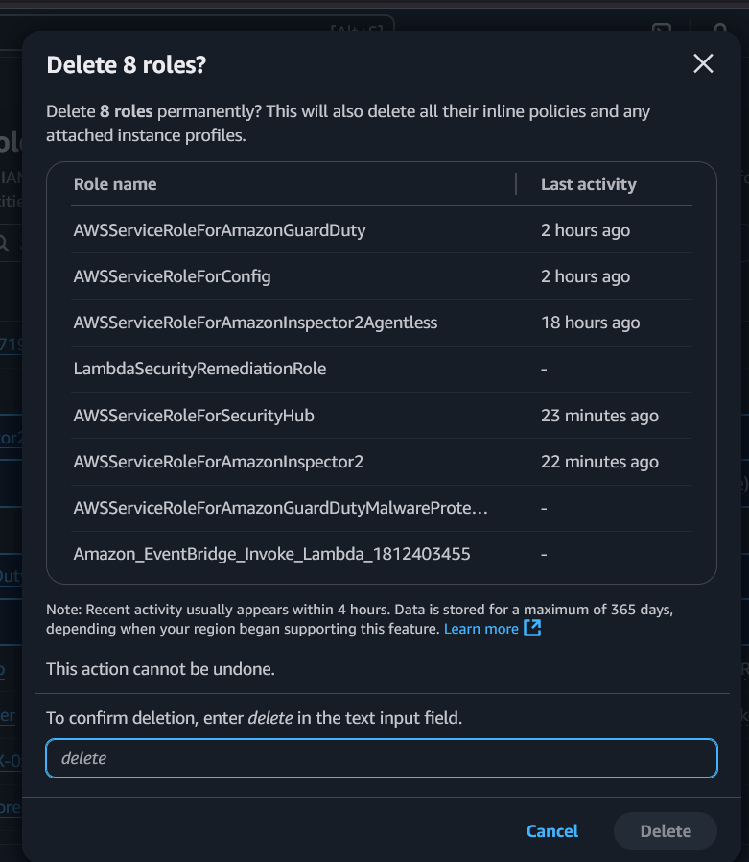

The last thing that needs to be done is heading over to the account’s billing and cost management console and check under cost explorer to see the entire expense of running this project based on our use cases for it.

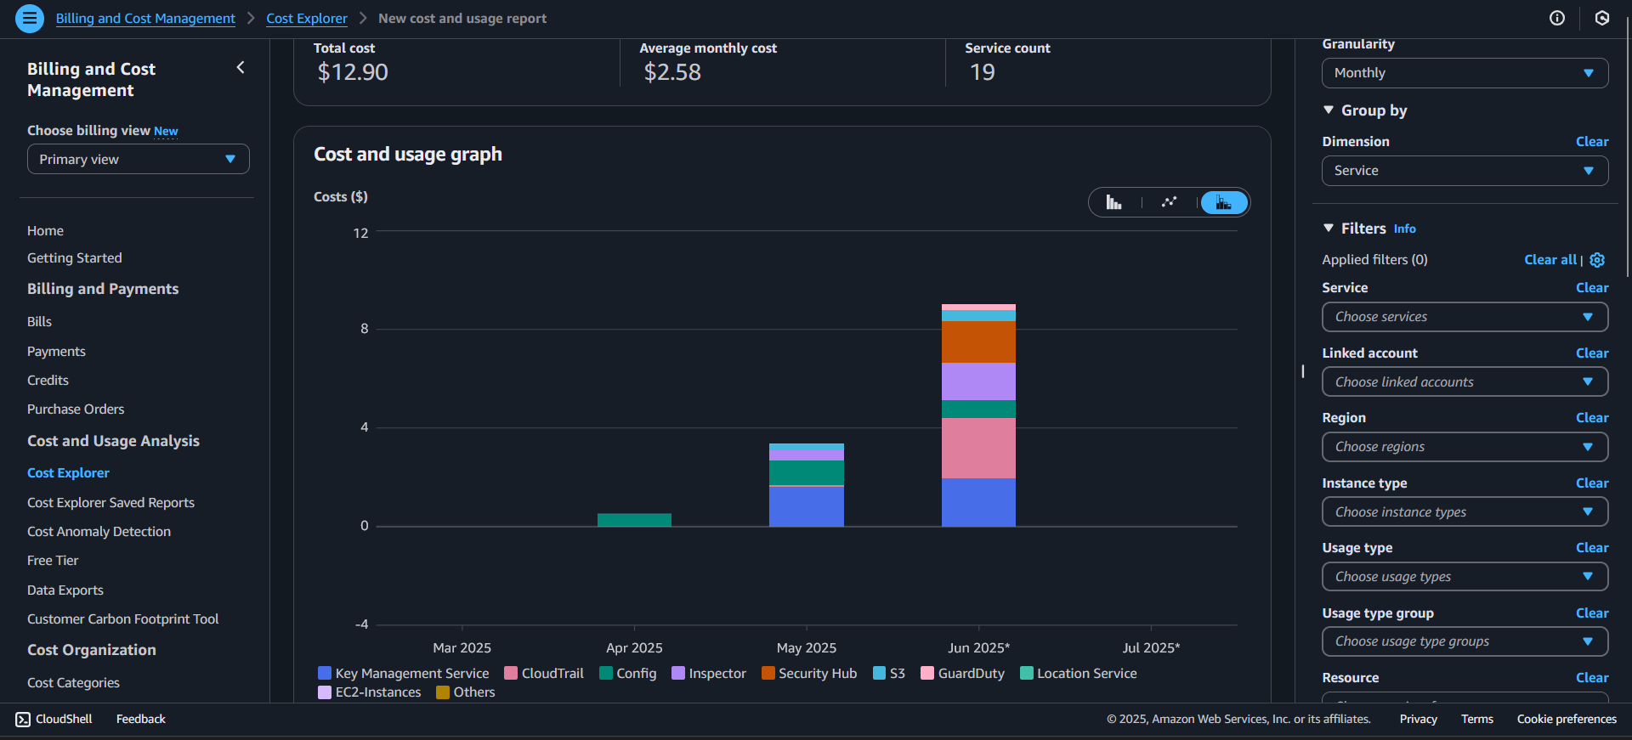

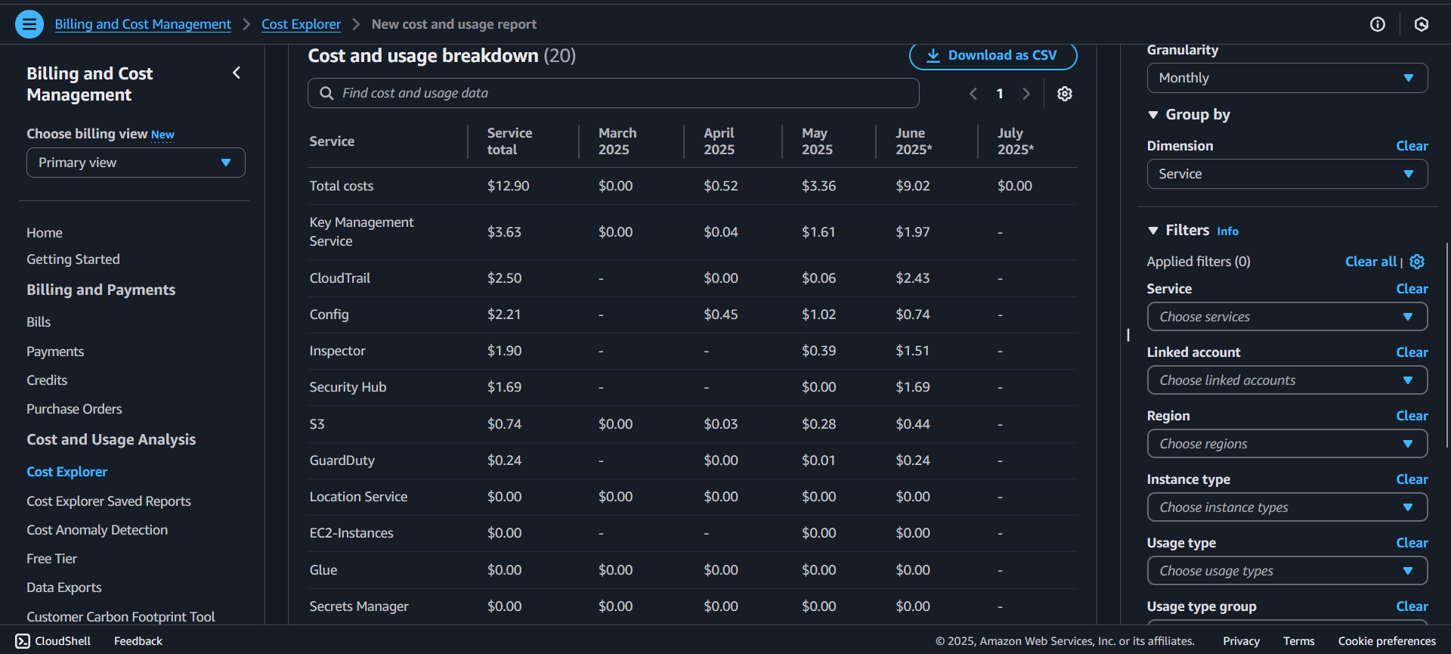

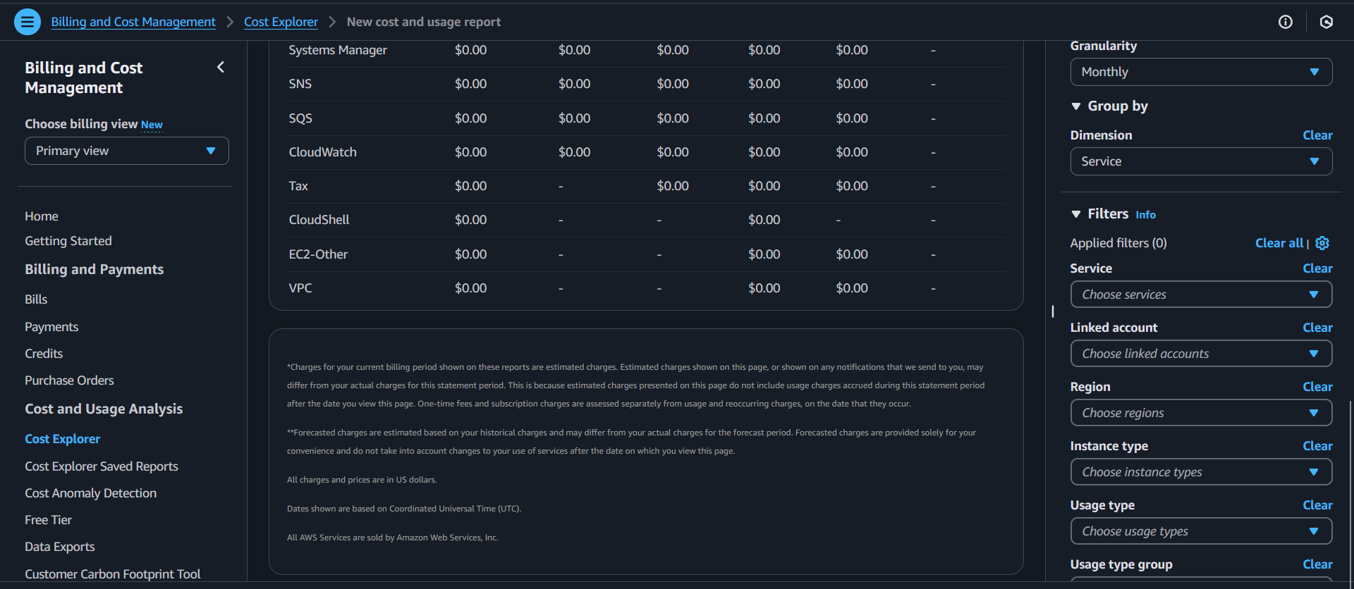

**Summary of Everything**

Developed and thoroughly documented a comprehensive 109 page project simulating a real-world AWS security and compliance environment. Leveraged key AWS services including IAM for fine-grained access control, KMS for encryption and key management, CloudTrail for auditing user activity, AWS Config for resource compliance monitoring, Security Hub for centralized security alerts, GuardDuty for intelligent threat detection, and CloudWatch for performance monitoring and automated alerting. The system enforces strict access policies, continuously monitoring for configuration drift and security threats, provides detailed audit logs, and automates alerts to help proactively identify and mitigate potential vulnerabilities. This project demonstrates practical skills in cloud security architecture, compliance best practices, and proactive threat management, highlighting a strong capability to design and manage secure cloud environments.